WALLOWS SET TO EMBARK ON LARGEST GLOBAL TOUR TO DATE
IN SUPPORT OF NEW ALBUM MODEL ARRIVING MAY 24TH

MODEL TOUR INCLUDES ARENA, AMPHITHEATER & THEATER PERFORMANCES AT
WORLDWIDE LEGENDARY VENUES
MADISON SQUARE GARDEN, RED ROCKS, KIA FORUM, ALEXANDRA PALACE, ZENITH, AFAS LIVE

SPECIAL GUEST BENEE TO JOIN IN NORTH AMERICA

TOUR ANNOUNCE ARRIVES ALONGSIDE EPIC SHORT FILM
STARRING THE BAND & DIRECTED BY NINA LJETI
WATCH HERE

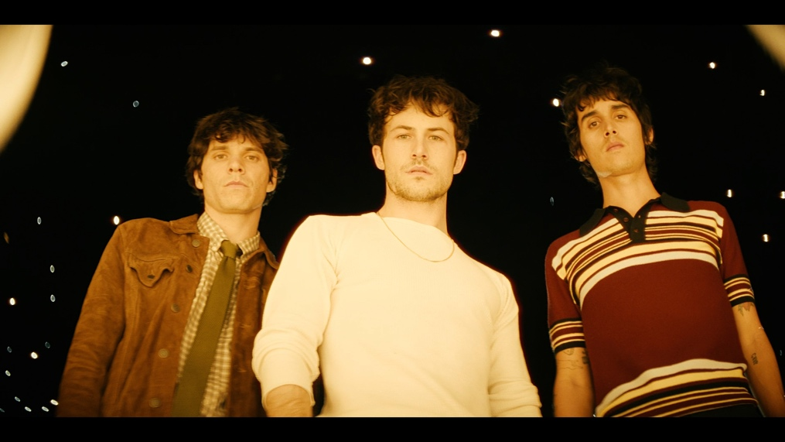
PRESALE BEGINS MARCH 12TH | GENERAL ONSALE MARCH 15TH
COMPLETE DETAILS AVAILABLE HERE

Multi-platinum alt-rock trio Wallows have announced their eagerly awaited global tour in support of their forthcoming album Model. Wallows’ Model Tour, their biggest tour to date, was revealed this morning with a spectacular short film directed by Nina Ljeti and stars the band themselves, along with a few of their friends. Watch the eerie, horror-film esque video which was shot at Los Angeles’ Kia Forum HERE.

Produced by Live Nation, the tour kicks off August 6th in Portland, OR at Alaska Airlines’ Theater of the Clouds and will take the band across North America, Europe and the United Kingdom (full list of shows below). The 38 city tour marks Wallows’ first ever headline performances at Madison Square Garden, The Kia Forum, Red Rocks Amphitheatre, Budweiser Stage, Alexandra Palace, Zenith, and AFAS Live. Additionally, very special guest BENEE will join the band on all North American dates.

Wallows newsletter subscribers will get first access to pre-sale tickets starting Tuesday, March 12th at 10am local time through Thursday, March 14th at 10pm local time. If you aren’t already a subscriber, you can register HERE by 7pm ET tonight (March 11th) for access. Tickets go on sale to the general public at 10am local time on Friday, March 15th. For tickets and more information, visit wallowsmusic.com.

Citi is the official card of Model Tour. Citi cardmembers will have access to pre-sale tickets for U.S. dates beginning March 12th at 10am local time as well until March 14th at 10pm local time through the Citi Entertainment program. For complete details visit www.citientertainment.com.

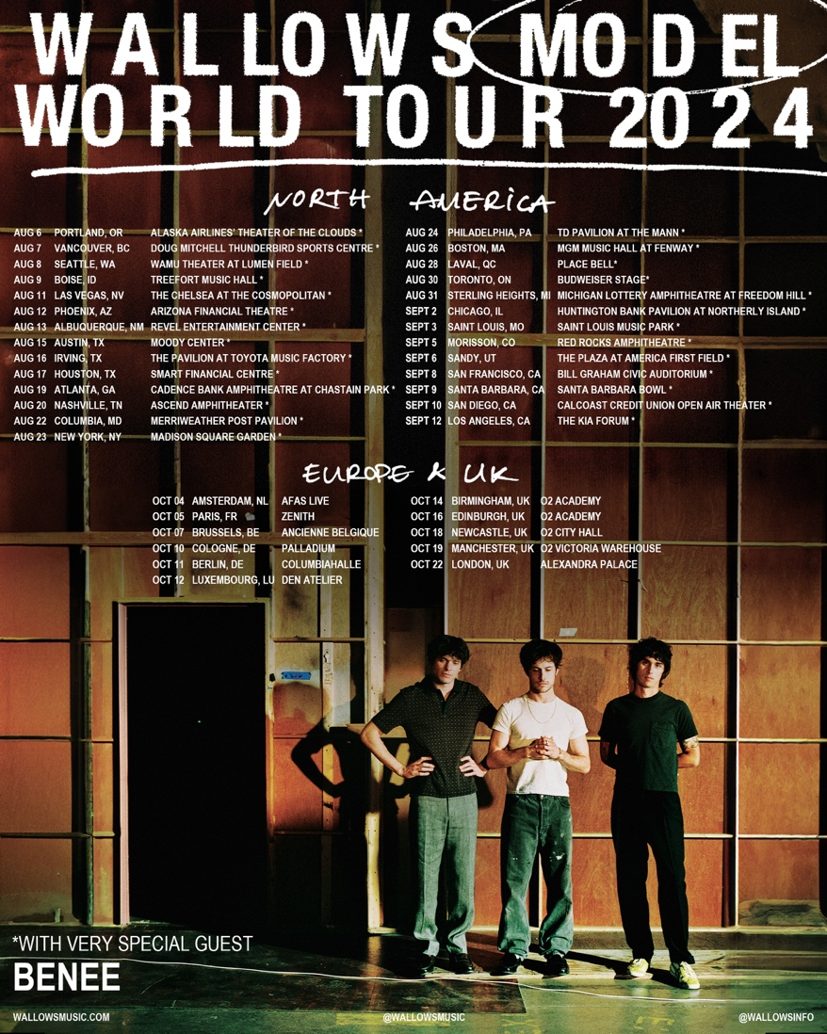
DOWNLOAD HI-RES ADMAT

The tour announcement follows Wallows triumphant return with the release of "Your Apartment” last month – the first track off of the band’s forthcoming album, Model, and their highest streaming debut to date. The second single “Calling After Me” is due to arrive March 21st. The John Congleton-produced album arrives May 24th via Atlantic Records and is available for pre-order/pre-save now HERE. Model will be available physically on standard clear vinyl, limited edition “sunset” vinyl (lemon, tangerine & apple three-color mix) exclusively in Wallows’ web store, CD, and clear cassette. Watch official album trailer HERE.

The tour will also offer two VIP packages – Gold & Silver – for fans to take their concert experience to the next level. Packages vary based on offer selected but include premium tickets, signed screen printed poster, VIP tote bag, VIP playing card set, early entry to the venue & more. For more information, visit vipnation.com.

WALLOWS MODEL TOUR 2024
* with very special guest BENEE
^ not a Live Nation date

AUGUST
6 – Portland, OR – Alaska Airlines’ Theater of the Clouds *
7 – Vancouver, BC – Doug Mitchell Thunderbird Sports Centre *
8 – Seattle, WA – WAMU Theater at Lumen Field *
9 – Boise, ID – Treetfort Music Hall *^
11 – Las Vegas, NV – The Chelsea at the Cosmopolitan *
12 – Phoenix, AZ – Arizona Financial Theatre *
13 – Albuquerque, NM – Revel Entertainment Center *
15 – Austin, TX – Moody Center *
16 – Irving, TX – The Pavilion at Toyota Music Factory *
17 – Houston, TX – Smart Financial Centre *
19 – Atlanta, GA – Cadence Bank Amphitheatre at Chastain Park *
20 – Nashville, TN – Ascend Amphitheater *
22 – Columbia, MD – Merriweather Post Pavilion *
23 – New York, NY – Madison Square Garden*
24 – Philadelphia, PA – TD Pavilion at The Mann*
26 – Boston, MA – MGM Music Hall at Fenway *
28 – Laval, QC – Place Bell *
30 – Toronto, ON – Budweiser Stage *
31 – Sterling Heights, MI – Michigan Lottery Amphitheatre *
SEPTEMBER
2 – Chicago, IL – Huntington Bank Pavilion at Northerly Island *
3 – Saint Louis, MO – Saint Louis Music Park *
5 – Morrison, CO – Red Rocks Amphitheatre *
6 – Sandy, UT – The Plaza at America First Field *
8 – San Francisco, CA – Bill Graham Civic Auditorium *
9 – Santa Barbara, CA – Santa Barbara Bowl *^
10 – San Diego, CA – Cal Coast Credit Union Open Air Theater *
12 – Los Angeles, CA – The Kia Forum *

OCTOBER
4 – Amsterdam, Netherlands – AFAS Live
5 – Paris, France – Zenith
7 – Brussels, Belgium – Ancienne Belgique
10 – Cologne, Germany – Palladium
11 – Berlin, Germany – Columbiahalle
12 – Luxembourg-City, Luxembourg – Den Atelier
14 – Birmingham, United Kingdom – O2 Academy
16 – Edinburgh, United Kingdom – O2 Academy
18 – Newcastle, United Kingdom – O2 City Hall
19 – Manchester, United Kingdom – O2 Victoria Warehouse
22 – London, United Kingdom – Alexandra Palace
MORE ON WALLOWS:
Wallows (composed of Dylan Minnette, Braeden Lemasters and Cole Preston) have been best friends since the age of 11. They began playing music together in the LA music program Join the Band almost two decades ago and haven’t stopped since. In March 2022, the band released their Sophomore album, Tell Me That It’s Over, produced by 3x GRAMMY Award-winner Ariel Rechtshaid (Vampire Weekend, Haim, Adele). TMTIO saw Wallows continuing on their ever-evolving journey of sonic exploration, fusing a vast array of musical ideas – from lo-fi post-punk and indie-folk to early ’90s dance-pop psychedelia – into their own one-of-a-kind creative vision.

TMTIO marked the full-length follow-up to Wallows’ hugely popular 2019 debut album, Nothing Happens, produced by GRAMMY Award-winner John Congleton (St. Vincent, Sharon Van Etten). The album proved to be one of that year’s highest streamed debuts. In the live space, Wallows have headlined sold out shows around the globe and have performed at marquee festivals such as Coachella, Lollapalooza, Reading and Leeds, and more.

About Live Nation Entertainment
Live Nation Entertainment (NYSE: LYV) is the world’s leading live entertainment company comprised of global market leaders: Ticketmaster, Live Nation Concerts, and Live Nation Sponsorship. For additional information, visit www.livenationentertainment.com.

CONNECT WITH WALLOWS
WALLOWSMUSIC.COM I FACEBOOK I TWITTER I YOUTUBE I INSTAGRAM | TIK TOK | PRESS SITE

PRESS CONTACTS
COREY BREWER | COREY.BREWER@ATLANTICRECORDS.COM
KELLY MCWILLIAM | KELLY.MCWILLIAM@ATLANTICRECORDS.COM
GABRIELLE REESE | GABRIELLE.REESE@ATLANTICRECORDS.COM
Live Nation Concerts
Monique Sowinski | MoniqueSowinski@livenation.com
Valeska Thomas | ValeskaThomas@livenation.com

To apply for media credentials for show coverage: livenation.com/pressrequests

