FOR IMMEDIATE RELEASE
APRIL 19, 2024

RISING HIP-HOP/DANCE ARTIST BOSSA
ARRIVES WITH “GO CRAZY”

EXPLOSIVE MAJOR LABEL DEBUT SINGLE FOLLOWS BREAKTHROUGH HIT, “TOO MUCH”

“GO CRAZY” AVAILABLE NOW VIA ATLANTIC RECORDS/ANEMOIA RECORDS
LISTEN HERE

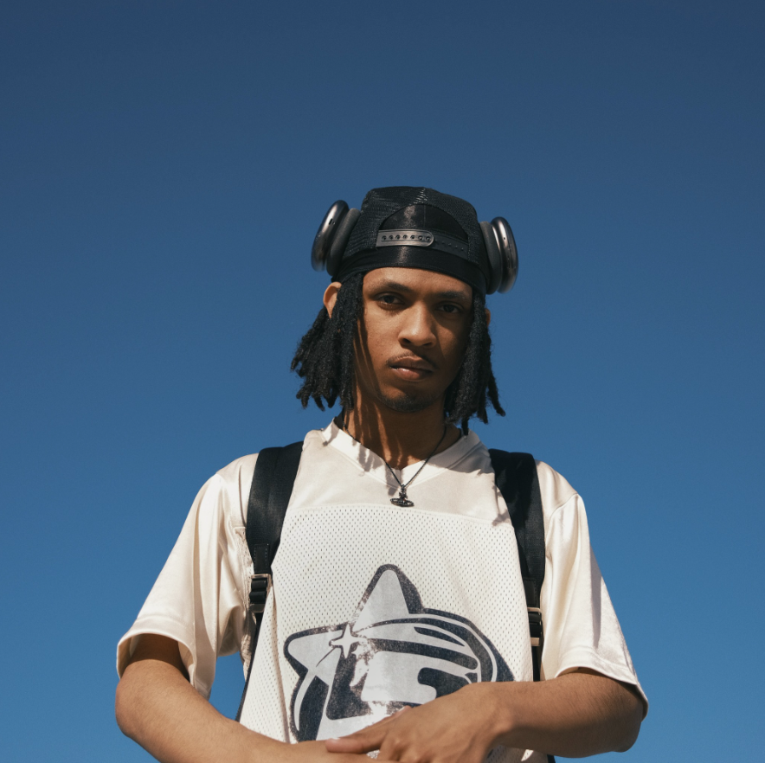
DOWNLOAD ASSETS HERE

Rising hip-hop/dance music artist Bossa has shared his label debut single, “Go Crazy,” available now via Atlantic Records/Anemoia Records – Listen HERE. Produced by Mystic DA Kid, dyl, and Lunas, the track is an invitation to “go dumb and have fun,” says Bossa, marked by multilayered production, driving drums, and a wash of vocals that transport listeners to an impossibly ecstatic party space.

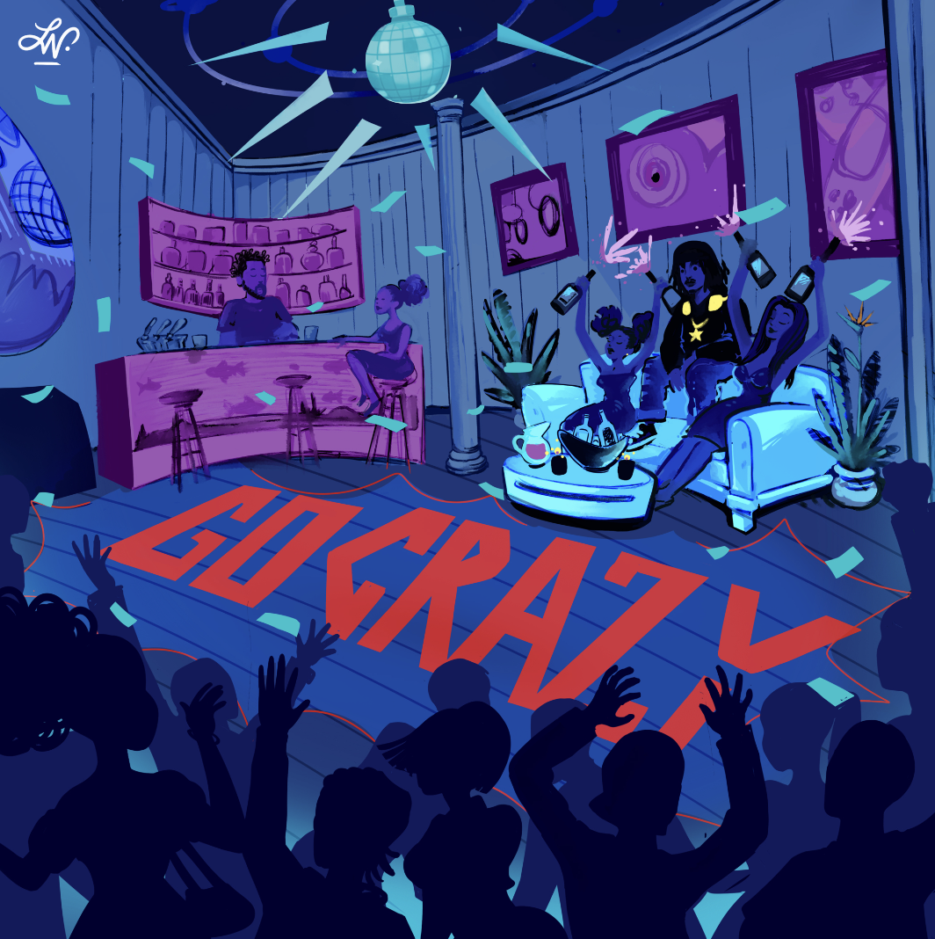
DOWNLOAD ASSETS HERE

“Go Crazy” follows his breakthrough viral hit “Too Much,” which has already amassed over 11M global streams and counting on Spotify, with the remixes garnering over a total of 6M streams - “Too Much – Remix," “Too Much – Slowed,” “Too Much – Sped Up,” and most recently “Too Much – DJ Smallz 732 Remix.” The track came together in August of 2023, when a dancefloor-ready drum pattern synonymous with Jersey Club music from producer Nate Morgan caught Bossa’s attention, inspiring the propulsive track. He performed "Too Much” at a recent pop-up show in a packed Washington Square Park – Watch HERE.

Now signed to Atlantic Records/Anemoia Records, Bossa is constantly developing as a singer and a rapper, strengthening his vocals and experimenting with different cadences, eager to remove barriers, find new flows, and tap into something new.

##

At just 17 years old, Bossa is one of the hottest new artists making music at the intersection of hip-hop and dance music. Born and raised in California’s Coachella Valley, he grew up loving the elastic melodies and rhythms of Michael Jackson, cementing his deep connection between music and dance. Through TikTok, Bossa soon stumbled upon pluggnb, a hip-hop adjacent subgenre with a particularly sweet production style that favored melody akin to early 2000s R&B. Suddenly, there were new sonic possibilities and a world of friends and collaborators online, and with his catchy flows and addictive cadences, Bossa is ready to change the game.

“I don’t want to be put in a box,” Bossa says, “I just want to make good music. I want to have an everlasting career. I wasn’t making music to get a record deal; I made what I liked. I’m just about making good music.”

CONNECT WITH BOSSA
INSTAGRAM | TIKTOK | YOUTUBE

PRESS CONTACT
Olivia Lee | olivia.lee@atlanticrecords.com

