BRELAND REVEALS SECOND PHASE OF HEADLINING
LITTLE MORE COUNTRIER TOUR 2024

FIVE MORE SHOWS SET TO TRACE THE WEST COAST IN JUNE

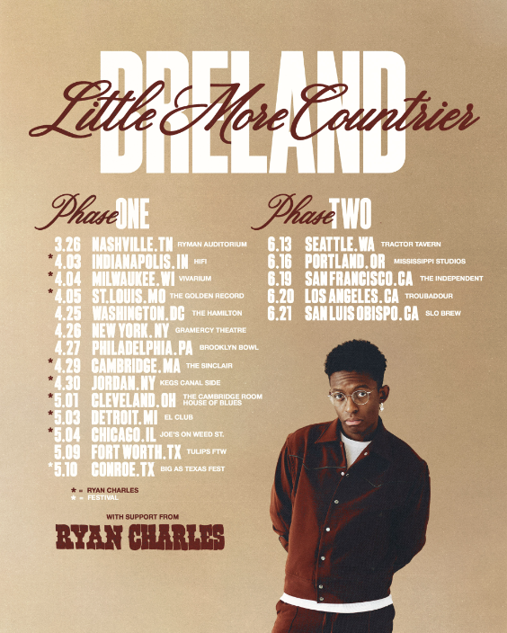

Following the launch of his LITTLE MORE COUNTRIER TOUR with a SOLD-OUT charity concert at Nashville’s Ryman Auditorium, PLATINUM artist BRELAND is announcing phase two of headline dates, set for June of 2024.

Tracing the West Coast of the U.S. with his infectious mix of Country, Hip-Hop and Soul, BRELAND will visit five major markets including Seattle, San Francisco, Los Angeles, and more. The early-summer run will begin on June 13, and include the high-flying entertainer's first-ever headline appearance at Troubadour in West Hollywood – one of L.A.'s most iconic and historic music venues.

The tour news follows the February reveal of phase one, which features more than a dozen shows scattered across the East Coast and Midwest. Now underway and set to run through May, that initial trek includes stops in St. Louis, New York City, Chicago and beyond, with Ryan Charles serving as special guest on select dates.

Tickets for phase two of the LITTLE MORE COUNTRIER TOUR will go on sale this Friday, April 5 at 10:00 a.m. local time, with phase one tickets available now here.

Announced dates, cities, and venues for BRELAND’s LITTLE MORE COUNTRIER TOUR:

APRIL
03 | Indianapolis, IN – HiFi ^
04 | Milwaukee, WI – Vivarium ^
05 | St. Louis, MO – The Golden Record ^
25 | Washington, DC – The Hamilton
26 | New York, NY – Gramercy Theatre
27 | Philadelphia, PA – Brooklyn Bowl
29 | Cambridge, MA – The Sinclair ^
30 | Jordan, NY – Kegs Canal Side ^

MAY
01 | Cleveland, OH – The Cambridge Room at House Of Blues ^
03 | Detroit, MI – El Club ^
04 | Chicago, IL – Joe’s on Weed St. ^
09 | Fort Worth, TX – Tulips FTW
10 | Conroe, TX – Big As Texas Fest

JUNE
13 | Seattle, WA – Tractor Tavern*
16 | Portland, OR – Mississippi Studios*
19 | San Francisco, CA – The Independent*
20 | Los Angeles, CA – Troubadour*
21 | San Luis Obispo, CA – Slo Brew*

^ Ryan Charles supporting
*On sale this Friday (4/5) at 10:00 a.m. local time

The LITTLE MORE COUNTRIER TOUR kicked off March 26, when the emerging hitmaker took over the iconic Ryman Auditorium for another presentation of his popular BRELAND & Friends charity concert. Now in its third year, the SOLD-OUT night of music and giving featured special and surprise guests like Anthony Hamilton, Avery Anna, Caitlyn Smith, Chase Rice, Dalton Dover, Drake White, Dylan Marlowe, Hailey Whitters, Josh Groban, Matt Stell, Nelly, Quinn XCII, Tanner Adell, The War And Treaty, and Walker Hayes, and raised over $140,000 for the Oasis Center and its mission to benefit at-risk youth in Middle Tennessee.

Meanwhile, momentum continues to build with BRELAND celebrating a memorable cameo in the new film remake of Road House starring Jake Gyllenhaal. Appearing on screen as a bandleader during a riveting fight scene with actor Lukas Gage, BRELAND brings his trademark energy and spotlight smile to a film capturing attention from a wide cross-section of fans, and the star was also on hand at this year’s SXSW festival, where Road House made its acclaimed premiere. Fans can watch the film exclusively on Amazon Prime Video.

For full list of tour dates, visit here.

CONNECT WITH BRELAND
WEBSITE | INSTAGRAM | FACEBOOK | X
AMAZON MUSIC | YOUTUBE | SOUNDCLOUD

ABOUT BRELAND:
Boundary-shattering, breakout star BRELAND is pushing the possibilities of Country music on a global scale. Since the arrival of his PLATINUM-certified debut single “My Truck,” the New Jersey-bred singer/songwriter/producer has amassed over 1.1 BILLION career streams, brought his crowd-thrilling live show to an international headline tour, and gained acclaim from many of the world’s leading music publications (with Rolling Stone hailing him as “a symbol of Country music’s ongoing evolution” and Billboard calling him a “keen, visionary solo artist”). On his critically acclaimed 2022 debut album CROSS COUNTRY, the Bad Realm Records/Atlantic Records/Warner Music Nashville artist introduced a high-energy sound that blurs the barriers between Country, Pop, Hip-Hop, Soul, and Southern Gospel, offering up smash hits like the GOLD-certified “Praise The Lord (feat. Thomas Rhett).” A blockbuster year for BRELAND, 2023 has included such triumphs as teaming up with superstar Keith Urban to open the 16th annual Academy of Country Music Honors by performing their GOLD-certified collaboration “Throw It Back” and — immediately following the performance — receiving the ACM Lift Every Voice Award, recognizing his role in “elevating underrepresented voices throughout the Country music genre, transcending demographics and geography.” Released in September, CROSS COUNTRY: THE EXTRA MILE delivered a star-packed bonus version of his full-length debut, with the expanded album’s six fresh tracks including a brand-new feature with Brittney Spencer as well as live favorite “Cowboy Don’t.” With his high-profile TV appearances to date including Good Morning America, Jimmy Kimmel Live!, The Voice, and TODAY, he also spent much of 2023 on the road as support for the legendary Shania Twain’s QUEEN OF ME TOUR in the U.S. and U.K. (with stops at iconic venues like Madison Square Garden), in addition to taking his THE EXTRA MILE TOUR across the U.K., Germany, Netherlands, Denmark, Sweden, and Norway. A truly magnetic live performer, BRELAND has also graced the stage at major festivals like Stagecoach and C2C: Country to Country Festival, fulfilling his mission of uniting audience members from all walks of life with his wildly joyful music.

# # #

MEDIA CONTACTS:
Fairley McCaskill / Fairley.McCaskill@atlanticrecords.com
Jensen Sussman / Jensen@sweettalkpr.com

