JACK HARLOW LAUNCHES GAZEBO FESTIVAL
SZA & JACK HARLOW SET TO HEADLINE

MAY 25-26, 2024 IN LOUISVILLE, KY

Multiple GRAMMY-nominated rapper & Louisville native unveils immersive two-day festival in his hometown, celebrating the intersection of music and culture

Two-day lineup includes performances by SZA, James Blake (DJ Set), Omar Apollo, PinkPantheress, Vince Staples & more

Tickets go on sale to the general public Friday, March 8 at 10 a.m. EST via www.GazeboFest.com

Festival presale begins MARCH 6 at 10am EST

Fans can sign-up for exclusive artist presale access HERE

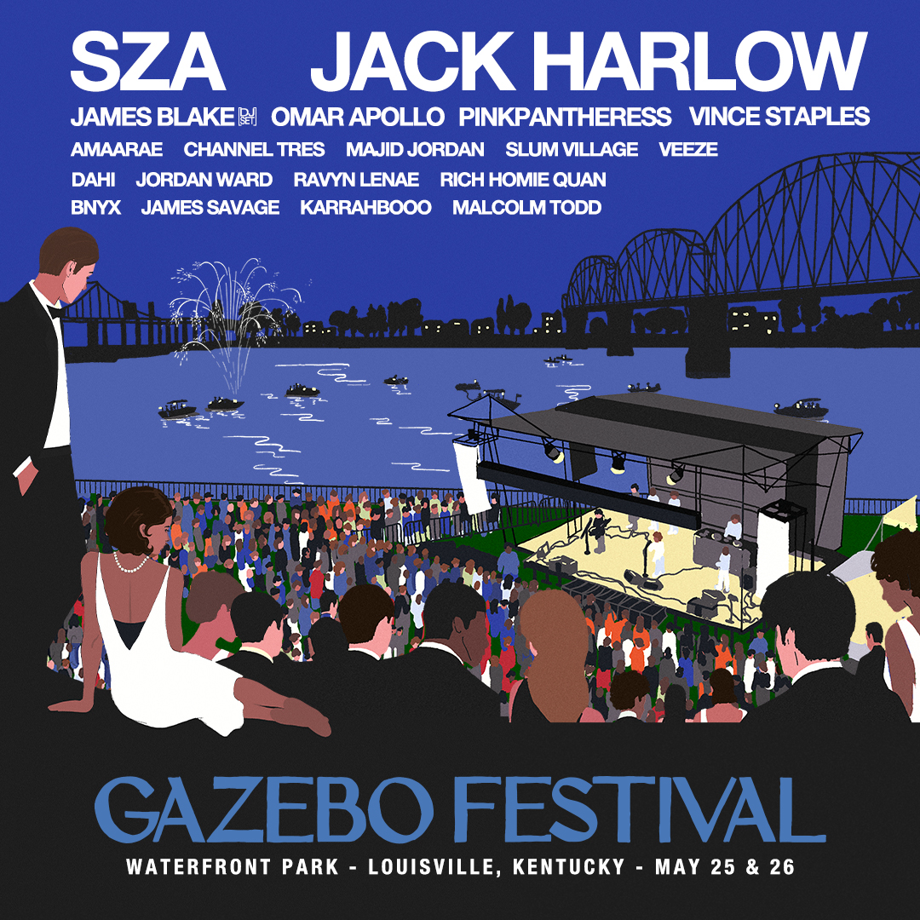

Louisville, Ky. (February 28, 2024) – Jack Harlow announces GAZEBO Festival, a music festival he will co-headline with multiple GRAMMY Award winner, SZA, on May 25 & 26 at Louisville’s Waterfront Park. The line-up also includes James Blake (DJ Set), Omar Apollo, PinkPantheress, Vince Staples and more.

The two-day event will feature 26 acts on two stages and highlight some of Louisville’s local food and culture. The Waterfront Park location uniquely marries the energy of downtown Louisville with more than 85 acres of green space on the Ohio River.

Tickets for the festival will go on sale Friday, March 8, 2024 at 10 a.m. EST. Special fan presales will take place beginning March 6, 2024 at 10 a.m. EST. General admission weekend tickets are available starting at $255. A VIP ticket offers access to a VIP lounge with air conditioning, premium restrooms, dedicated bar and food offerings, and a merchandise tent. VIP ticket buyers will also have access to dedicated VIP entrance lanes into the festival and up-close, premium viewing at both stages. VIP tickets include a branded clear tote bag and a limited edition festival line-up t-shirt. For available ticket types and details, visit gazebofest.com.

A portion of proceeds from every ticket, plus a number of other on-site revenue streams, will benefit various community organizations in Louisville through the Jack Harlow Foundation. Harlow created The Jack Harlow Foundation in 2023 to reinvest, uplift, and support organizations in his hometown of Louisville. In 2023 alone, the Jack Harlow Foundation distributed more than $500,000 in funds and product donations.

“Jack Harlow is an extraordinary Louisvillian who continues to give back to his hometown,” said Louisville Mayor Craig Greenberg. “This is yet another way Jack is showing up for our city and I can’t wait to see the excitement this festival creates. I am so grateful for his commitment to making first class things happen for Louisville and our people.”

“We are beyond excited to support our city’s hometown hero, Jack Harlow, as he launches a new music festival at Louisville’s Waterfront Park,” said Cleo Battle, President and CEO of Louisville Tourism. “In addition to great music, festival goers will get a taste of this city's iconic attractions, renowned heritage and global culinary scene."

GAZEBO Festival is a partnership between two Louisville institutions - Jack Harlow and Production Simple. Tixr, the world's fastest growing independent ticketing company, is the official ticketing partner of GAZEBO Festival.

For all Jack Harlow press inquiries, please contact:
Jason Davis jason.davis@atlanticrecords.com

For all GAZEBO Festival press inquiries, please contact:
Jason Davis jason@gazebofest.com
Holly Weyler holly@gazebofest.com

Media application can be found here

Media materials can be found here

* * *

ABOUT JACK HARLOW
Hailed as the “hitmaker of tomorrow” by Variety, multiple GRAMMY-nominated rapper, actor, entrepreneur and philanthropist Jack Harlow is one of music’s brightest stars. Harlow ascended to global superstar status thanks to hits such as “WHATS POPPIN,” “First Class,” “Industry Baby'' with Lil Nas X and most recently, the inescapable, “Lovin On Me,” as well as his 3 critically acclaimed studio albums: THATS WHAT THEY ALL SAY (2020), COME HOME THE KIDS MISS YOU (2022), and Jackman.(2023).

With 3 Billboard Hot 100 #1 singles, over 11 billion global streams, 6 GRAMMY nominations, over 30 RIAA platinum certifications and multiple sold-out arena tours across the world, the Louisville, KY native has already left an indelible mark on the culture and landscape of the music and entertainment industries, alike, while showing no signs of slowing down any time soon.

Harlow created The Jack Harlow Foundation in 2023 to reinvest, uplift, and support organizations in his hometown of Louisville. In 2023 alone, the Jack Harlow Foundation distributed more than $500,000 in funds and product donations.

*Approved press image can be found here. (Photo credit: Cian Moore)*

ABOUT PRODUCTION SIMPLE
Launched in 2005, Production Simple is a boutique talent-buying, promotion company based in Louisville, KY. Since its inception the ProSim team has worked with Louisville’s premiere venues, including its sister company and flagship venue, Headliners Music Hall, Kentucky Performing Arts, Old Forester's Paristown Hall, Iroquois Amphitheater, The Louisville Palace and Waterfront Park as well as regionally in Lexington, Covington, Cincinnati and Pikeville.

With 50 years of combined experience in the concert and event promotion field they are dedicated to delivering the highest level of quality to fans and artists. From the most intimate of venues to the large-scale outdoor events, they continue to nurture and grow these artists along the way and to bring the best and brightest entertainment to the ever growing Louisville music scene. Production Simple is proud to be a part of the Louisville community and part of keeping it local and “weird.”

FULL LINEUP
SZA
Jack Harlow
James Blake (DJ Set)
Omar Apollo
Pinkpantheress
Vince Staples
Amaarae
Channel Tres
Majid Jordan
Slum Village
Veeze
Dahi
Jordan Ward
Ravyn Lenae
Rich Homie Quan
BNYX
James Savage
Karrahbooo
Malcolm Todd

Festival Socials
Instagram - @gazebo
X - @gazebofestival
TikTok - @gazebofest
Facebook - facebook.com/gazebofestival
General Email - Info@gazebofest.com

# # #

