FOR IMMEDIATE RELEASE
APRIL 26, 2024

GALANTIS ANNOUNCES NEW ALBUM Rx

FOURTH STUDIO ALBUM ARRIVES MAY 17 VIA BIG BEAT RECORDS,
FEATURING SMASH SINGLE “LIGHTER” WITH DAVID GUETTA & 5 SECONDS OF SUMMER

NEW TRACK “DUST” OUT NOW

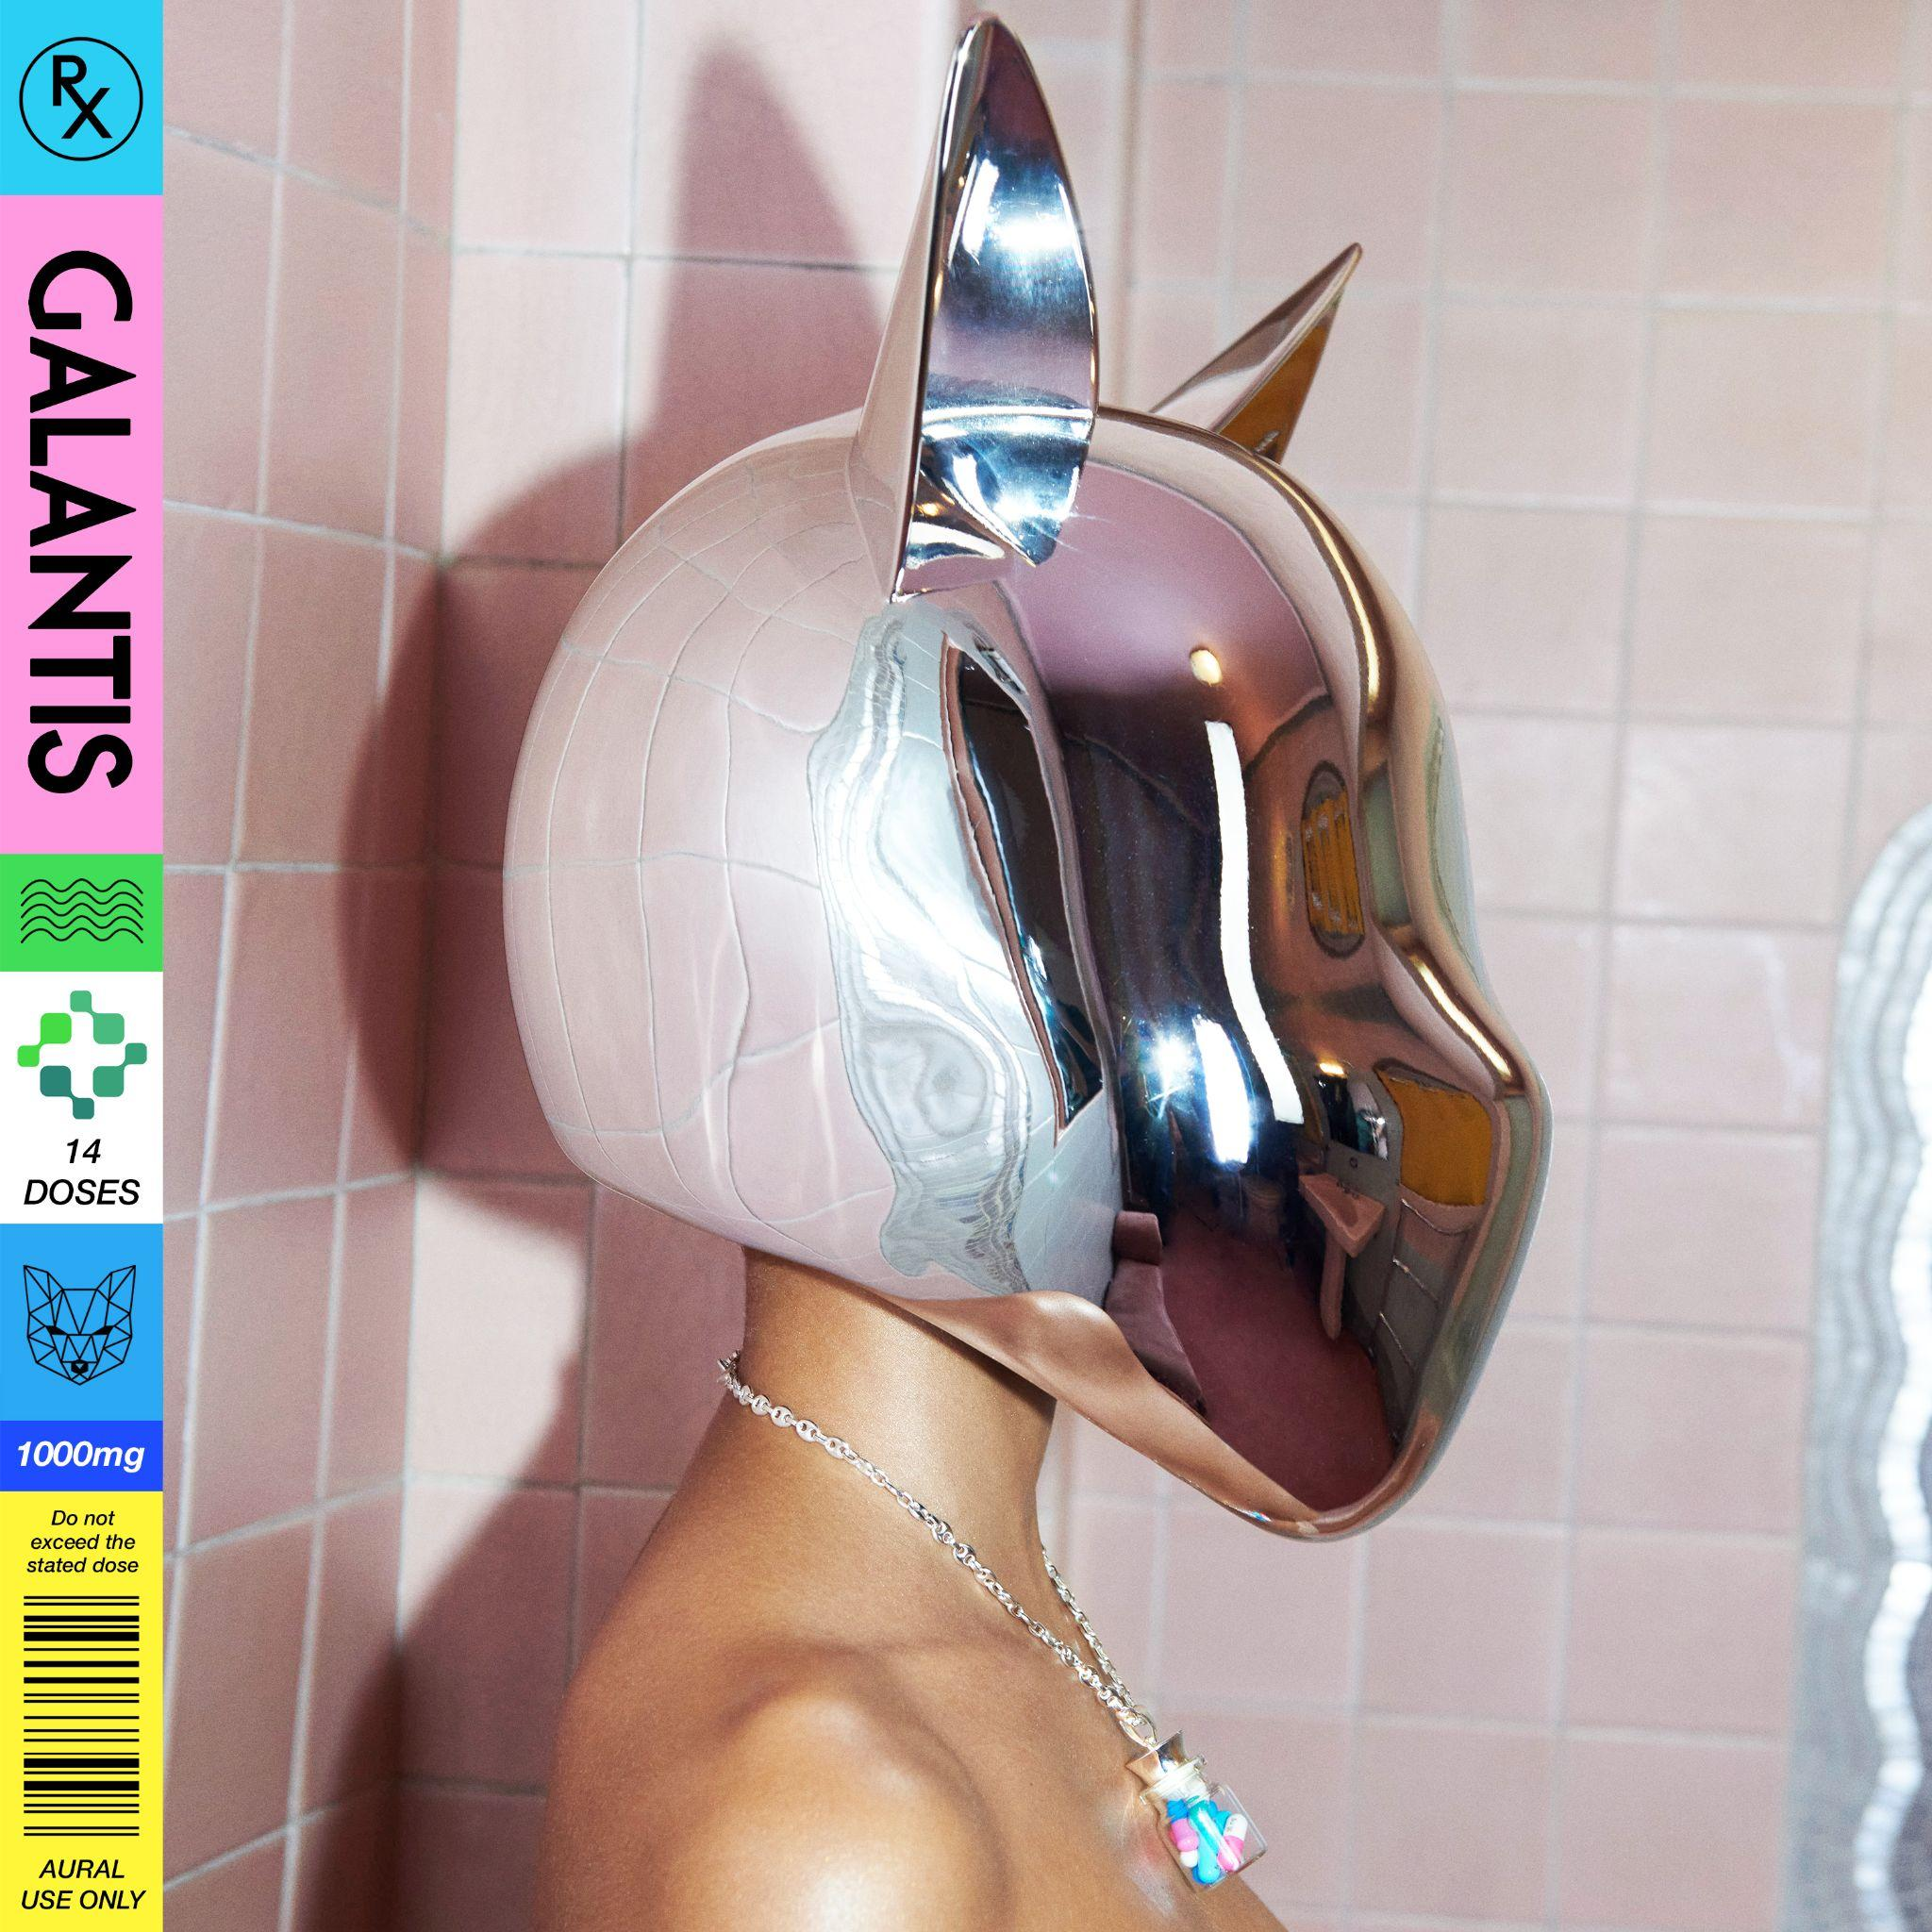
DOWNLOAD HIGH-RES IMAGES/ARTWORK

STREAM “DUST”: https://galantis.lnk.to/Dust
PRE-SAVE Rx: https://galantis.lnk.to/RxAlbum

“one of the most influential and untamed voices in modern music” – GRAMMY.com

Internationally-acclaimed dance music powerhouse Galantis has announced fourth studio album, Rx, arriving May 17th via Big Beat Records. The 14-track collection is further previewed today by new track “Dust” (stream here).

Galantis, the genre-bending dance music project of Christian Karlsson (aka Bloodshy), has been universally celebrated as one of the most innovative of the past decade, receiving over 7.3 billion cumulative worldwide streams and over 1.9 billion video views to date. Along this journey, however, the lifelong creator was writhing inside his own head. To Karlsson, music was not simply a passion but rather a compulsion. His life changed for the better in a major way a few years back: after years of suffering in silence, he was officially diagnosed with ADHD and proceeded to embark on a journey of self-discovery and medical treatment. The artist’s now-public mental health journey has excitingly coincided with him creating some of the most thrilling and reflective music of his already-massive career.

Whereas he had hinted at his personal struggles on 2015’s aptly-titled Pharmacy, Galantis’ latest LP, Rx, is Karlsson’s most soul-baring work yet. “Pharmacy was when I knew I was neurodivergent and I knew the studio was like a pharmacy for me,” he says in reflection. “I was the patient. Rx is when I found medication. For me, it was key, but of course, everyone walks their own path.”

Rx, which Karlsson has been working on for the better part of two years, is a straight shot of adrenaline and emotional catharsis. Its centerpiece is “BANG BANG! (My Neurodivergent Anthem),” a hair-raising sing-along that lays bare the musician’s diagnosis and was praised by Rolling Stone as “an upbeat festival-ready banger.” And from “Koala” to some of the album’s monumental collaborations, like the missile of a pop banger “Lighter” with David Guetta and 5 Seconds of Summer, Rx is a mind-bending shot to the synapses.

One of dance music's most dynamic and in-demand live performers, Galantis has sold out countless venues around the world and has thrilled crowds across the global festival circuit. This year will mark the third-annual return to Brooklyn Mirage for Midsommar on June 22nd and 23rd in between high-profile summer festival sets at Bonnaroo, Lollapalooza & more. For full live routing, visit wearegalantis.com/tour.

Galantis’ RIAA gold-certified debut album Pharmacy reached No. 1 on the Billboard Dance album chart on the strength of gold-certified single “Peanut Butter Jelly” and 3x platinum certified smash “Runaway (U & I)” – the latter of which earned a GRAMMY nomination for “Best Dance Recording” – while 2017’s sophomore album The Aviary (featuring platinum-certified single “No Money”) saw a top 10 debut in 23 countries. The third Galantis album, 2020’s Church, featured the chart-topping gold-certified single “Faith” with country music icon Dolly Parton featuring Mr. Probz, which saw a #1 debut on Billboard’s Dance/Electronic Chart before quickly reaching #1 on the Dance/Mix Show Airplay Chart where it remained for 5 weeks. Meanwhile, gold-certified collaborative single “Heartbreak Anthem” with David Guetta & Little Mix proved a global sensation, spending 10 weeks on the Billboard Global 200 chart and 13 consecutive weeks in the top 10 on the UK Official Chart.

Karlsson has been at the helm of Galantis since 2012 before officially debuting the project at 2014’s Coachella Valley Music and Arts Festival. His career has spanned across the musical genres of punk-rock, hip-hop and pop – including work as one half of acclaimed production duo Bloodshy & Avant and one third of indie pop band Miike Snow. Karlsson’s songwriting/production credits have included the likes of Madonna, Kylie Minogue, Katy Perry and extensive work with Britney Spears (including “Toxic” which earned a GRAMMY for “Best Dance Recording” and her widely acclaimed 2007 album Blackout). Declared “pop’s mastermind producer” by UPROXX, “eternally effervescent” by Billboard and “one of the most influential and untamed voices in modern music” by GRAMMY.com, the Swedish-born artist continues to evolve and push the boundaries of songwriting within the world of dance music and beyond.

Rx TRACKLIST:
1. Dust
2. One, Two & 3
3. BANG BANG! (My Neurodivergent Anthem)
4. Dreamteam (with Neon Trees)
5. Koala
6. Fool 4 U (with JVKE & Enisa)
7. Get You Alone
8. Side Effects (ft. Rain Davis)
9. One Cry (ft. Rosa Linn)
10. Damn (You’ve Got Me Saying) [with David Guetta & MNEK]
11. Little Bit Yours (with Hannah Boleyn)
12. Lighter (with David Guetta & 5 Seconds of Summer)
13. 6 Feet Down
14. Heartbreak Anthem (with David Guetta & Little Mix)

GALANTIS LIVE:
May 17 – Big Night Live – Boston, MA
May 18 – LIV – Miami, FL
May 24 – KC Live! – Kansas City, MO
May 25 – REBEL – Toronto, ON
May 26 – Ubbi Dubbi – Dallas, TX
May 31 – Brännbollsyran Festival – Umea, Sweden
June 8 – S2O Festival – Hong Kong
June 16 – Bonnaroo – Manchester, TN
June 22 – Midsommar @ Brooklyn Mirage – New York, NY
June 23 – Midsommar@ Brooklyn Mirage – New York, NY
August 1 – Lollapalooza – Chicago, IL
September 12 – Pacha – Ibiza, Spain

CONNECT WITH GALANTIS:
WeAreGalantis.com | Twitter | Facebook | YouTube | Instagram | Assets

CONTACT:
Ted Sullivan | Ted.Sullivan@atlanticrecords.com

