IN CASE YOU MISSED IT: BRELAND SITS DOWN WITH GMA3: WHAT YOU NEED TO KNOW TO DISCUSS HEADLINE LITTLE MORE COUNTRIER TOUR, ROAD HOUSE CAMEO, AND REPRESENTATION

"PRAISE THE LORD (THE ROAD HOUSE EDIT)” AVAILABLE NOW

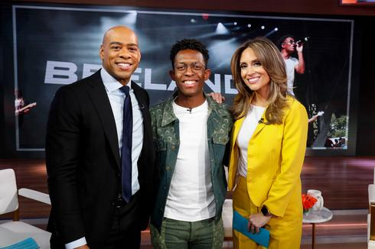
DOWNLOAD PHOTOS HERE + HERE

Wednesday (4/24), PLATINUM artist/songwriter/producer BRELAND sat down with GMA3: WHAT YOU NEED TO KNOW anchor DeMarco Morgan and ABC NEWS' Rhiannon Ally to discuss his nationwide headline LITTLE MORE COUNTRIER TOUR and how he dove into Country music through songwriting.
The interview also touched on his electrifying performance in Prime Video’s new Road House remake with spirit-lifting "Praise the Lord," recent release of the version of the song seen in the film - "Praise the Lord (The Road House Edit)” – plus his viral success on TikTok in sports predictions, leading to a special guest appearance on ESPN’s Pat McAfee Show. Additionally, BRELAND weighed in on representation in Country music and the impact of Beyonce’s Country album. Watch the segment here.
Bringing his “outstanding charisma” (Austin American-Statesman) and “genre-defying set” (as lauded by Variance), BRELAND’s tour stops at The Hamilton in Washington, DC, tonight (4/25), before returning to NYC’s Gramercy Theatre on Friday (4/26).

Remaining dates, cities, and venues for BRELAND’s LITTLE MORE COUNTRIER TOUR:

APRIL
25 | Washington, DC – The Hamilton *
26 | New York, NY – Gramercy Theatre *
27 | Philadelphia, PA – The Fillmore *
29 | Cambridge, MA – The Sinclair ^
30 | Jordan, NY – Kegs Canal Side ^

MAY
01 | Cleveland, OH – The Cambridge Room at House Of Blues ^
03 | Detroit, MI – El Club ^
04 | Chicago, IL – Joe’s on Weed St. ^
09 | Fort Worth, TX – Tulips FTW
10 | Conroe, TX – Big As Texas Fest

JUNE
13 | Seattle, WA – Tractor Tavern
16 | Portland, OR – Mississippi Studios
19 | San Francisco, CA – The Independent
20 | Los Angeles, CA – Troubadour
21 | San Luis Obispo, CA – Slo Brew

* Chapel Hart supporting
^ Ryan Charles supporting

For full list of tour dates and to purchase tickets, visit here.

CONNECT WITH BRELAND
WEBSITE | INSTAGRAM | FACEBOOK | X | AMAZON MUSIC | YOUTUBE | SOUNDCLOUD

ABOUT BRELAND:
A truly one-of-a-kind force on the Country scene, BRELAND is reshaping the genre’s future with his fearless originality and visionary sound. With over 1.2 BILLION career streams to date, the fast-rising global sensation first broke through with his PLATINUM-certified debut single “My Truck” and soon set off on an unstoppable rise that’s now included embarking on an international tour, collaborating with many of Country’s biggest superstars, and earning massive acclaim from major outlets like NPR, The New York Times, and Rolling Stone (who praised the New Jersey-bred singer/songwriter/producer for merging “elements of Country, Hip Hop, R&B, Gospel, and Pop — in a way that many have not experienced before”). With his catalog including his critically lauded debut album CROSS COUNTRY — a 2022 LP featuring smash hits like the GOLD-certified “Praise The Lord (feat. Thomas Rhett)” — the Bad Realm Records/Atlantic Records/Warner Music Nashville artist recently ushered in the next chapter of his career with his early-2024 single “Heartbreak & Alcohol,” which he announced on ESPN’s The Pat McAfee Show. As the genre-bending slow-groover landed on coveted playlists like CMT Roundup, Entertainment Tonight’s New Music Friday, HITS Daily Double, and more, BRELAND began gearing up for his LITTLE MORE COUNTRIER TOUR: a headlining run that kicked off in March with his third annual BRELAND & Friends charity concert at Nashville’s Ryman Auditorium. An unforgettably magnetic performer with stadium-sized appeal, the hitmaker has also brought his boundless charisma to an ever-growing list of high-profile TV appearances (including Good Morning America, Jimmy Kimmel Live!, and TODAY) and in March 2024 performed the national anthem at the Big 12 Men's Basketball Championship in Kansas City. With his many accolades including winning the Academy of Country Music Lift Every Voice Award, BRELAND is now at work on more new music rooted in his mission of redefining the possibilities of Country and uniting fans from all walks of life.

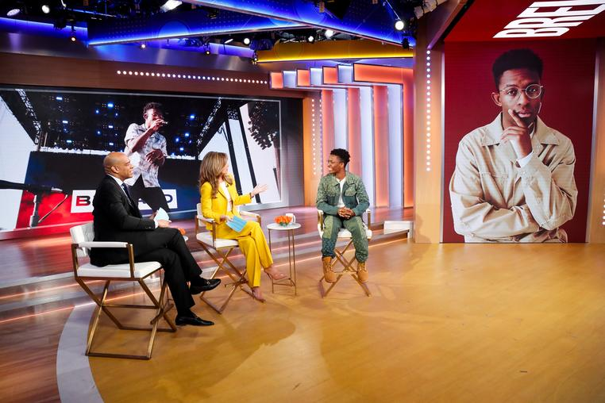
DOWNLOAD PHOTO

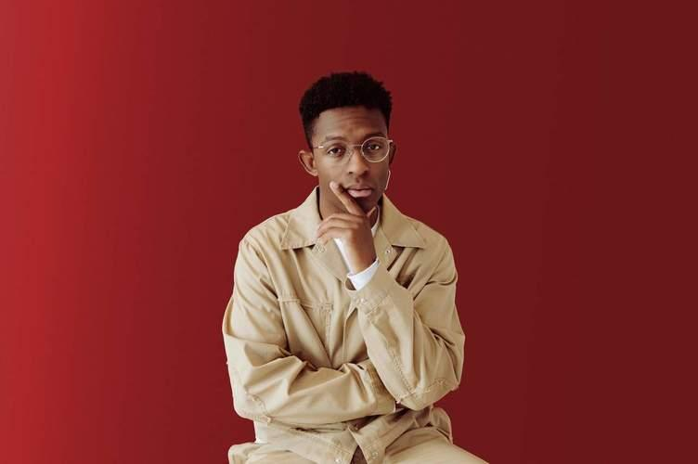
DOWNLOAD PRESS PHOTO
PHOTO CREDIT: HENRY AMMANN

​​MEDIA CONTACTS:

Fairley McCaskill, Atlantic Records
Fairley.McCaskill@atlanticrecords.com

Jensen Sussman, Sweet Talk Publicity
Jensen@sweettalkpr.com

