KNOX CONTINUES HIS RISE TO THE TOP WITH
“CHANGE YOUR MIND”

ALT-POP SINGER-SONGWRITER SHARES LATEST SINGLE
AS “NOT THE 1975” EXPLODES AT TOP 40 & HOT AC RADIO

SOLD-OUT HEADLINE TOUR WRAPS UP THIS WEEKEND,
FOLLOWED BY EAGERLY AWAITED DEBUT FESTIVAL APPEARANCES
AT LOLLAPALOOZA & HANGOUT FEST

WATCH THE “CHANGE YOUR MIND” MUSIC VIDEO HERE

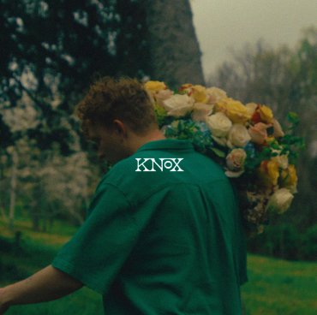
DOWNLOAD HI-RES ARTWORK HERE

Nashville-based alt-pop artist Knox releases his latest single, “Change Your Mind,” available via Atlantic Records HERE. Watch the official music video HERE. The video also made its broadcast premiere on NickMusic and on the Paramount Times Square billboards today.

“Change Your Mind” arrives just as the breakthrough fan favorite, “Not The 1975,” explodes into the upper echelons of multi-format pop success, currently boasting more than 15M global streams while positioned at #19 at Top 40 and #11 at Hot AC radio outlets nationwide.

Knox is celebrating his ascent with the latest run in his sold-out debut headline tour, “The I’m So Good At Being Alone Tour,” with stops continuing through dates this weekend in at Houston, TX’s House of Blues – Bronze Peacock Room (April 20) and Dallas, TX’s Club Dada (April 21). Support on both shows comes from Atlantic Records labelmate maryjo. In addition, Knox recently announced his performances at Lollapalooza (August 4 in Chicago) and Hangout Fest (May 18 in Gulf Shores). Additional dates will be announced soon. For updates, please visit www.musicbyknox.com.

KNOX
ON TOUR 2024

APRIL
20 – Houston, TX – House of Blues Bronze Peacock (SOLD OUT)
21 – Dallas, TX – Club Dada (SOLD OUT)

MAY
18 – Gulf Shores, AL – Hangout Fest †

AUGUST
1-4 – Chicago, IL – Lollapalooza †

† Festival Appearance

# # #

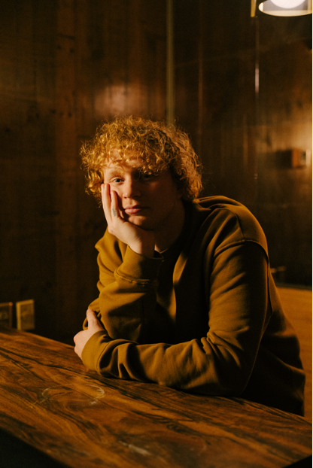
DL PRESS PHOTOS HERE – PHOTO CREDIT: CHASE DENTON // WORKING HOLIDAY

ABOUT KNOX:
Growing up, Knox knew he had an interest in music more than the average kid. His teenage years were sound tracked by artists such as Fall Out Boy & Ed Sheeran, and the summer before he started college, Knox taught himself guitar. He began playing open mic nights and by his sophomore year, his musical ambitions were so all-consuming that he dropped out of school, moved in with his grandma and saved up money to move to Nashville. He made the leap in January 2019.

Knox used Covid isolation to work on his craft. The focus paid off: Knox signed a publishing deal in 2022 but was struck with the urge to record songs he had been working on. The result was How to Lose a Girl in 7 Songs, Knox’s debut EP, released February 2023. Knox filmed TikToks featuring his song “Sneakers”, and 1 amassed nearly 2M views overnight. “Sneakers” now has over 33M streams. Another fan favorite track, “Not The 1975," can be seen on the Top 40 and Hot AC radio charts, and is featured on Knox’s latest EP, “I’m So Good At Being Alone?” released October 2023.

Knox has since been touring, opening for the Band Camino, Nightly, and Boys Like Girls and most recently performing on his own sold out headline tour. “I'm 6 states away from home and there’s a thousand people in the audience that are singing the song that I wrote with my friends in my bedroom. That's when it gets you, when you see people connecting to something that I made with my best friends. It’s the most unreal feeling in the world.”

# # #

CONNECT WITH KNOX
WEBSITE | INSTAGRAM | SPOTIFY | TIKTOK | YOUTUBE

Press Contact: gabrielle.reese@atlanticrecords.com

