FOR IMMEDIATE RELEASE
APRIL 19, 2024

NOLAN TAYLOR SHARES EMOTIONALLY STIRRING SINGLE
“IN THE OTHER ROOM”

ACCOMPANIED BY AN OFFICIAL MUSIC VIDEO

CINCINNATI HEART TOUR CONTINUES THROUGH LATE JUNE

NON-STOP LIVE SCHEDULE ALSO INCLUDES FESTIVAL APPEARANCES
AND DATES ALONGSIDE THE REVIVALISTS, SAM BARBER, AND THE RED CLAY STRAYS

LISTEN | WATCH

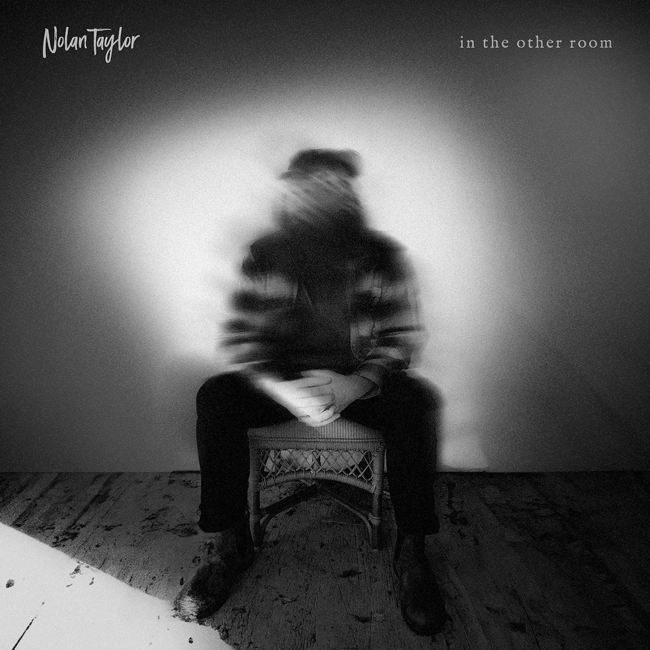
DOWNLOAD HI-RES ARTWORK

Rising singer-songwriter Nolan Taylor has shared emotionally stirring single, “In The Other Room,” available via Atlantic Records HERE. The captivating new release is joined by an official music video. Watch HERE.

“‘In The Other Room’ is a song that for me resonates in so many ways,” says Taylor. “It could be from death to living in some sort of hostility, to ‘when you have more than one room, you can be in the other room.’ I’m excited to be able to keep releasing these songs that take such deep looks into my life and the things that live inside my head. I hope you all enjoy this one cause I am so extremely proud of it. Onward and upward. I love you all.”

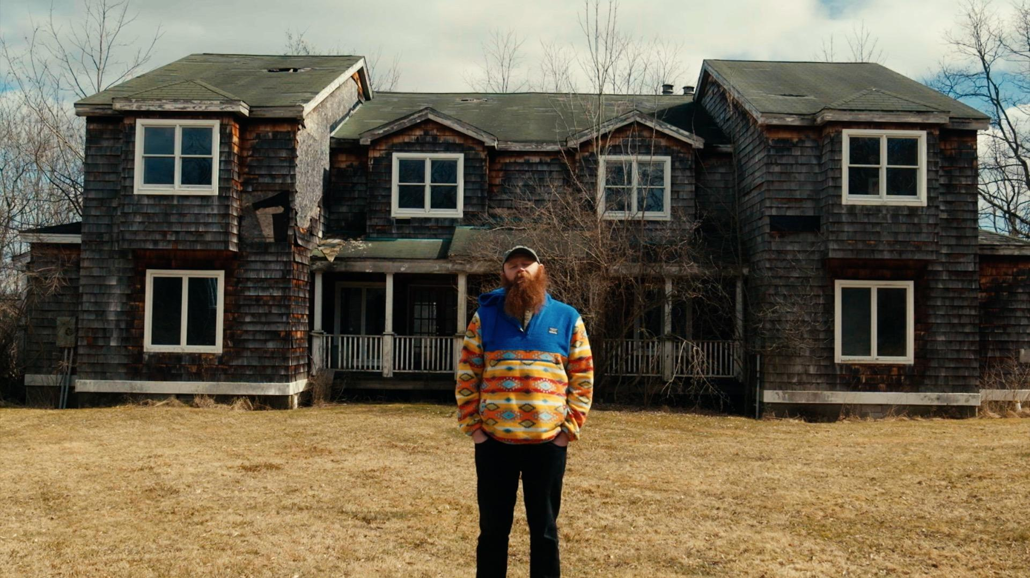

“In The Other Room” follows a series of heartfelt releases from Taylor, including his fan-favorite cover of Logan Halstead’s “Bluefoot.” The Ohio-native’s recent run also includes such singles as “Cincinnati Heart,” “Double Life,” and “Wicked Ways,” as well as the EPs, radiowv, and Life & Love. An array of live acoustic renditions, lyric videos, and more can be seen at Taylor’s official YouTube channel HERE.

WATCH NOLAN TAYLOR’S GRAND OLE OPRY DEBUT
WATCH ‘LIFE LOVE’ LIVE DREAMY DRAW SESSION FOR HOLLER
WATCH A FULL SET LIVE PERFORMANCE ON JAM IN THE VAN
WATCH OLIVER ANTHONY PRAISE NOLAN ON JOE ROGAN EXPERIENCE

Taylor is currently traveling on first-ever headline run, CINCINNATI HEART TOUR, with dates set through late June. In addition, coming months will see Taylor making festival appearances as well as sharing stages with such like-minded artists as The Revivalists, Sam Barber and The Red Clay Stays, including a sold-out show at Nashville’s iconic Ryman Auditorium (September 5). For complete details and ticket information, please visit www.nolantaylormusic.com.

NOLAN TAYLOR
CINCINNATI HEART TOUR
APRIL
19 – Fort Worth, TX – Tulips
20 – Georgetown, TX – Two Step Inn 2024 †
21 – Beaumont, TX – 7 Oaks Event Garden
30 – Los Angeles, CA – The Roxy Theatre Online *

MAY
2 – Kansas City, MO – recordBar ^
3 – Columbia, MO – Rose Music Hall ^
4 – St. Louis, MO – Old Rock House *
8 – Atlanta, GA – Terminal West ^
9 – Charlotte, NC – Amos’ Southend ^
10 – Ashland, KY – Paramount Arts Center
11 – Indianapolis, IN – Hi-Fi Annex
16 – Pittsburgh, PA – Thunderbird Music Hall ^^
17 – Columbus, OH – The Bluestone ^^
31 – Virginia Beach, VA – Elevation 27 ^^^

JUNE
1 – Durham, NC – Motorco Music Hall ^^^
2 – Lexington, KY – Railbird Music Festival †
27 – Des Moines, IA – xBk Live
28 – Milwaukee, WI – Summerfest †
29 – Omaha, NE – Reverb Lounge ^^^

JULY
20 – Salt Lake City, UT – The Complex #
21 – Redmond, OR – FairWell Festival †
24 – Airway Heights, WA – Spokane Live #
25 – Seattle, WA – The Showbox #
27 – Rexford, MT – Abayance Bay Marina #

AUGUST
3 – Hamilton, OH – RiversEdge Amphitheater**

SEPTEMBER
5 – Nashville, TN – Ryman Auditorium # (SOLD OUT)

OCTOBER
5 – Salt Lake City, UT – RedWest Fest 2024 †

† Festival Appearance
* Supporting Sam Barber
** Supporting The Revivalists
^ w/ Zandi Holup
^^ w/ Logan Halstead
^^^ w/ William Matheny
# Supporting The Red Clay Strays

# # #

ABOUT NOLAN TAYLOR
The backroads of America tell its truest stories. The heartbreak and heartbeat of the country thumps the loudest in the cracks between its big cities. A 2021 census in Blanchester, OH registers the village’s population at around 4,230 people. Nolan Taylor isn’t quite sure of the exact number, but he knows it’s small from growing up in this place with his dad and older brother. His father managed plants and factories, yet money was scarce and the winters were brutal. Mom battled addiction and mental struggles, eventually estranging her from the boys. As a kid, Taylor found solace in music, discovering The Grateful Dead through his dad while developing an appreciation for Pinegrove. Throughout junior high, he studied classic MTV Unplugged concerts by the likes of Alice In Chains, Pearl Jam, and Nirvana. When Taylor could finally afford a left–handed guitar, he began to write and record music of his own, grafting hard-earned wisdom, heart-wrenching memories, and hypnotic melodies to rustic and ruddy acoustic phrasing. After graduating high school, he hit the road, playing anywhere and everywhere around West Virginia, Virginia, and Kentucky. In 2023, a live performance of “68“ filmed in the backwoods of West Virginia lit up the influential radiowv channel, now boasting over 4.8M views. Taylor soon signed with Atlantic Records and began a new journey that has seen a steady stream of new releases, his debut performance at Nashville’s iconic Grand Ole Opry, and shows alongside such artists as The Red Clay Strays, Charley Crockett, 49 Winchester, Morgan Wade, and Charles Wesley Godwin.

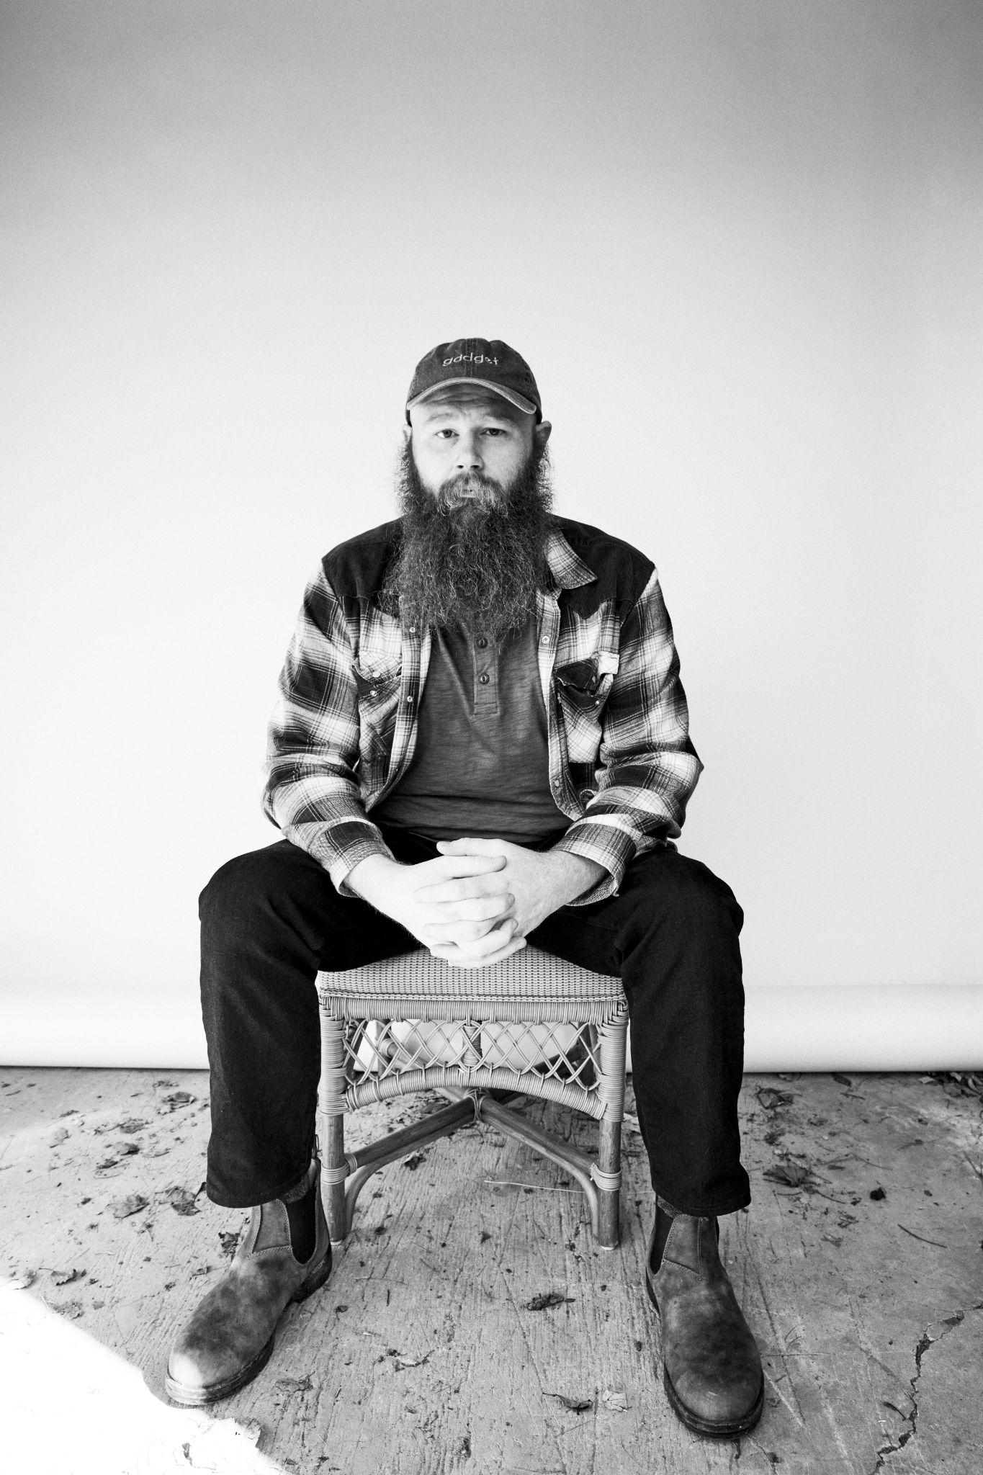
DOWNLOAD HI-RES PRESS IMAGES // PHOTO CREDIT: JIMMY FONTAINE

# # #

CONNECT WITH NOLAN TAYLOR
OFFICIAL | FACEBOOK | INSTAGRAM | SPOTIFY | TIKTOK | YOUTUBE

PRESS CONTACTS
Corey Brewer | Corey.Brewer@atlanticrecords.com
Jensen Sussman | Jensen@sweettalkpr.com

