FOR IMMEDIATE RELEASE
APRIL 22, 2024

ATLANTIC RECORDS ANNOUNCES ORIGINAL BROADWAY CAST RECORDING
FOR NEW MUSICAL SUFFS

OFFICIAL COMPANION TO THE GROUNDBREAKING NEW ORIGINAL MUSICAL FROM
AWARD-WINNING SINGER SONGWRITER SHAINA TAUB ARRIVES JUNE 14TH
WITH PRE-ORDERS AVAILABLE NOW HERE

SUFFS IS NOW PLAYING AT BROADWAY’S MUSIC BOX THEATRE
TICKETS AVAILABLE AT SUFFSMUSICAL.COM

LISTEN TO “KEEP MARCHING” PERFORMED BY SHAINA TAUB
WATCH THE OFFICIAL PERFORMANCE VIDEO HERE

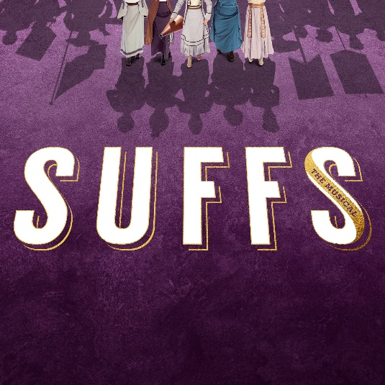
DOWNLOAD ASSETS HERE

Following the show’s opening on Thursday, April 18, Atlantic Records has announced the upcoming release of Suffs (Original Broadway Cast Recording), the official companion to the groundbreaking new musical from award-winning singer-songwriter Shaina Taub, arriving everywhere on Friday, June 14th. The album is now available for pre-order HERE.

Now playing at Broadway’s Music Box Theatre, Suffs boldly explores the victories and failures of a struggle for equality that’s far from over. ”Smart, witty, and teeming with mighty performances” (New York Magazine), Suffs stars book writer, composer, and lyricist Shaina Taub in the role of Alice Paul, making history as only the second woman ever to write the book, music, lyrics and star in her own Broadway musical. Taub is an Obie Award-winning, Emmy Award-nominated songwriter and winner of the Kleban Prize, the Fred Ebb Award, the Jonathan Larson Grant, and the NYCLU's Michael Friedman Freedom Award for activism. She created and starred in acclaimed musical adaptations of Twelfth Night and As You Like It at Shakespeare in the Park, has released three solo albums, and is currently signed to Atlantic Records.

Earlier this year in celebration of International Women’s Day, Taub shared the official audio recording of her stripped-down version of “Keep Marching,” the empowering finale from Suffs. The stunning performance video for “Keep Marching” can be streamed on YouTube HERE.

Suffs (Original Broadway Cast Recording) continues Atlantic Records’ long-running string of landmark Original Broadway Cast Recordings, including 2015’s GRAMMY® Award-winning, RIAA Diamond-certified milestone, “Hamilton (Original Broadway Cast Recording),”2017’s GRAMMY® Award-winning “Dear Evan Hansen (Original Broadway Cast Recording)” and 2021’s GRAMMY® Award-winning “Jagged Little Pill (Original Broadway Cast Recording).”

"I grew up in rural Vermont listening obsessively to Broadway cast albums on the boombox in my bedroom,” said Shaina Taub. “To get to make one of my own with this miraculous cast and orchestra is beyond my wildest childhood dreams. I'm so grateful to Atlantic Records for making it possible, and can't wait to share these songs and this story with the world."

“We are deeply proud to partner with Atlantic Records to release the Suffs Original Broadway Cast Recording,” said producers Jill Furman and Rachel Sussman. “This new musical inspires audiences eight times a week at the Music Box Theatre, and we are thrilled to introduce this powerful story, and Shaina’s remarkable score, to fans all around the world.”

“Over the past decade, we’ve been honored to work with visionary composers to help bring their stories to life on record-breaking cast albums,” said GRAMMY® Award-winning Atlantic Records President, A&R Pete Ganbarg. “We’ve been huge fans of Shaina’s for a while and are thrilled to be working with her and her incredible team to bring the timely story of Suffs to the world.”

ABOUT Suffs
It’s 1913 and the women’s movement is heating up in America, anchored by the suffragists — “Suffs,” as they call themselves — and their relentless pursuit of the right to vote. Reaching across and against generational, racial, and class divides, these brilliant, flawed women entertain and inspire us with the story of their hard-won victory in an ongoing fight. So much has changed since the passing of the Nineteenth Amendment over a century ago, and yet we’re reminded sometimes we need to look back, in order to march fearlessly into the future.

Suffs stars book writer, composer, and lyricist Shaina Taub in the role of Alice Paul, making her only the second woman in history to write the book, music, lyrics and star in her own Broadway musical. Suffs also stars Tony Award-winner Nikki M. James (The Book of Mormon) as Ida B. Wells, Tony Award-nominee Jenn Colella (Come From Away) as Carrie Chapman Catt, Grace McLean (Natasha, Pierre and The Great Comet of 1812) as President Woodrow Wilson, Hannah Cruz (MCC’s The Connector) as Inez Milholland, Kim Blanck (Signature Theatre’s Octet) as Ruza Wenclawska, Anastacia McCleskey (Waitress) as Mary Church Terrell, Ally Bonino (Broadway debut) as Lucy Burns, Tsilala Brock (The Book of Mormon National Tour) as Dudley Malone, Nadia Dandashi (Broadway debut) as Doris Stevens, and Tony Award-nominee Emily Skinner (Side Show) as Alva Belmont/Phoebe Burn.

Rounding out the company are Hawley Gould (Lincoln Center Theater’s Camelot) as the Alternate for Alice Paul, Jaygee Macapugay (Here Lies Love) as Mollie Hay, and Laila Drew (Broadway debut) as Phyllis Terrell/Robin. The ensemble will feature Dana Costello (Pretty Woman) as well as Jenna Bainbridge, Monica Tulia Ramirez, and Ada Westfall making their Broadway debuts. The cast also includes Christine Heesun Hwang (Les Misérables National Tour), Chessa Metz (Broadway debut), Kirsten Scott (Jersey Boys), Housso Semon (Girl From The North Country), and D’Kaylah Unique Whitley (Dear Evan Hansen).

Suffs features book, music and lyrics by Kleban Prize, Fred Ebb Award, and Jonathan Larson Grant recipient Shaina Taub, direction by Tony Award-nominee Leigh Silverman (Violet), choreography by Mayte Natalio (How to Dance in Ohio), scenic design by Tony Award-nominee Riccardo Hernández (Jagged Little Pill), costume design by Tony Award-winner Paul Tazewell (Hamilton), lighting design by Tony Award-nominee Lap Chi Chu (Camelot), sound design by Jason Crystal (Sweeney Todd) with associate Sun Hee Kil (Choir Boy), orchestrations by Tony Award-winner Michael Starobin (Next to Normal), music supervision and music direction by Andrea Grody (The Band’s Visit), and casting by Heidi Griffiths and Kate Murray (Soft Power). 101 Productions, Ltd. serves as General Manager.

Jill Furman and Rachel Sussman serve as lead producers of Suffs, with Hillary Rodham Clinton and Malala Yousafzai serving as two of the musical’s producers.

Suffs was originally developed and produced at The Public Theater in 2022 (Artistic Director, Oskar Eustis; Executive Director, Patrick Willingham).

Tickets, starting at $49, are on sale now and can be purchased at SuffsMusical.com, through Telecharge.com, or by calling (800) 447-7400 or (212) 239-6200.

CONNECT WITH Suffs
WEBSITE | FACEBOOK | INSTAGRAM | TIKTOK | X | YOUTUBE

CONNECT WITH SHAINA TAUB
WEBSITE | FACEBOOK | INSTAGRAM | X | YOUTUBE | PRESS ASSETS

PRESS CONTACT:
ANDREW GEORGE | ANDREW.GEORGE@ATLANTICRECORDS.COM

