FOR IMMEDIATE RELEASE
MARCH 29, 2024

RICO NASTY AND BOYZ NOIZE RELEASE HVRDC0RE DR3AMZ

ARRIVES ALONGSIDE VISUAL FOR “H.O.T.”

COMES ON THE HEELS OF THEIR PREVIOUS SINGLE “ARINTINTIN”

WATCH/SHARE “H.O.T.”
DOWNLOAD/STREAM HVRDC0RE DR3AMZ

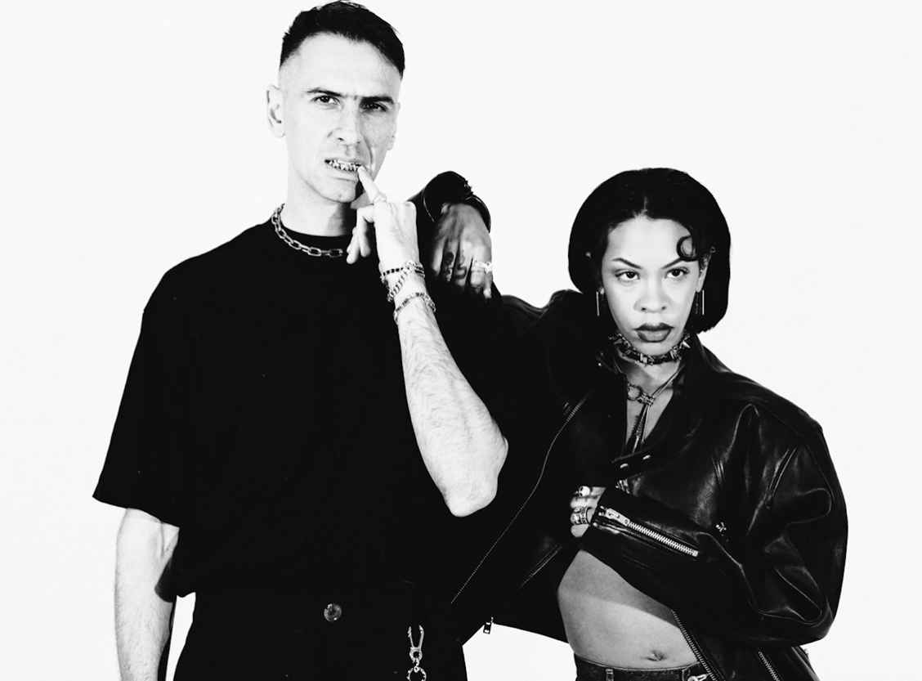
(Photo Credit: Jamie-Lee Boyd | download)

"loopy, upbeat dance floor stomper"
- UPROXX

"Rico Nasty contorts her traditional rage rap into a surprising Eurodance framework, and, amazingly, it works, Boys Noize’s hypnotic high-BPM pulse providing the perfect playground for her to swing around."
- PAPER

Today, American rapper, songwriter, fashion trailblazer and visionary Rico Nasty and German-Iraqi artist, DJ, producer and subcultural oracle Boys Noize release their new project HARDC0RE DR3AMZ, along with a video for the synth-heavy “H.O.T.”

“We made ‘H.O.T.’ for our fans to enjoy during the summertime, riding around with the top down,” Rico says of the track. “Let the haters know something and give the lurkers a show! Making this was so refreshing and reminded me that everything doesn’t have to be so serious all the time.”
The bond between the two artists is undeniable. Their previous release “Arintintin” follows their collaboration on Rico Nasty's "Money" ft Flo MIlli and Boys Noize’s “Girl Crush.” HARDCORE DR3AMZ offers a more eclectic and celebratory experience - one that will defy genre, expectation and creative boundaries. Rico continues to flourish and challenge every sound while still incorporating their energetic flow and authentic approach to each song.

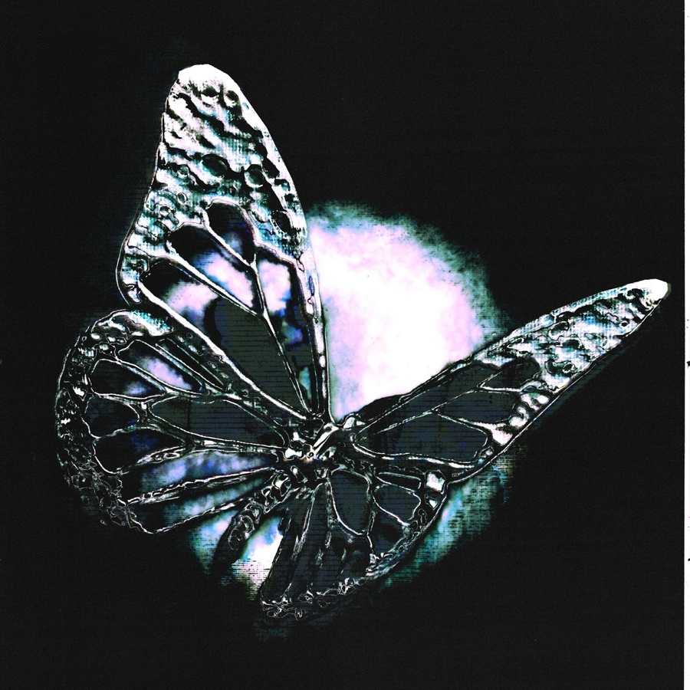
(EP art | download)

TRACKLIST
Arintintin
Vvgina
H.O.T.

ABOUT RICO NASTY
Many artists change the game. However, Rico Nasty reinvents, recharges, and reimagines it with every move. Instead, the Washington, D.C.-born and Maryland-raised sonic sorceress shapeshifts at the speed of the culture, infusing airtight rap with uncontainable punk energy, hyperpop unpredictability, industrial intensity, and just the right amount of heavy metal attitude. Back in high school, she made waves with a series of independent projects before reaching critical mass with 2017’s Sugar Trap 2. On its heels, she maintained this momentum with the fan favorite Nasty in 2018. The collaborative mixtape Anger Management with Kenny Beats closed out 2019 on over a dozen year-end lists, including Complex, Dazed, Fact, The FADER, GQ, NME, Pitchfork, Rolling Stone, Stereogum, and Vice. During 2020, her full-length debut, Nightmare Vacation, boasted the gold-certified hit “Smack A Bitch.” Peers sought her out for high-profile collaborations, including the platinum “Tia Tamera” with Doja Cat, “#PROUDCATOWNERREMIX” with the late XXXTentacion, “¡aquí yo mando!” with Kali Uchis, and more. Rico’’s the rare outlier who can grace the cover of the XXL Freshman issue or light up Rihanna’s Savage X Fenty Show as an ambassador and ignite a mosh pit.

With an inimitable and influential signature style, she has reached multi-platinum status, posted up nearly 1 billion streams, and sold out countless shows. In 2022, she unleashed unfiltered truth with the force of a tornado through a tidal wave on Las Ruinas. After Las Ruinas, Rico hit the road first with Kehlani and then she embarked on a national tour in collaboration with Monster Energy Drink with direct support from Omeretta The Great. Since then, Rico released HARDCORE DR3AMZ in collaboration with Boys Noize. The project is a slight deviation from the signature Sugar Trap sound we know her for as she dives head first into the world of electronic and dance music.

ABOUT BOYS NOIZE
BOYS NOIZE (Alex Ridha) builds worlds, then builds bridges between them. Propelled by an infatuation with sonic invention and a prescience for subculture, the German-Iraqi artist, DJ and producer has developed a peerless practice that is both deeply informed by electronic music history and determinedly transcending conventions. As an international festival headliner and A-list producer, BOYS NOIZE embodies the transformation and expansion of 21st century techno, house and electro into the current zeitgeist. Yet as a Berliner and lifelong DJ, he remains dedicated to the underground, regularly flexing the decks at BERGHAIN, TRESOR, RSO, and HÖR, all while running his record label BNR.

Some fans find BOYS NOIZE through his b2b sets with SOLOMUN and VTSS, others through his productions for A$AP ROCKY, TOMMY CASH and FRANK OCEAN; through his house hit "Mvinline" on DEFECTED RECORDS, his remixes for DAFT PUNK, YEAH YEAH YEAHs and DEPECHE MODE, or his EP with VIRGIL ABLOH; through features with RICO NASTY, PUSSY RIOT, SHYGIRL and KELSEY LU, or reworks of SEGA BODEGA and SOPHIE; through this year’s blazing run of 140+ bpm techno tracks, or his massive "Fine Day Anthem" with SKRILLEX, his other half in the duo DOG BLOOD. BOYS NOIZE's most important collaboration of all, however, is with the ravers that join him across the globe from basements to warehouses to the main stage. Ridha’s sets open a dialogue between DJ and dancefloor, always unique and always peaking in ecstatic nights and delirious dawns. There are many facets of BOYS NOIZE, but when the exchange of energy and music is alive and in full force, the one you’ll find is the one you make together.

CONNECT WITH RICO NASTY:
WEBSITE | INSTAGRAM | TWITTER | FACEBOOK | YOUTUBE

FOR PRESS INQUIRIES, PLEASE CONTACT:
Ariana White | Ariana.White@atlanticrecords.com

CONNECT WITH BOYS NOIZE
INSTAGRAM | TWITTER | FACEBOOK

