THE MARÍAS ANNOUNCE “THE SUBMARINE TOUR”

ARTIST PRESALE APRIL 16 10AM LOCAL TIME
GENERAL ON SALE APRIL 19 10AM LOCAL TIME
TICKETS AVAILABLE HERE

NEW ALBUM SUBMARINE OUT MAY 31ST
PRE-ORDER/PRE-SAVE THE ALBUM HERE

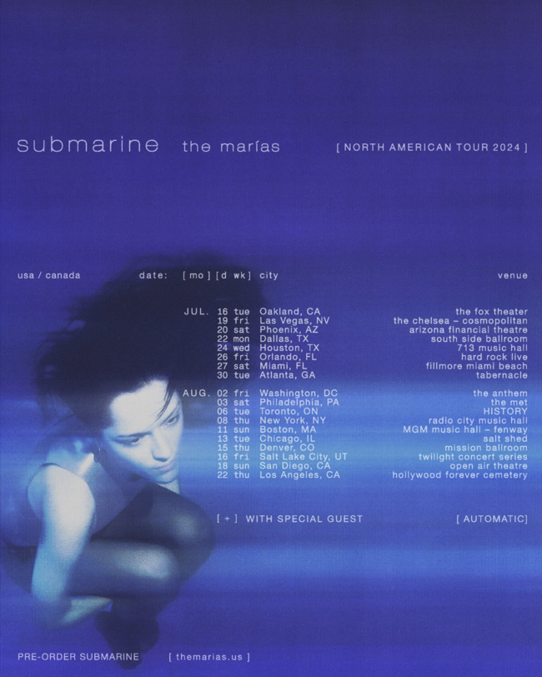

Los Angeles, CA (April 15, 2024) – Today, Grammy-nominated band The Marías announce their long-awaited and highly anticipated “The Submarine Tour,” produced by Live Nation, hitting major cities across North America including Los Angeles, New York, Miami, Chicago, Toronto and more. They will play iconic venues including Radio City Music Hall in NYC and Hollywood Forever Cemetery in LA. Last week, the band announced their run of shows in support of the album for Mexico City. The first two nights sold out immediately in pre-sale, leading to the addition of two extra nights due to high demand. The 4-night run, now fully-sold out, will be June 11th, 12th, 14th, and 15th, marking the first shows where fans will experience Submarine live.

The Marías will be supported by opener, Los Angeles based-band, Automatic. Artist presale tickets will be available starting Tuesday, April 16th at 10am local time through Thursday, April 18th at 10pm local. Additional presales will run ahead of the general on sale beginning Friday April 19th at 10am local time. For more information and to register for the artist presale, please visit themarias.us/shows.

The tour will follow the release of The Marías’ new album, Submarine, out May 31st via Nice Life Recording Company/Atlantic Records. Pre-order/pre-save Submarine here. The first single released from the new album “Run Your Mouth,” garnered over 1 million streams in its first week of release – listen and watch here. Second release from the album, “Lejos De Ti,” is a Spanish-language track showcasing lead singer María’s versatility – listen and watch the video directed by María here.

Submarine is the follow up to the band’s critically acclaimed debut album Cinema (2021), with lead single “Hush” going No.1 on Billboard’s Adult Alternative Airplay chart. Known for delivering striking visuals that compliment their dreamlike songs, the band continues to create a unique and transformative experience for fans and audiences alike.

“The Submarine Tour” Routing
Tue Jun 11 | Mexico City, MX | Foro Puebla - SOLD OUT
Wed Jun 12 | Mexico City, MX | Foro Puebla - SOLD OUT
Fri Jun 13 | Mexico City, MX | Foro Puebla - SOLD OUT
Sat Jun 14 | Mexico City, MX | Foro Puebla - SOLD OUT
Tue Jul 16| Oakland, CA | Fox Theater *
Fri Jul 19 | Las Vegas, NV | The Chelsea at The Cosmopolitan of Las Vegas
Sat Jul 20 | Phoenix, AZ | Arizona Financial Theatre
Mon Jul 22 | Dallas, TX | South Side Ballroom
Wed Jul 24 | Houston, TX | 713 Music Hall
Fri Jul 26 | Orlando, FL | Hard Rock Live
Sat Jul 27 | Miami, FL | The Fillmore Miami Beach
Tue Jul 30 | Atlanta, GA | Tabernacle
Fri Aug 02 | Washington, DC | The Anthem *
Sat Aug 03 | Philadelphia, PA | The Met Presented by Highmark
Tue Aug 06 | Toronto, ON | HISTORY
Thu Aug 08 | New York, NY | Radio City Music Hall
Sun Aug 11 | Boston, MA |MGM Music Hall at Fenway
Tue Aug 13 | Chicago, IL | The Salt Shed
Thu Aug 15 | Denver, CO | The Mission Ballroom *
Fri Aug 16 | Salt Lake City, UT | Twilight Concert Series *
Sun Aug 18 | San Diego, CA | Cal Coast Credit Union Open Air Theatre at SDSU
Thu Aug 22 | Los Angeles, CA | Hollywood Forever Cemetery *

*Non-Live Nation date

FOLLOW THE MARÍAS
INSTAGRAM
X
TIKTOK
YOUTUBE

About The Marías
The Marías are the Grammy-nominated psychedelic-soul lovechild of Puerto Rican-bred, Atlanta-raised María Zardoya and Los Angeles native, Josh Conway. The two are joined by their closest friends, Jesse Perlman on guitar and Edward James on keys. Their undeniably intuitive musical chemistry can be heard in the band’s smooth rendezvous of jazz percussion, hypnotic guitar riffs, smoke-velvet vocals and nostalgic horn solos. There’s something undeniably sensual in their dreamlike fusion of jazz, psychedelia, funk and lounge. Since the release of their critically acclaimed debut album, Cinema, The Marías have earned the reputation behind their impressive upward trajectory, including two Grammy nominations, a Billboard chart-topper and collaborations with some of the biggest names in Latin music, including Bad Bunny and Tainy. In the live show, The Marías are joined by Gabe Steiner on trumpet and Doron Zounes on bass. The detail that has defined their cinematic style off-stage is brought to life during their live performance as the group delivers striking visuals that beautifully compliment their dreamlike songs, creating an indisputably unique and seemingly transportive experience. Their upcoming sophomore album Submarine, set for release on May 31st, features new single “Run Your Mouth,” which garnered over one million streams in its first week of release.

About Live Nation Entertainment
Live Nation Entertainment (NYSE: LYV) is the world’s leading live entertainment company comprised of global market leaders: Ticketmaster, Live Nation Concerts, and Live Nation Sponsorship. For additional information, visit www.livenationentertainment.com.

The Marías Contacts:
Kristin Somin
Kristin.Somin@ledecompany.com
Viveca Ortiz-Torres
Viveca.Ortiz-Torres@ledecompany.com
Libby Kober
Libby.Kober@atlanticrecords.com

Live Nation Concerts Contacts:
Monique Sowinski
Monique.Sowinski@livenation.com
Maya Sarin
Maya.Sarin@livenation.com

