FOR IMMEDIATE RELEASE
APRIL 25, 2024

VANCE JOY ANNOUNCES dream your life away ANNIVERSARY SHOWS

MULTI-PLATINUM SUPERSTAR TO CELEBRATE BREAKTHROUGH DEBUT ALBUM
WITH VERY SPECIAL HEADLINE TOUR

DATES BEGIN SEPTEMBER 6 IN SAN DIEGO AT CAL COAST CREDIT UNION OPEN AIR THEATRE
INCLUDES STOPS AT LA’S HOLLYWOOD BOWL, NY’S RADIO CITY MUSIC HALL
AND BERKELEY’S THE GREEK THEATRE

PRESALES BEGIN TUESDAY, APRIL 30 AT 10:00 AM (LOCAL)

GENERAL ON-SALE STARTS FRIDAY, MAY 3 AT 10:00 AM (LOCAL)

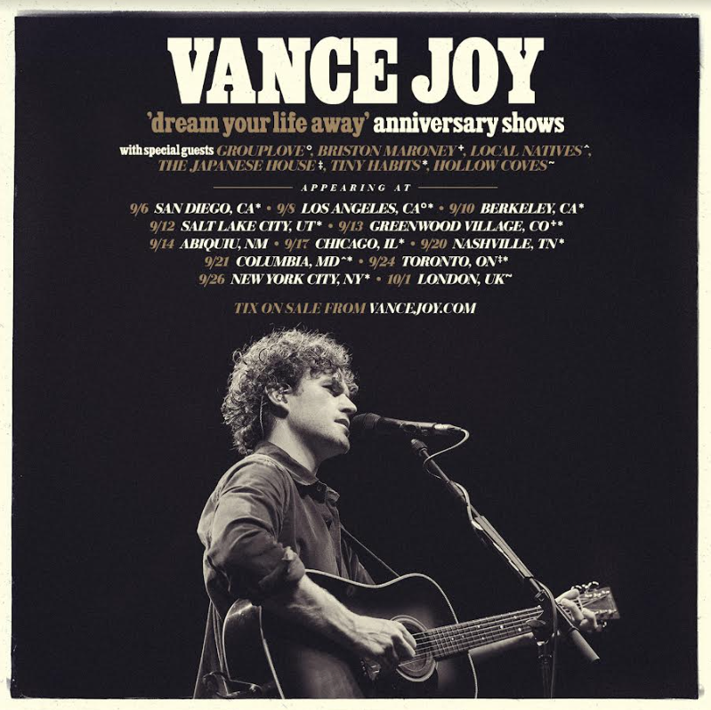

Multi-Platinum global superstar Vance Joy will celebrate the 10th anniversary of his now-classic, RIAA 2x Platinum-certified debut album, dream your life away, with a very special headline tour. Dates get underway September 6 in San Diego at Cal Coast Credit Union Open Air Theatre. With songs from dream your life away and other Vance Joy hits, the show will have people singing, swaying, clapping, dancing and screaming for more.

The tour then continues through North America with stops at Los Angeles, CA’s Hollywood Bowl, Berkeley, CA’s The Greek Theatre and New York City’s world-famous Radio City Music Hall. In addition, Vance will be doing an exclusive UK performance at London’s OVO Arena Wembley on October 1 and an exclusive Canada performance at Toronto’s Scotiabank Arena on September 24. Tiny Habits will be touring in support of Vance Joy across all shows in North America, plus special guests GROUPLOVE joining for LA, Briston Maroney joining for Denver, Local Natives joining for Columbia, and The Japanese House joining for Toronto.

Artist presales for all newly announced dates begin Tuesday, April 30 at 10:00 am (local). Spotify presales follows on Wednesday, May 1 at 10:00 am (local). Local presales begin Thursday, May 2 at 10:00 am (local). All remaining tickets will be released to the general public on Friday, May 3 at 10:00 am (local). For complete details, please see www.vancejoy.com.

Supporting the global single “Riptide,” dream your life away spawned further hits & fan favorites including “Mess Is Mine,” “Georgia” & “Fire and the Flood.” Since 2014, Vance Joy has toured the world supporting a further two albums Nation of Two & In Our Own Sweet Time. With over 5B global streams across all platforms, it’s no surprise that listeners all over the world connect to Vance Joy’s intimate yet anthemic song writing. Bringing together a unique, charming mix of folk music with pop influences, these songs capture the familiar pulse of everyday experiences in a unique and celebratory manner.

VANCE JOY
dream your life away Anniversary Shows – 2024

With Special Guest GROUPLOVE ++, Briston Maroney ^, Local Natives #, The Japanese House **
With support from Tiny Habits across all North America shows.

SEPTEMBER
6 – San Diego, CA – Cal Coast Credit Union Open Air Theatre
8 – Los Angeles, CA – Hollywood Bowl * ++
10 – Berkeley, CA – Greek Theatre at UC Berkeley
12 – Salt Lake City, UT – Red Butte Garden Outdoor Concert Series >
13 – Greenwood Village, CO – Fiddlers Green Amphitheatre ^
14 – Abiquiu, NM – Blossom & Bones † “
17 – Chicago, IL – The Salt Shed
20 – Nashville, TN – Ascend Amphitheater
21 – Columbia, MD – Merriweather Post Pavilion #
24 – Toronto, Canada – Scotiabank Arena **
26 – New York City, NY – Radio City Music Hall

OCTOBER
1 – London, UK - OVO Arena Wembley “

“ ON SALE NOW
* TICKETS ON SALE TUESDAY, MAY 7
> PRESALE ON MAY 13, GENERAL ON SALE ON MAY 16
† FESTIVAL APPEARANCE

# # #

ABOUT VANCE JOY
Currently boasting over 5 billion global streams across all platforms, dream your life away instantly catapulted Vance Joy to worldwide stardom upon its September 2014 release, fuelled in part by his RIAA Diamond-certified breakthrough single, “Riptide,” as well as such Platinum-certified hits as “Mess Is Mine” and “Georgia” and the Gold-certified fan favorite, “Fire and the Flood” (the latter featured on the album’s 2015 special edition). Known as a charming, charismatic live performer, the Australian singer-songwriter celebrated dream your life away with a wide-ranging world tour that saw him lighting up audiences around the globe with sold-out headline shows, show-stealing festival appearances, and a turn as main support on Taylor Swift’s “The 1989 World Tour.”

Joy continued his ascent with 2018’s Nation of Two and 2022’s In Our Own Sweet Time, both of which arrived on the upper reaches of charts around the world amidst critical acclaim for his intimate yet anthemic songcraft and ever-engaging gift for human connection. Last year saw the release of Vance Joy Live At The Sydney Opera House, a 16-track album recorded at the world famous Sydney Opera House in Sydney, Australia during the Australia/New Zealand leg of Joy’s epic “In Our Own Sweet Time World Tour.”

ABOUT TINY HABITS
Tiny Habits came together in Boston in 2022 while the band were still students at the Berklee College of Music. They soon began gaining recognition for the harmony-focused song covers recorded in their dorm stairwell and posted to millions of listeners on TikTok. They released their first EP of original songs Tiny Things in April 2023 and soon earned a spot opening for Gracie Abrams on her North American tour. Later that year they hit the road again supporting Noah Kahan in Europe. They have performed with Lizzy McAlpine on her Tiny Desk appearance, harmonized with Kacey Musgraves and Laufey among many others, and were recently profiled in The New Yorker which touted them “The Prodigies of Harmonies”. The band just wrapped their first-ever headlining North American tour which continues across Europe in May before making their Lollapalooza debut later this summer.

# # #

CONNECT WITH VANCE JOY:
WEBSITE | FACEBOOK | INSTAGRAM | TWITTER | YOUTUBE

FOR PRESS INQUIRIES, PLEASE CONTACT:
Kelly McWilliam // Kelly.McWilliam@atlanticrecords.com
Libby Kober // Libby.Kober@atlanticrecords.com

