fast-rising DIY artist re6ce shares “i dont even own prada shoes lol”

follows “brown eyes,” re6ce’s largest song debut yet

heralds upcoming new ep arriving this may

WATCH HERE | LISTEN HERE

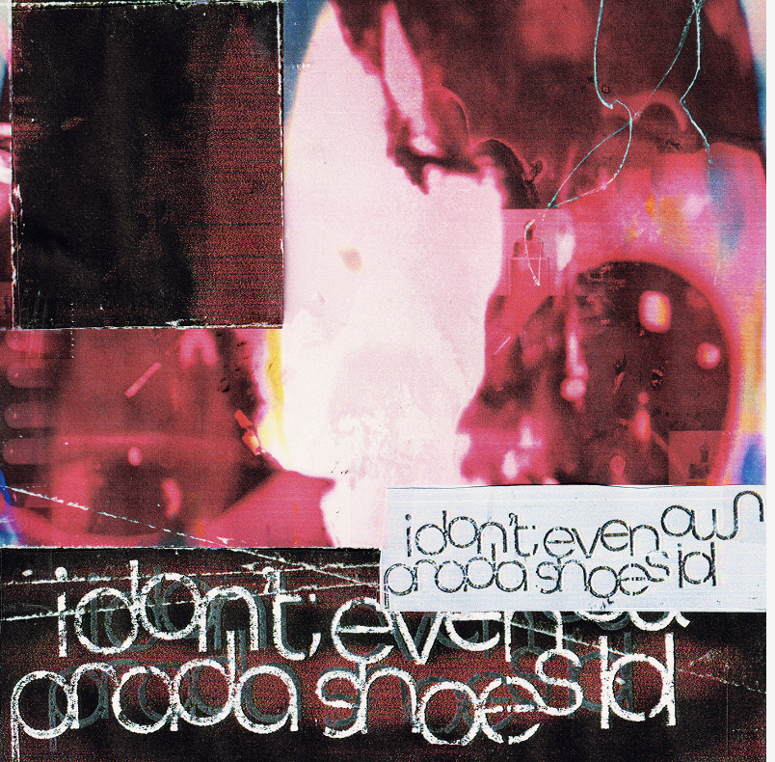
DOWNLOAD HI-RES IMAGE

a ‘choose your own adventure’ type of experience. Each song is unique and offers something different from the last. (re6ce’s) music has a distinct style that sets it apart from other artists, with a youthful teenage energy and mostly guitar driven production.”
-COMPLEX’S PIGEONS & PLANES

18-year-old singer/multi-instrumentalist re6ce has shared their new single, “i dont even own prada shoes lol,” co-produced with re6ce, glaive and Alex Craig and available now via Atlantic Records/Good Luck Have Fun HERE.

The single follows “brown eyes,” which was re6ce’s biggest debut yet with Instagram reels totaling 5M+ views. “brown eyes” and “i dont even own prada shoes lol” herald their upcoming EP, arriving this May.

Having begun making music in their teenage bedroom, re6ce has quickly drawn critical applause and a fast-growing fan following for their exceptional combination of modern rock, futuristic hyperpop, and sentimental indie pop. Now boasting tens of millions of worldwide streams for tracks like “brown eyes,” “teeth (you)” and “cabin fever,” re6ce has since taken their music from their room to the live stage, recently touring with Ekkstacy through Belgium, Germany and the Netherlands with more live dates coming soon. For the latest info please see www.re6cemusic.com.

# # #

connect with re6ce
WEBSITE | DISCORD | INSTAGRAM | TIKTOK | X | YOUTUBE

Press contact: gabrielle.reese@atlanticrecords.com

