FOR IMMEDIATE RELEASE
JANUARY 17, 2020

YBN ALMIGHTY JAY RELEASES NEW SINGLE “OOOUUU” FT. BLAC YOUNGSTA

YBN ALMIGHTY JAY & BLAC YOUNGSTA SPEND A DAY AT THE SPA IN COMPANION VISUAL

WATCH OFFICIAL “OOOUUU” VISUAL HERE

STREAM/DOWNLOAD “OOOUUU” HERE

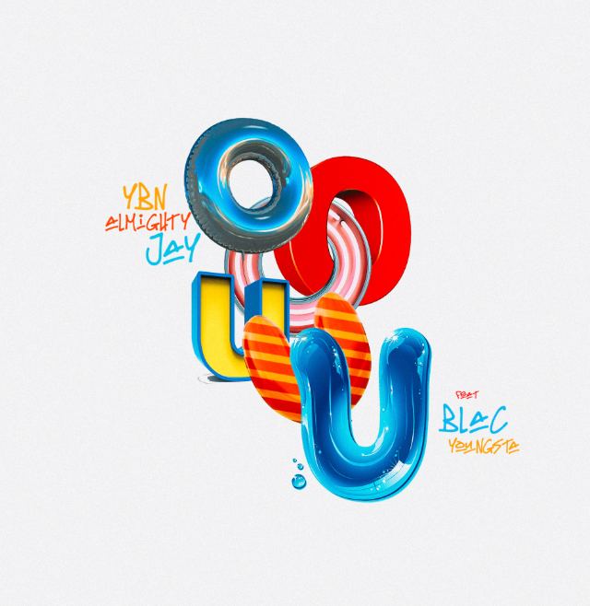
DOWNLOAD HIGH-RES COVER ART HERE

Art @ War and Atlantic recording artist YBN Almighty Jay has released a new single titled “Ooouuu” feat. CMG artist, Blac Youngsta. Complete with lots of beautiful women and a few face masks, YBN Almighty Jay takes Blac Younsta out for an otherworldly relaxation day at the spa in the colorful companion visual. Watch the official “Ooouuu” video HERE, directed by The Buff Nerds. “Ooouuu” ft. Blac Youngsta is available to stream and download on all major DSPs and streaming services HERE.

YBN Almighty Jay completed 2019 with the release of his EP UNTOLD LOVE STORY. The 14 track project includes “ Voicemail” and “ Hate It”; listen to the full EP HERE.

YBN Almighty Jay, who broke through with his buzzworthy single "Chopsticks" in 2017, has kept himself busy prepping his solo project. Taking a step back to reorganize priorities after a well-publicized attack and the birth of his first born, the 20-year old Texas native has dropped a series of singles including “Let Me Breathe,” “God Save Me,” and “Spaceship,” and now his latest single featuring Blac Youngsta

Recently, the YBN crew received a "Best Mixtape" nomination at the 2019 BET Hip Hop Awards for their project, YBN: The Mixtape. The gold-selling breakthrough effort from Nahmir, Almighty Jay and Cordae features appearances from Gucci Mane, Chris Brown, Wiz Khalifa, Machine Gun Kelly, Lil Skies, Cuban Doll, and Asian Doll, and has been streamed over one billion times. Thanks to two of the mixtape's viral tracks, the Alabama native would earn two platinum-certified singles "Rubbin Off the Paint" and "Bounce Out With That" all before his 19th birthday.

ABOUT ART@WAR
ART@WAR is a record label and management company founded by entertainment executive James McMillan. ART@WAR is committed to artist development and invests in the careers of emerging musical talent of all genres to create opportunities across multiple entertainment platforms. More than a label, ART@WAR functions as an artist rights management company.

The ART@WAR label name was inspired by Sun Tzu’s stratagem and reflects the label’s “Artist First” ethos and takes a collaborative approach in building artists into multi-tiered global brands. The ART@WAR record label roster includes the YBN collective (YBN Nahmir, YBN Almighty Jay and YBN Cordae), SK8, Jucee Froot and Prince Taee.

ART@WAR operates as a Limited Liability company with label and management headquarters based in New York with offices in Los Angeles.

CONNECT WITH YBN ALMIGHTY JAY
INSTAGRAM | TWITTER | WEBSITE

PRESS CONTACTS
Fairley McCaskill | Fairley.McCaskill@atlanticrecords.com

Duncan at Orienteer | duncan@orienteer.us

