FOR IMMEDIATE RELEASE
JANUARY 24th, 2020

BURNA BOY KEEPS IT ON THE DOWN LOW WITH “SECRET” FT JEREMIH & SERANI

AFROFUSION STAR RECIEVES GRAMMY NOMINATION FOR BEST WORLD MUSIC ALBUM

STREAM/DOWNLOAD “SECRET” HERE

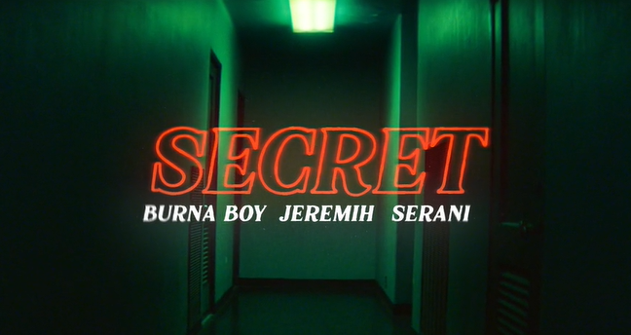
DOWNLOAD HIGH-RES COVER ART HERE

GRAMMY-nominated Burna Boy celebrates the new year with the release of “Secret” ft Jeremih and Serani. The single is accompanied by an electrifying visual directed by David Camarena; watch HERE. “Secret” arrives on the heels of the African Giant’s well-deserved GRAMMY-nomination for Best World Music Album, which followed his latest late night performance on The Tonight Show Starring Jimmy Fallon. “Secret” is available for download and streaming on all DSPs HERE.

“Secret” proceeds the release of “Money Play,” which closed out a wildly successful year for the star. Burna Boy recently graced the playlist cover of Apple Music’s Africa Now, which highlights African music. He made his U.S. late night television debut on Jimmy Kimmel Live!, along with an appearance on The Daily Show with Trevor Noah and his most recent performance on The Tonight Show Starring Jimmy Fallon. Watch Burna Boy discuss his international success on the Rap Radar Podcast exclusively on Tidal. The Nigerian star also recently performed on NPR’s Tiny Desk, performing four live songs including his global hit “Ye.” His album, African Giant, saw incredible critical acclaim at its release and now adorns a galore of ‘best of’ lists – including Pitchfork’s 50 Best Albums of 2019, NPR’s Best Albums of 2019, Billboard’s 50 Best Albums of 2019, Rolling Stone’s 50 Best Albums of 2019, Complex’s Best Albums of 2019, and many more.

The African Giant was named Apple Music's Up Next Artist for the month of July, won Best International Artist at the BET Awards, and received an in-depth profile piece with the Wall Street Journal which explores how the Nigerian star is finding success on his own terms in the United States. He also had an extensive year of live performances, travelling across North America on his The African Giant Returns Tour with sold-out stops in Toronto, New York, and LA through September, spending an additional two months for its European leg from Paris through Leicester, and had two fiery live sets at both weekends of Coachella.

ABOUT BURNA BOY
Burna Boy was born in Port Harcourt City and started producing music when he was ten years old. After graduating from school, Burna relocated to London for university. After two years, he dropped out and moved back to Nigeria to pursue his passion. A creative by the name of LeriQ allocated studio space for Burna to record and produce. His father always listened to dancehall and reggae music, an early influence and integral part of his musical style. Burna's grandfather managed Fela Kuti for the first 15 years of his career, a relationship that would come to shape Burna's sound and his understanding of himself as an artist that represents Nigeria, and more broadly Africa, to the world. Burna Boy classifies his own music as Afrofusion, a genre he coined.

CONNECT WITH BURNA BOY
TWITTER | FACEBOOK | INSTAGRAM | YOUTUBE

For additional press assets, visit press.atlanticrecords.com/burna-boy

PRESS CONTACT
Brittany Bell | Brittany.Bell@atlanticrecords.com

