FOR IMMEDIATE RELEASE
JANUARY 27, 2021

BRI STEVES IS AN “ANTI QUEEN”

GROUNDBREAKING RAPPER/SINGER REDEFINES FEMALE HIP-HOP IMAGE
WITH LATEST SINGLE OFF FORTHCOMING PROJECT

OFFICIAL VIDEO DIRECTED BY DEREK BLANKS STREAMING NOW HERE

“ANTI QUEEN” AVAILABLE TODAY VIA ATLANTIC RECORDS HERE

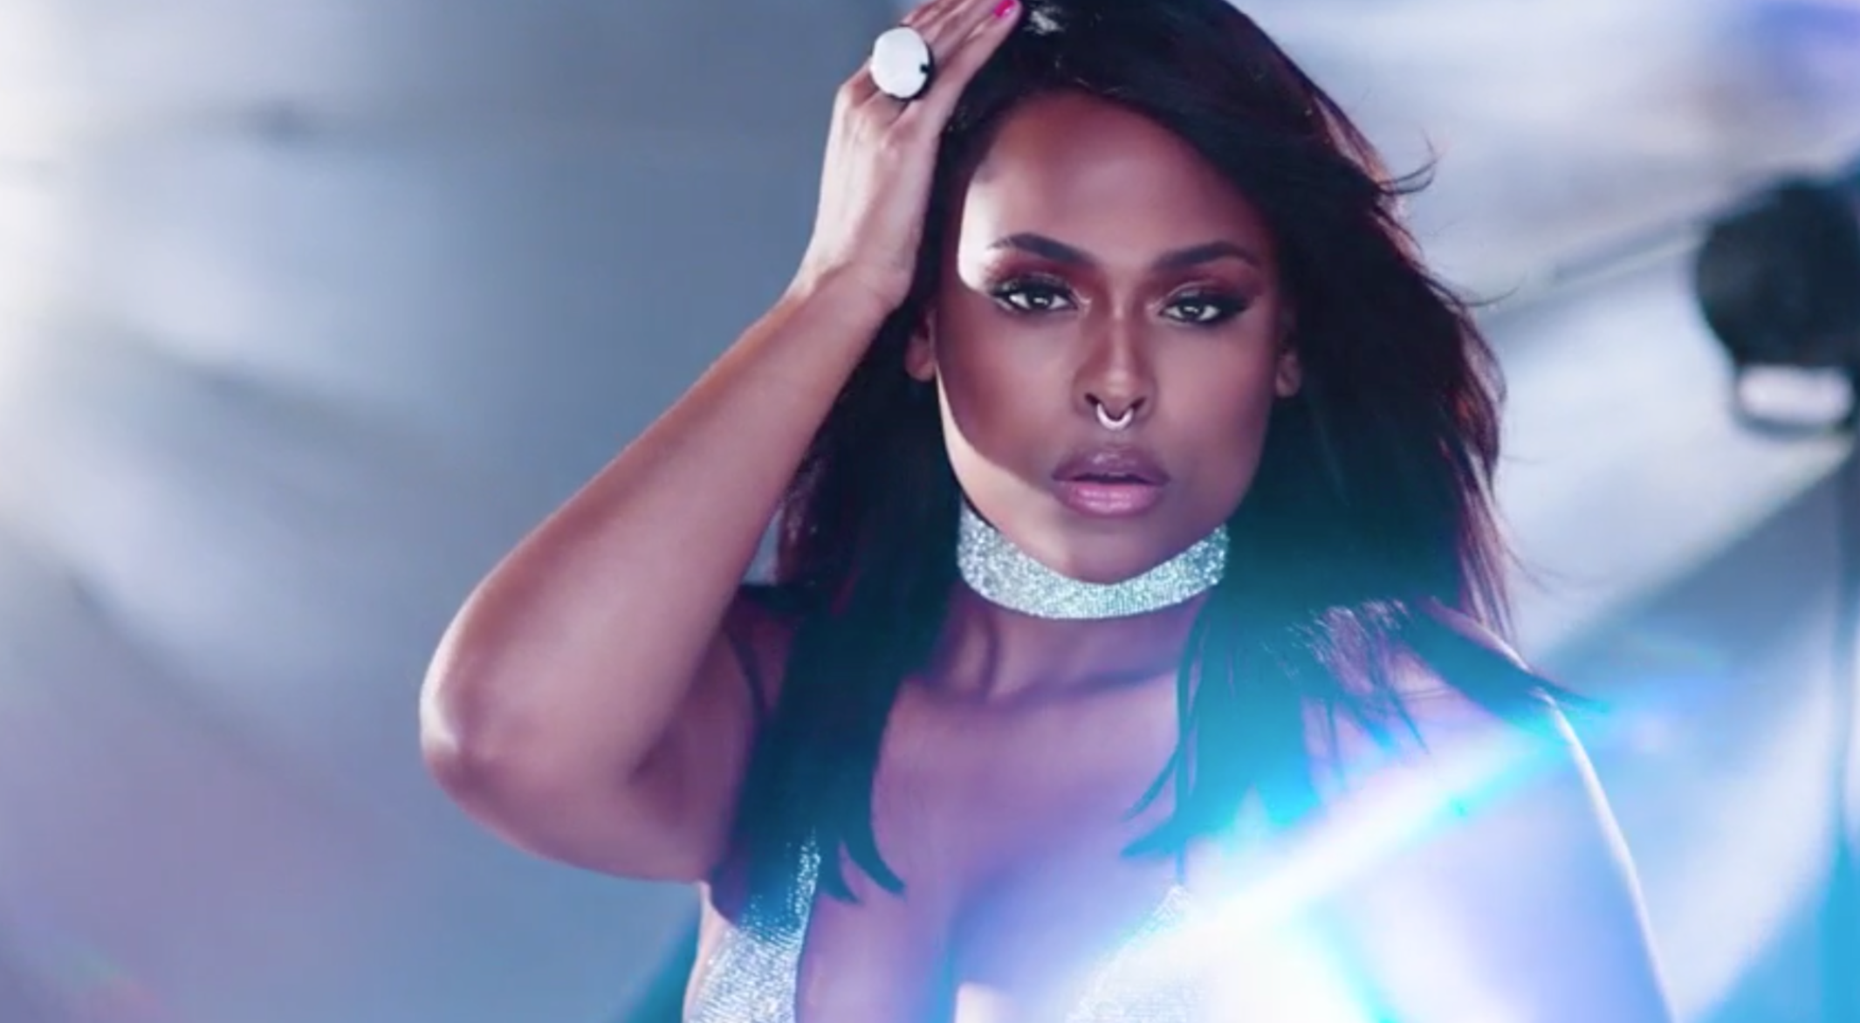
DOWNLOAD BRI STEVES PRESS ASSETS HERE

Philadelphia rapper, singer, producer, and musician Bri Steves has announced today’s premiere of a landmark new single, “Anti Queen,” is available now via Atlantic Records HERE. The companion video – directed by ATL-based photographer/filmmaker Derek Blanks – is streaming now via YouTube HERE. “Anti Queen” sees Bri Steves reimagining what a female MC should look and sound like, fusing rap and vocals, femininity and masculinty, nostalgia and modernity to create a strikingly powerful new approach unlike any other. She’s starting a new conversation about what it means to be a female in hip-hop and paying homage to the true anti queens who redefined female MCs. Indeed, “Anti Queen” marks the first Bri Steves project to truly display the duality and dimensions of this remarkable, idiosyncratic artist, showcasing her independent spirit and utter refusal to live by anyone’s standards other than her own.

“‘Anti Queen’ challenges people’s expectations and perceptions of female artists,” notes Steves of her latest single. “I’m pointing out there's more than one way to wear the crown. In my video, I pay homage to a few women who came before me – Missy Elliott, Aaliyah, Erykah Badu, Lauryn Hill, and Lisa “Left Eye” Lopez. These women inspired and influenced hip-hop by not fitting the mold. They are the original ANTI QUEENS.”

Last fall saw Steves drop a pair of acclaimed singles, “Stick Up (Feat. Poundside Pop)” and “Sober,” both available now at all DSPs and streaming services; official music videos directed by David Janoff (Joey Bada$$, CJ Fly) are streaming now at the official Bri Steves YouTube channel HERE.

Hailed by Ones to Watch as a “hip-hop visionary,” Bri Steves is quickly proving a milestone artist, a gifted rapper and powerhouse vocalist who easily alternates between steely and confrontational rhymes to sugary melodic hooks, all capturing her unique perspective on the female experience. The Philadelphia-born rapper, singer, multi-instrumentalist, poet, and producer studied viola with the Delaware Symphony Orchestra at the tender age of 10 but eventually chose to embark on a different path inspired by such champion lyricists as the Notorious B.I.G., Joey Bada$$, and J.Cole. Having mastered her rap skills, Bri focused on her singing voice while attending Temple University, establishing herself as a true double threat on the mic.

Steves signed to Atlantic Records in her senior year and in 2018, released her T-Minus and Hitmaka-produced debut single, “Jealousy.” The track proved a top 15 chart smash while drawing critical acclaim from the likes of The FADER, which named her one of “5 Artists Ready To Be Philadelphia’s Next Champion,” writing, “Steves alternates between rapping and singing with ease…(She) exudes a confidence that's contagious.”

As remarkable on stage as she is in the studio, Bri has spent a great deal of time honing her talents on the road, including shows supporting such like-minded artists as H.E.R., Mary J. Blige, Pharrell, and her mentor, Kendrick Lemar.

CONNECT WITH BRI STEVES
TWITTER | INSTAGRAM | YOUTUBE

PRESS CONTACT
Fairley McCaskill | Fairley.McCaskill@atlanticrecords.com

