FOR IMMEDIATE RELEASE
FEBRUARY 4, 2019

2 CHAINZ’S T.R.U. ARTIST WORL DROPS “NEW LEVELS NEW DEVILS”
FOR THIS WEEK’S #TRUSDAYS RELEASE

NEW SINGLE ARRIVES AHEAD OF T.R.U.’S DEBUT COMPILATION ALBUM
NO FACE NO CASE OUT THIS FRIDAY FEBRUARY 7TH

WATCH ACCOMPANYING VISUAL DIRECTED BY HDOTROSS HERE
STREAM IT HERE

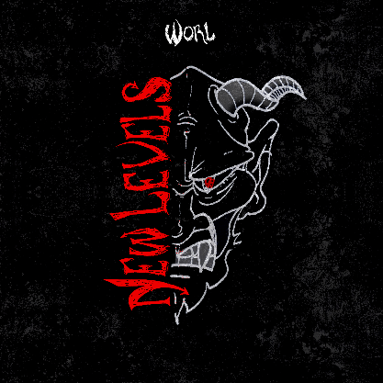

DOWNLOAD HIGH-RES SINGLE COVER ART HERE
DOWNLOAD HIGH-RES ALBUM COVER ART HERE

It’s Tuesday and T.R.U.’s Worl is up for the fourth installment of #TRUSdays with a new single and visual – “New Levels New Devils,” produced by Hood Famous. Stream the track HERE and watch the visual HERE.
“New Levels New Devils” is a follow up to Skooly’s “How I Feel” remix featuring NoCap and Quando Rondo, with the visual directed by HDotRoss. Watch it HERE. Previous #TRUsday drops have included Sleepy Rose’s rambunctious “Woo” and the Off White-inspired “Virgil Discount” by Skooly and 2 Chainz. These weekly #TRUsdays have been building anticipation for T.R.U.’s upcoming compilation, No Face No Case due February 7th.

2 Chainz took to Instagram last week to highlight the upcoming album’s creative direction. Hot New Hip Hop describes the announcement post as it “finds each member embodying the album title in a literal sense. Last but not least comes the album cover, which depicts the five rappers standing as a united, albeit incognito, front.” Check out more solo shots from the project HERE.

Worl has been buzzing in the streets of Southeast Atlanta with tracks like “Insomnia,” “YAMS,” and “By the Coast” from his Went Broke From Buying Dreams mixtape that saw fans lining up outside his public housing neighborhood to purchase physical copies. His latest mixtape Generally Speaking is out now featuring single “Village,” “Give My All” and the 2 Chainz-assisted “Tell Me.” The “street activist” is known locally for his “No Child Left Behind” initiative in his 4 Seasons neighborhood that hosts holiday events for at-risk and abandoned youth.
“If we can get our music across to just one person, they will hopefully feel it in their hearts,” he remarks. “I’m really believing in myself and the people around me. You can hear the pain in my music. It’s real. I’d love it if audiences just want to hear more.”

ABOUT T.R.U. (THE REAL UNIVERSITY)
Founded by GRAMMY® Award-winning multiplatinum rapper and Atlanta trailblazer 2 Chainz in 2019, T.R.U. (The Real University) provides a home to a rising vanguard of hip-hop talent and posits a platform for personal success as well. In partnership with Atlantic Records, the Atlanta-based label imprint includes flagship artists: Skooly, WORL, Hott LockedN, and Sleepy Rose. The whole crew makes a splash on the label’s first-ever 2019 compilation, Looking Like It Records, introduced by singles such as Sleepy Rose’s “Shoot It Out” [feat. 2 Chainz, WORL, & Hott LockedN], 2 Chainz’s “Virgil Discount” [feat. Skooly], and more. Now, the lessons of T.R.U. will ultimately ring out through the culture for a long time to come.

T.R.U. PRESS CONTACT
Fairley McCaskill | Fairley.McCaskill@atlanticrecords.cm

