FOR IMMEDIATE RELEASE

FEBRUARY 7TH, 2020

**4TH & ORANGE TAKES IT EASY “IN THE LBC”**

**WATCH THE LONG BEACH-INSPIRED COMPANION VISUAL** [**HERE**](https://www.youtube.com/watch?v=gFJsYbWiJtE&feature=youtu.be)

**DOWNLOAD/STREAM “IN THE LBC”** [**HERE**](http://4thandorange.lnk.to/InTheLBCPR)

**TODAY MARKS THEIR FESTIVAL DEBUT AT LONG BEACH’S ONE LOVE CALI FEST**

**CONFIRMED IN ARIZONA ROOTS + FLORDIA REGGAE RISE UP FESTIVAL + MORE**

**4TH & ORANGE TO TOUR THE SUNSHINE STATE IN SUPPORT OF COLLIE BUDDZ**

**DATES BEGIN MARCH 18TH IN MIAMI BEACH | TICKET DETAILS** [**HERE**](https://www.4thandorange.com/tour/)

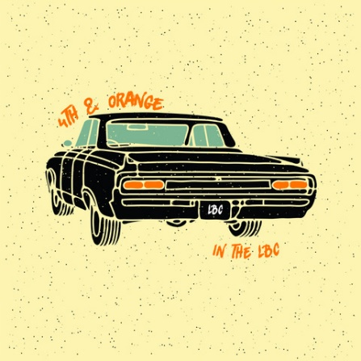

*DOWNLOAD HIGH-RES PRESS PHOTOS + COVER ART* [*HERE*](https://press.atlanticrecords.com/4th-orange/)

Acclaimed reggae-rock outfit **4th & Orange** reveals their first track of the decade today in celebration of their iconic hometown, “[In the LBC](http://4thandorange.lnk.to/InTheLBCPR).” The feel-good Long Beach anthem – an ode to **Dove Shack’s** classic ’95 song “**Summertime in the LBC**” ft **Warren G** – arrives alongside a summertime vibe visual directed by Michael Garcia. Let 4th & Orange take you on a journey through their favorite beachside city – watch [HERE](https://www.youtube.com/watch?v=gFJsYbWiJtE&feature=youtu.be). Today marks their festival debut in Long Beach, CA’s [One Love Cali Reggae Fest](https://www.onelovecalifest.com/) – making today all about LBC. “[In the LBC](http://4thandorange.lnk.to/InTheLBCPR)” is available now to download and stream on all DSPs [HERE](http://4thandorange.lnk.to/InTheLBCPR).

Yesterday, [tmrw magazine](https://www.tmrwmagazine.com/features/music/first-look-4th-orange-in-the-lbc) offered an exclusive first look at “In The LBC.” tmrw notes how it “doesn’t gloss over anything. It shows the city fully, even the rougher edges, and embraces it for all that it is. 4th & Orange feels good doing it, too, and listeners are sucked into their feel-good vibe.” Check out behind the scenes footage of the official video and premiere with tmrw mag [HERE](https://www.tmrwmagazine.com/features/music/first-look-4th-orange-in-the-lbc).

4th & Orange will embark on their first tour run in support of **Collie Buddz** for dates across Florida. The Long Beach-based group will trek across the Sunshine State, hitting Miami Beach, Ft. Meyers, Ft. Pierce, Orlando, and will perform at St. Petersburg’s [Reggae Rise Up Music Festival](http://reggaeriseupflorida.com/) on March 22nd at Vinoy Park. Tickets are currently on sale to the public [HERE](https://www.4thandorange.com/tour/). For live tour itinerary, see below.

4th & Orange brought some California sunshine to the big apple at the end of 2019 with their eagerly awaited live debut at NYC’s renowned **Mercury Lounge**. Check out the exclusive behind-the-scenes recap on [Noisetrend](https://www.noisetrend.com/4th-orange-mercury-lounge-new-york-city/). In addition, the band will appear at a number of upcoming festivals, including Long Beach, CA’s [One Love Cali Reggae Fest](https://www.onelovecalifest.com/) (February 7-9); Chandler, AZ’s [Arizona Roots Music & Arts Festival](https://arizonarootsfestival.com/4th-and-orange) (February 22-23); St. Petersburg, FL’s [Reggae Rise Up Music Festival](http://reggaeriseupflorida.com/) (March 20-22); and Las Vegas, NV’s [Reggae Rise Up Music Festival](https://reggaeriseup.com/festival/reggaeriseupvegas/) (April 18-19). Additional festival dates will soon be announced.

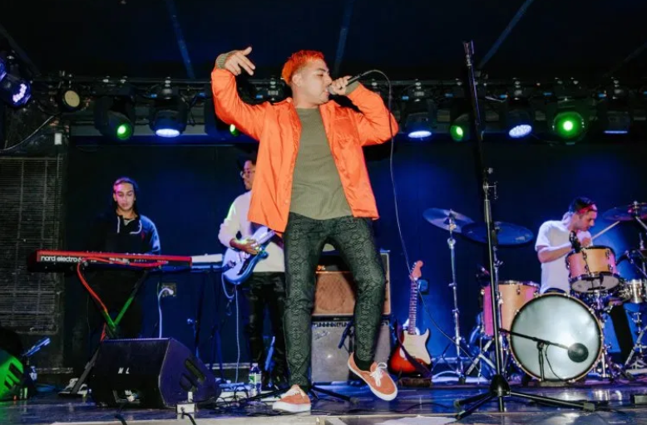 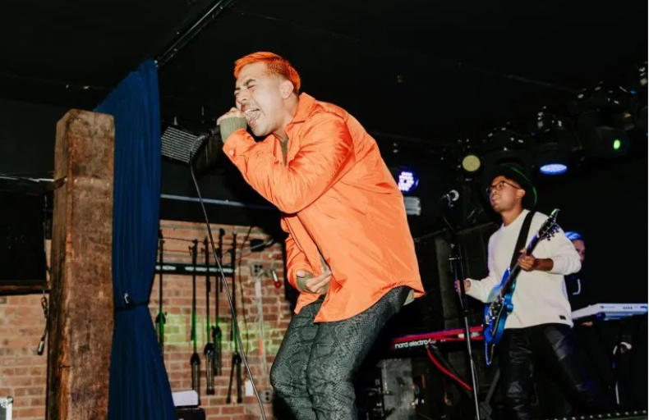

*4TH & ORANGE LIVE IN NYC |* [*NOISETREND*](https://www.noisetrend.com/4th-orange-mercury-lounge-new-york-city/)*, PHOTO CREDIT: GRACE PRACHTHAUSER*

“In the LBC” arrives on the heels of 4th & Orange’s latest single “[Only You](https://atlantic.lnk.to/OnlyYouPr),” which sees the group putting their quintessential SoCal pop-reggae touch on an undisputed classic song. The track dropped alongside an electric [companion visual](https://www.youtube.com/watch?v=YOA4_U5yeiA) directed by **Jose Omar**. They kickstarted the summer of 2019 with their sizzling debut single, “[Girl Next Door](https://atlantic.lnk.to/GirlNextDoorID),” with an [official video](https://www.youtube.com/watch?v=6S9cpWTOYcw) directed by **Michael Garcia** that’s now boasting more than **2.5 million** individual views. The single was swiftly followed by two additional summer smashes in “[No More Favors](https://atlantic.lnk.to/NoMoreFavorsID)” and “[Junky](https://atlantic.lnk.to/JunkyID).”

Their debut single “[Girl Next Door](https://atlantic.lnk.to/GirlNextDoorID)” arrived amidst a tidal wave of positive press attention, beginning with its exclusive premiere via [Alternative Press](https://www.altpress.com/features/4th-and-orange-girl-next-door/), which wrote, “Merging pop elements with reggae in the likes of Sublime, ‘Girl Next Door’ introduces (4th & Orange’s) summery, poolside vibe along with their storytelling style that draws on relatable circumstances from real-life experiences.” “It is clear that 4th & Orange are on an exciting track for some relaxing and fun music,” wrote [Poptized](https://poptized.com/blog/2019/7/5/1vite09ty4umlr5sgjoa4qpbhmmllz). “’Girl Next Door’ is an exciting first single for the band, with easy and fun music that’s perfect for your next summer backyard party or casual radio listening.” “4th & Orange is taking this summer by storm,” raved [Earmilk](https://earmilk.com/2019/07/12/the-message-behind-4th-oranges-girl-next-door/). “For the rest of 2019, we can look forward to the group engaging with fans and providing us with even more music, hopefully sooner than we think.”

**4TH & ORANGE 2020 LIVE ITINERARY**

*\* * in support of Collie Buddz*

FEBRUARY

7 Long Beach, CA One Love Cali Festival [TICKETS](https://www.onelovecalifest.com/)

23 Chandler, AZ Arizona Roots Festival [TICKETS](https://arizonarootsfestival.com/4th-and-orange)

MARCH

18 Miami Beach, FL North Beach Bandshell [TICKETS](https://colliebuddzmiamibeach.eventbrite.com)**

19 Fort Meyers, FL The Ranch [TICKETS](https://colliebuddzftmyers.eventbrite.com)**

20 Fort Pierce, FL Rhumcay Resort  [TICKETS](https://colliebuddzftpierce.eventbrite.com)**

21 St. Petersburg, FL Reggae Rise Up Festival [TICKETS](http://reggaeriseupflorida.com/)

22 Orlando, FL Ace Café [TICKETS](https://colliebuddzftpierce.eventbrite.com)**

APRIL

19 Las Vegas, NV Reggae Rise Up Festival [TICKETS](https://reggaeriseup.com/festival/reggaeriseupvegas/)

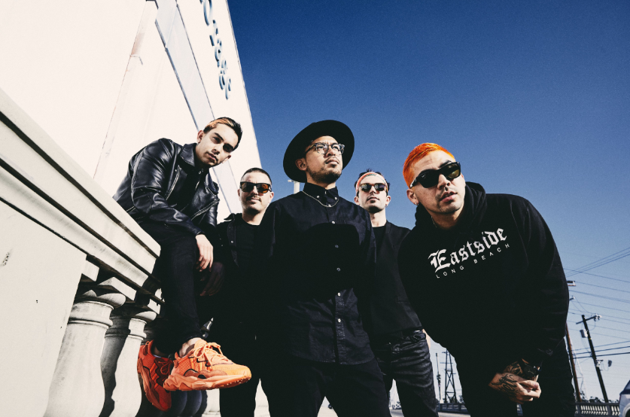

*DOWNLOAD HIGH-RES PRESS PHOTO* [*HERE*](https://press.atlanticrecords.com/4th-orange/)

*PHOTO CREDIT: JIMMY FONTAINE*

**BAND MEMBERS**

Garret Douglas - Lead Vocals

Chris “DJ Irey” Garcia - Keyboards / Producer

Ricardo Santiago – Guitar

Alex Bursztyn – Bass

Sam Ward – Drums

**CONNECT WITH 4TH & ORANGE**

[INSTAGRAM](https://www.instagram.com/4thandorange/) | [TWITTER](https://twitter.com/4thandorange) | [FACEBOOK](https://www.facebook.com/4thandorange/) | [YOUTUBE](https://www.youtube.com/channel/UClmb8V8yRbLQYWYwinVXBBQ)

*For additional press assets, please visit their press site* [*HERE*](http://press.atlanticrecords.com/4th-orange/)*.*

**PRESS CONTACT**

Chandler Owen | [Chandler.Owen@atlanticrecords.com](mailto:Chandler.Owen@atlanticrecords.com)