FOR IMMEDIATE RELEASE
MARCH 3RD, 2020

4TH & ORANGE JOINS REGGAE ICONS NATIRUTS
FOR 2020 NORTH AMERICAN TOUR

TOUR DATES KICK OFF MAY 15TH IN DC WITH STOPS IN LA + NY
TICKET DETAILS HERE

FESTIVAL APPEARENCES CONFIRMED AT
REGGAE RISE UP FLORIDA + REGGAE RISE UP VEGAS

4TH & ORANGE TO TOUR FLORIDA IN SUPPORT OF COLLIE BUDDZ
DATES BEGIN MARCH 18TH IN MIAMI BEACH | TICKET DETAILS HERE

WATCH THEIR LATEST LONG BEACH-INSPIRED VISUAL “IN THE LBC” HERE
DOWNLOAD/STREAM “IN THE LBC” HERE

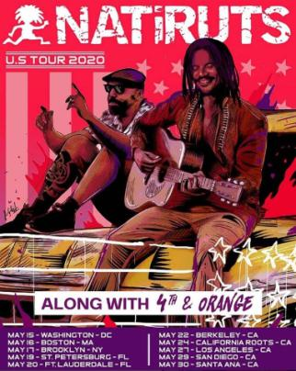
Long Beach-based reggae genre-benders 4th & Orange has announced tour support of Natiruts’ U.S. Tour 2020, adding additional live dates to their already bubbling year of performances. The tour kicks off at the 9:30 Club in Washington, DC (5/15) and rounds out at Santa Ana’s Observatory (5/30). 4th & Orange will also make highly anticipated stops at NYC’s Brooklyn Steel (5/17) and LA’s famed Fonda Theatre (5/27). See below for complete tour itinerary; tickets are currently on sale to the public HERE.

The Natiruts tour announcement arrives on the heels of their festival debut in Long Beach, CA at One Love Cali Reggae Fest, where 4th & Orange shared the bill with hometown heroes Sublime with Rome and reggae legends Dirty Heads. In addition, the band will appear at a number of upcoming festivals, including Chandler, AZ’s Arizona Roots Music & Arts Festival (February 22-23); St. Petersburg, FL’s Reggae Rise Up Music Festival (March 20-22); and Las Vegas, NV’s Reggae Rise Up Music Festival (April 18-19). Additional festival dates will soon be announced.

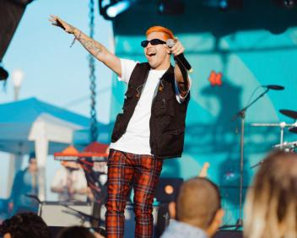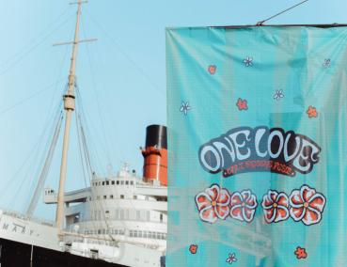
4TH & ORANGE LIVE ONE LOVE CALI REGGAE FEST | PHOTO CREDIT: GOLDENVOICE

4th & Orange will embark on their first tour run in support of Collie Buddz for dates across Florida during March. The Long Beach-based group will trek across the Sunshine State, hitting Miami Beach, Ft. Meyers, Ft. Pierce, Orlando, and will perform at St. Petersburg’s Reggae Rise Up Music Festival at Vinoy Park (3/22). Tickets are currently on sale to the public HERE. For live tour itinerary, see below.

Acclaimed reggae-rock outfit 4th & Orange reveals their first track of the decade earlier this month in celebration of their iconic hometown, “In the LBC.” The feel-good Long Beach anthem – an ode to Dove Shack’s classic ’95 song “Summertime in the LBC” ft Warren G – arrived alongside a summertime vibe visual directed by Michael Garcia. Let 4th & Orange take you on a journey through their favorite beachside city – watch HERE. “In the LBC” is available now to download and stream on all DSPs HERE.

““In The LBC” gloss over anything. It shows the city fully, even the rougher edges, and embraces it for all that it is. 4th & Orange feels good doing it, too, and listeners are sucked into their feel-good vibe.”
- tmrw magazine

“In the LBC” arrives on the heels of 4th & Orange’s latest single “Only You,” which sees the group putting their quintessential SoCal pop-reggae touch on an undisputed classic song. The track dropped alongside an electric companion visual directed by Jose Omar. They kickstarted the summer of 2019 with their sizzling debut single, “Girl Next Door,” with an official video directed by Michael Garcia that’s now boasting more than 2.5 million individual views. The single was swiftly followed by two additional summer smashes in “No More Favors” and “Junky.”

4TH & ORANGE 2020 LIVE ITINERARY
* * in support of Collie Buddz
++ in support of Natiruts

FEBRUARY
23 Chandler, AZ Arizona Roots Festival TICKETS

MARCH
18 Miami Beach, FL North Beach Bandshell TICKETS**
19 Fort Meyers, FL The Ranch TICKETS**
20 Fort Pierce, FL Rhumcay Resort TICKETS**
21 St. Petersburg, FL Reggae Rise Up Festival TICKETS
22 Orlando, FL Ace Café TICKETS**
APRIL
19 Las Vegas, NV Reggae Rise Up Festival TICKETS

MAY
15 Washington, DC 9:30 Club TICKETS ++
16 Boston, MA Paradise Rock Club TICKETS++
17 Brooklyn, NY Brooklyn Steel TICKETS++
19 St. Petersburg, FL Jannus Live TICKETS++
20 Ft. Lauderdale, FL Revolution Live TICKETS++
22 Berkley, CA UC Theatre TICKETS++
27 Los Angeles, CA Fonda Theatre TICKETS++
29 San Diego, CA Music Box TICKETS++
30 Santa Ana, CA The Observatory TICKETS ++

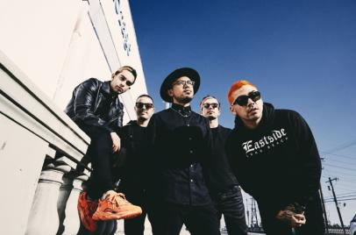
DOWNLOAD HIGH-RES PRESS PHOTO HERE
PHOTO CREDIT: JIMMY FONTAINE

BAND MEMBERS
Garrett Douglas - Lead Vocals
Chris “DJ Irey” Garcia - Keyboards / Producer
Ricardo Santiago – Guitar
Alex Bursztyn – Bass
Sam Ward – Drums

CONNECT WITH 4TH & ORANGE
INSTAGRAM | TWITTER | FACEBOOK | YOUTUBE

For additional press assets, please visit their press site HERE.

PRESS CONTACT
Chandler Owen | Chandler.Owen@atlanticrecords.com

