FOR IMMEDIATE RELEASE
MARCH 4, 2021

TAYLA PARX’S VIDEO FOR “SAD” PREMIERES TODAY
WATCH HERE: TAYLAPARX.LNK.TO/SADVIDEO

COPING MECHANISMS OUT NOW TO WIDESPEAD CRITICAL PRAISE

GRAMMY-NOMINATED FOR CONTRIBUTIONS TO JOHN LEGEND'S BIGGER LOVE
& HAIM’S WOMEN IN MUSIC PT. III

TAYLA PARX TO TEACH GRAMMY U MASTERCLASS MARCH 11

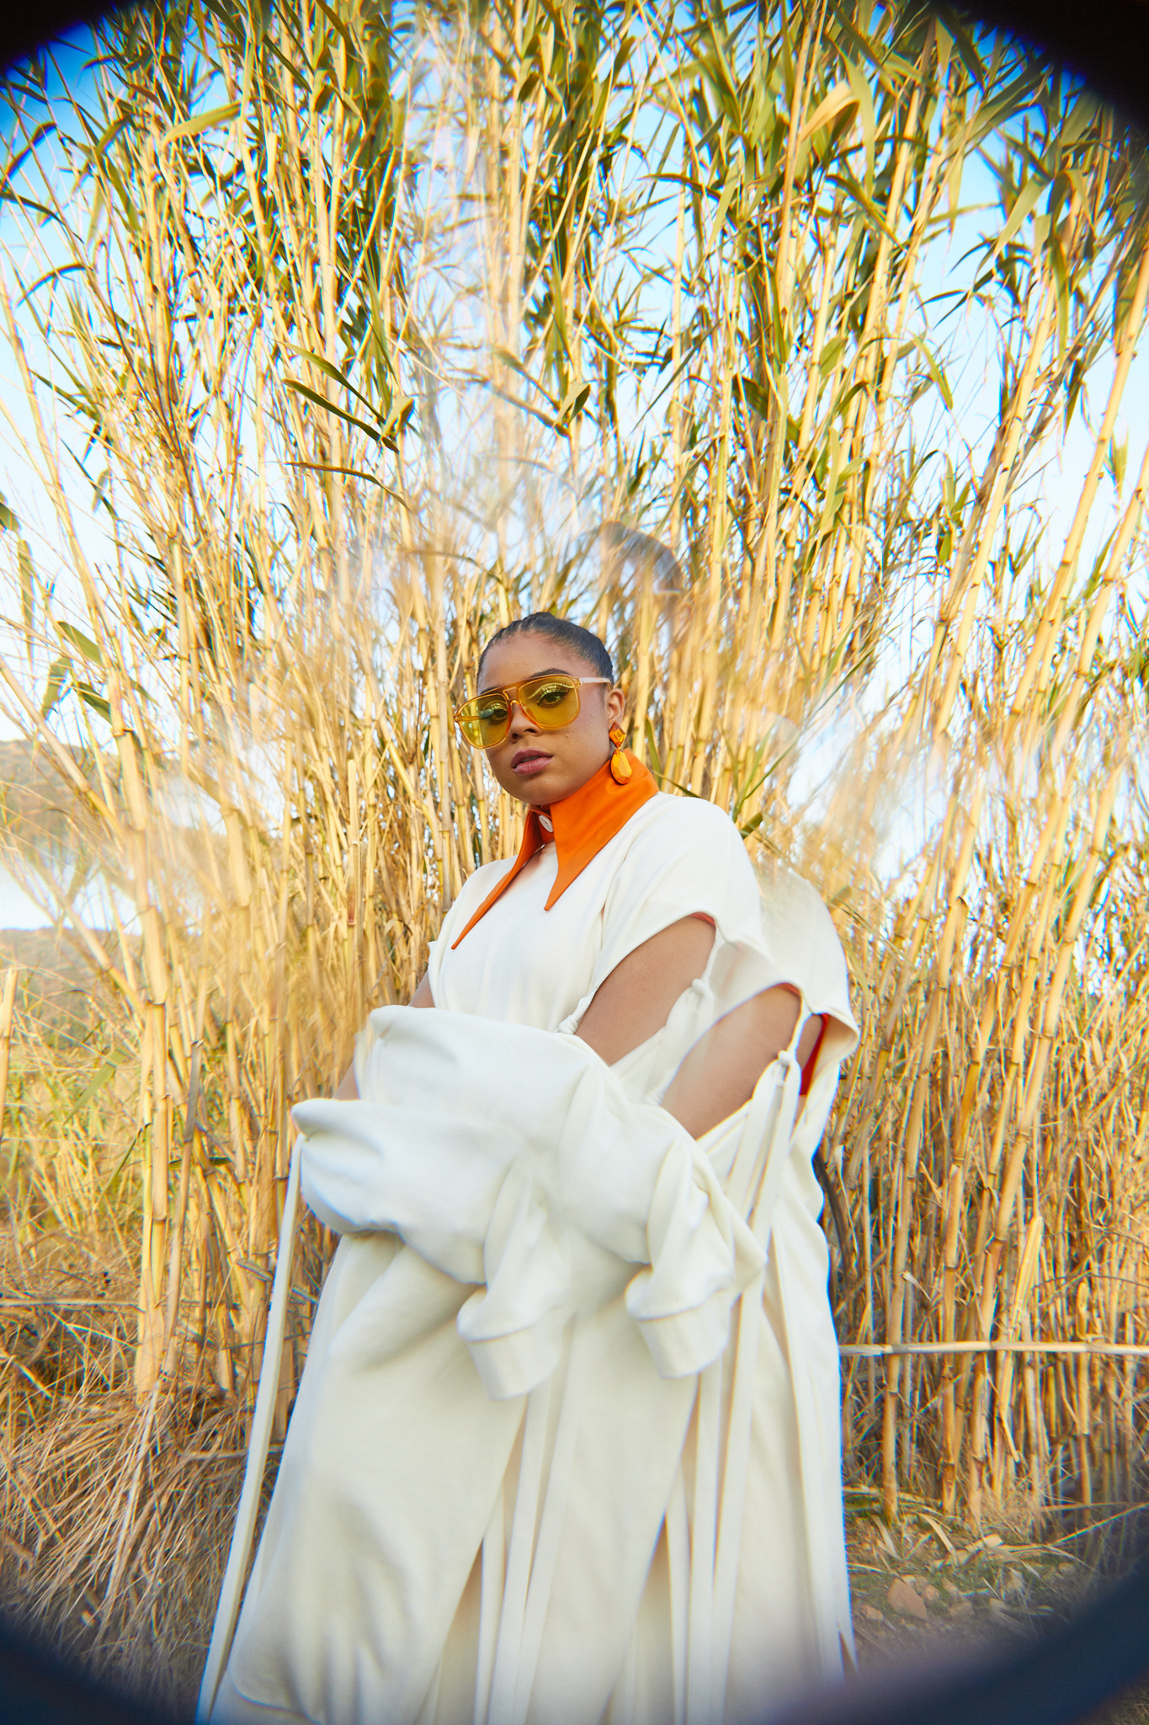

Breakout singer, songwriter, actress and entrepreneur Tayla Parx is debuting the official music video for her track “Sad.” The song appears on her acclaimed album Coping Mechanisms, which is out now on TaylaMade/Atlantic Records. Watch/share the video HERE and listen to/share the album HERE.

“My favorite part about releasing my own music is that it’s a bit of a time capsule into my emotions,” notes Parx. “When I listen to ‘Sad’ now it’s so funny that somebody could affect me so much so, that I wrote this quirky song about it. Maybe it wasn’t the healthiest reaction, but it was my own coping mechanism at the time.”

Most recently, Parx received two more Grammy nominations for her songwriting contributions to HAIM’s Women In Music Pt. III as well as John Legend’s Bigger Love, which is nominated for Album Of Year and Best R&B Album respectively. The nominations mark yet another career milestone for Parx, who was previously nominated for her work on Ariana Grande’s thank u, next, “7 Rings” and “My Everything;” Janelle Monáe’s Dirty Computer, Christina Aguilera’s “Like I Do” featuring GoldLink, The Internet’s “Ego Death” and the 2007 film Hairspray.

In addition, Parx will teach a Grammy U Masterclass on March 11 which will focus on the craft of songwriting while emphasizing the importance of being a multi-faceted artist. This virtual event is in collaboration with the Recording Academy’s Black Music Collective and can be viewed on the Recording Academy’s Facebook channel.

Taylor Parks, known by her stage name Tayla Parx, was born and raised in Dallas where she trained with legendary choreographer Debbie Allen who encouraged her to pursue acting and singing. After moving to Los Angeles, she began honing her musical talents and released her 2017 mixtape, TaylaMade, which has garnered over 25 million streams to date. In 2019 Parx released her debut album, We Need To Talk, via Atlantic Records to widespread praise; The New York Times proclaimed, “The new album, like Parx’s best hits, is playful and conversational, blending pop, R&B and traces of rap with plenty of Grande-esque high notes,” while Rolling Stone called it “a solid pop manifesto from a child-star-turned-pop-savant.” Entertainment Weekly added, “[Parx] exploded as one of pop music’s go-to songwriters.”

When Parx released We Need To Talk she was the first female songwriter to have three simultaneous top 10 songs—Grande’s “7 Rings” and “thank u, next,” and Panic! At The Disco’s “High Hopes”—in the Billboard Hot 100 since 2014 while also winning Billboard’s “2019 Hitmaker Award.” During that same year, Parx performed as a special guest on Lizzo’s Cuz I Love You Tour and Anderson .Paak’s ABC Tour while launching Burnout, a landmark new songwriting camp with the aim of fostering perspective, balance and self-care for creative artists. The premiere Burnout camp was held in 2019, with further virtual camps planned for the coming months.

CONNECT WITH TAYLA PARX
OFFICIAL | INSTAGRAM | YOUTUBE | TWITTER | FACEBOOK

PRESS CONTACT
BRITTANY BELL
BRITTANY.BELL@ATLANTICRECORDS.COM

