FOR IMMEDIATE RELEASE
MARCH 5, 2021

YBN ALMIGHTY JAY DROPS BATTLING MY SPIRIT MIXTAPE

TEXAN RAPPER RELEASES HIGHLY ANTICIPATED DEBUT MIXTAPE
YBN.LNK.TO/BATTLINGMYSPIRIT

WATCH “DRANK SEALED” OFFICIAL VIDEO
YBN.LNK.TO/DRANKSEALEDVIDEO

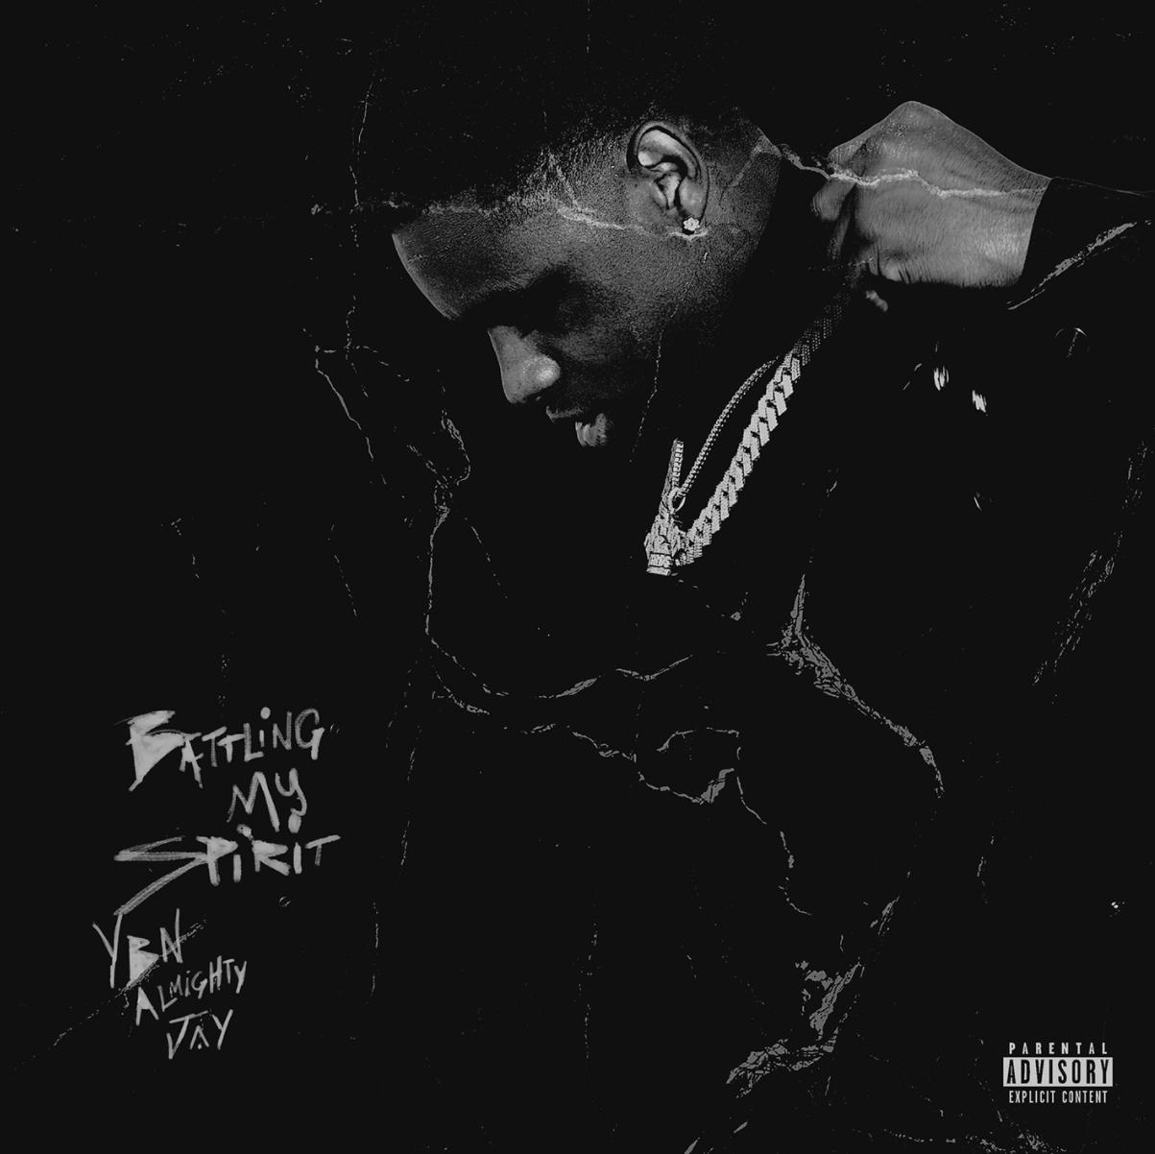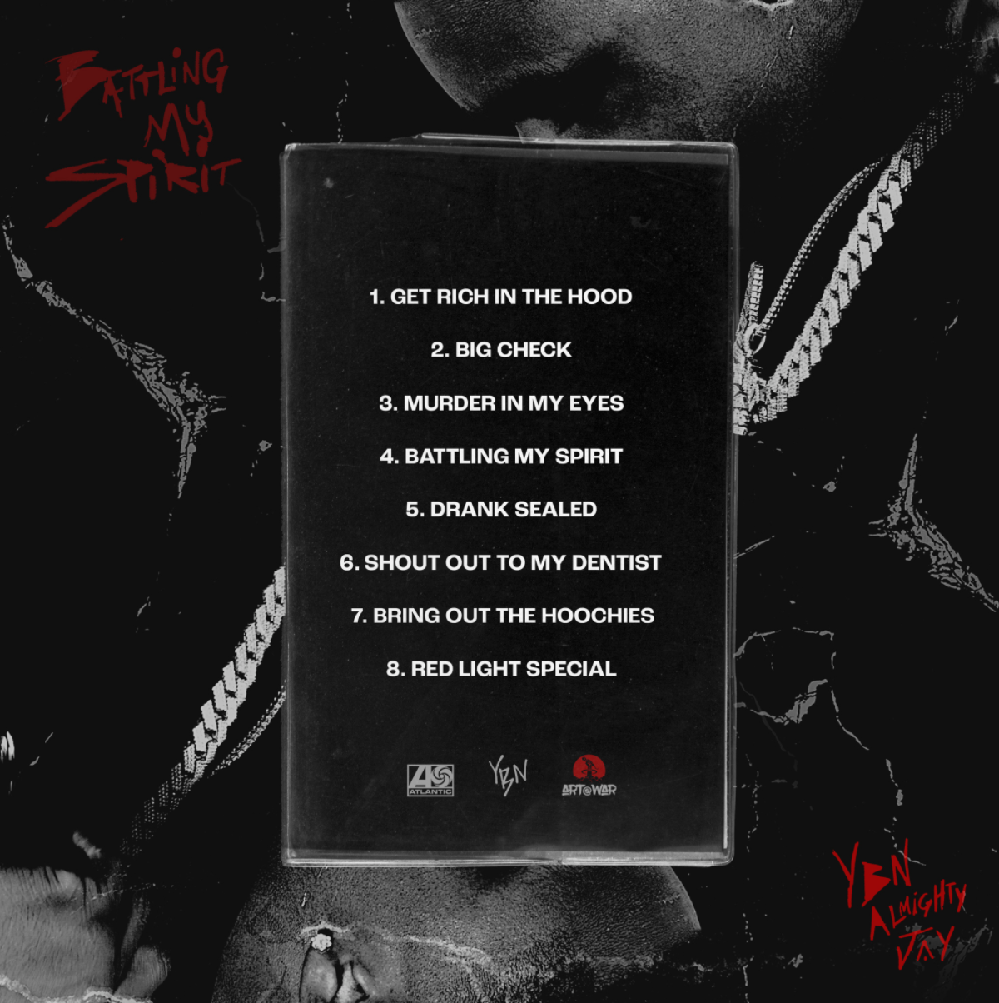
DOWNLOAD HIGH-RES COVER ART + TRACK LIST

Art@War and Atlantic recording artist YBN Almighty Jay once again catches listeners off guard on his debut mixtape, Battling My Spirit. The Texas rapper inserts hard-earned wisdom between ice cold flows, clever observations, and hard-hitting hooks. He twists up the drank-induced Houston swagger of his hometown with modern trap-style lyrical fireworks. It comes alongside the official video to “Drank Sealed,” a nod to classic codeine-drenched H-town with a fresh fire.

“When you listen to Battling My Spirit, I hope it opens up your ears and eyes to who I really am,” notes YBN Almighty Jay. “I’m a young turnt individual who has been through a lot of life experiences. It took bumping my head a few times to find myself. Now, I found myself, and I’m on the right track to being successful so generations of my family are taken care of. I molded myself into somebody I’m proud of.”

He ignited this chapter with the single and Rock Davis-directed official visual to “Shoutout to My Dentist” where he devours an airy beat with rapid fire rhymes before the hypnotic chant. YBN Almighty Jay also introduced fan’s to the outrageous “Bring Out the Hoochies” and the vulnerable title track “Battling My Spirit,” both complete with official videos. Fans get every side of YBN Almighty Jay within this mixtape. One minute he approaches “Murder In My Eyes” with uninhibited intensity, and the next he slides into a braggadocious bounce on “Rich In The Hood.”

ABOUT YBN ALMIGHTY JAY
Hailing from La Marque, TX, his parents divorced at a young age, but he looked up to his older brother who rapped in a local group. Influenced mostly by his big bro as well as Lil Wayne, Soulja Boy, and Chief Keef (Almighty So mixtape inspired his moniker), he started rapping. He competed on Xbox Live, met YBN Nahmir on the platform and formed a friendship. He also found himself in and out of trouble. Two weeks before he was set to leave for the U.S. Navy, plans changed when Nahmir called. A whirlwind followed. At 18 years old, Jay grew up in front of the world after making his way to Los Angeles and joining forces with Nahmir and Cordae for the gold-certified YBN: The Mixtape, which has over 1 billion streams to date. Jay’s solo single “Chopsticks” clocked 44 million Spotify streams and earned praise from Pitchfork. He accelerated his momentum via “2 Tone Drip” and “Spaceship” before teaming up with Blac Youngsta for “Ooouuu.”

TRACKLIST
1. Get Rich in the Hood
2. Big Check
3. Murder in My Eyes
4. Battling My Spirit
5. Drank Sealed
6. Shout Out to My Dentist
7. Bring Out The Hoochies
8. Red Light Special

CONNECT WITH YBN ALMIGHTY JAY
INSTAGRAM | TWITTER | WEBSITE

PRESS CONTACT
Fairley McCaskill | Fairley.McCaskill@atlanticrecords.com

