ACCLAIMED VOCALIST ABIR RETURNS WITH VISUAL FOR EP STANDOUT “TANGO”

U.S. TOUR ALONGSIDE JESS GLYNNE GETS UNDERWAY MARCH 25TH

DEBUT EP “MINT” AVAILABLE NOW AT ALL DSPS AND STREAMING SERVICES

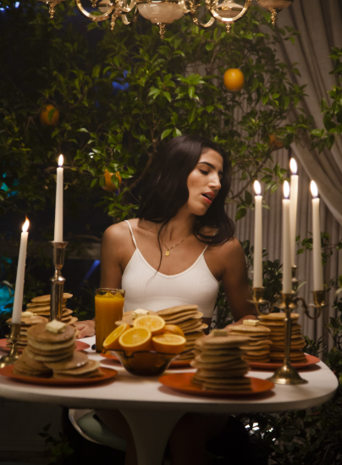

Atlantic recording artist ABIR has revealed the poetic visual for her empowering anthem “Tango” today via PAPER. Directed by Frank Borin (5 SOS, The Script, Little Mix, Tinashe), watch the video HERE. The mid-tempo R&B infused gem, which has surpassed 1 million streams, is also the opener on ABIR’s debut EP MINT, released last October. PAPER describes the track as “a positive message of self-love” and goes on to say, “ABIR swiftly breezes her way through the verses and chorus in a powerful yet silky tone singing...” On “Tango,” ABIR tells a soon-to-be ex-lover that she’ll be fine dancing alone, not relying on a partner.

“Tango is one of my favorite tracks from the EP,” said ABIR. “It’s about that feeling when someone tries to make you feel like you neeeeed them in your life, but you’re like “No boo, I got this!” I wanted to make a visual that felt fun and playful: at the crib, being comfortable in your own skin, dancing and eating happily on your own, getting ready for yourself!”

Fresh off a support slot on Jacob Banks’ US tour, ABIR will be heading out with fellow-vocal powerhouse and labelmate Jess Glynne, beginning March 25th in San Francisco, CA. See below for a full list of dates.

MINT, available at all DSPs and streaming services HERE, includes a special guest feature from rising rapper Buddy on the standout track, “Lose Me.” Listen HERE. MINT is highlighted by the single, “Young & Rude,” available for individual streaming and download HERE. The track, which has surpassed 3 million streams, is joined by a companion visual, directed by Shomi Patwary (Beyoncé, Beally Feat. The Weeknd) and is available now at ABIR’s official YouTube channel HERE.

“Young & Rude” received online applause upon its arrival last month, with Idolator raving, “ABIR is shaping up to be one of the breakout stars of 2018…The amazingly-titled ‘Young & Rude’ (is) an instantly anthemic pop song about letting your hair down and living in the moment. Those themes are conveyed perfectly in the video.”

Last Summer, ABIR collaborated with electronic production trio Cash Cash on the chart-topping anthem, “Finest Hour” (Big Beat Records). Written by ABIR, “Finest Hour” – available for streaming and download HERE – was one of last summer’s biggest dance tracks, topping iTunes’ “Dance Songs” chart for eight weeks on its way to the overall Top 40. The track is joined by an equally popular companion visual, directed by Phillip R. Lopez (Avicii, Kygo, Selena Gomez) and streaming now HERE.

“Finest Hour” was greeted by widespread critical praise, with Paper writing, “(ABIR’s) R&B-infused pop pairs uninhibited vocals with intimate, carefully-articulated observations of the world around her…’Finest Hour,’ which layers ABIR’s powerful Sia-esque vocals over Cash Cash’s characteristic wash of booming synth, metronomic drums, and meandering horns. ABIR laments that this isn’t her finest hour, but her confident vocals paired with the ecstatic instrumentals make it clear that she isn’t giving up any time soon.”

Named by Billboard as one of the “most exciting new voices” in recent pop memory, ABIR has already made an impact on contemporary pop, earning acclaim and attention for her sultry fusion of R&B, dance grooves, and intimate lyricism. In addition to her musical success, the Morocco-born, New York, NY-based artist has also teamed with Clinique and Beats By Dre for popular brand partnerships, not to mention live performances for Fendi and Made at the always-influential New York Fashion Week.

CONNECT WITH ABIR:
OFFICIAL |INSTAGRAM| TWITTER | FACEBOOK l SOUNDCLOUD

FOR ALL PRESS INQUIRIES, PLEASE CONTACT:
Corey.Brewer@atlanticrecords.com

ABIR
ON TOUR
W/JESS GLYNNE

MARCH
25 – San Francisco, CA – The Regency Ballroom
27 – Los Angeles, CA – The Wiltern
29 – Minneapolis, MN – First Avenue
30 – Chicago, IL – Vic Theatre

APRIL
1 – Boston, MA – House of Blues
2 – New York, NY – Terminal 5
5 – Washington, DC – Lincoln Theatre
6 – Philadelphia, PA – Union Transfer
27 – Dallas, TX – The Bomb Factory

# # #

