FOR IMMEDIATE RELEASE
MARCH 19, 2020

KEVIN GATES WILL “ALWAYS BE GANGSTA” IN LATEST FREESTYLE

KEVIN GATES DROPPED BY CHARLIE SLOTH’S
“FIRE IN THE BOOTH” TO SPIT THE FREESTYLE
LISTEN HERE | WATCH HERE

ARRIVES ON THE HEELS OF HIS LATEST TRACK “DREKA”
LISTEN HERE

LISTEN TO GATES’ #1 R&B/HIP-HOP ALBUM I’M HIM HERE

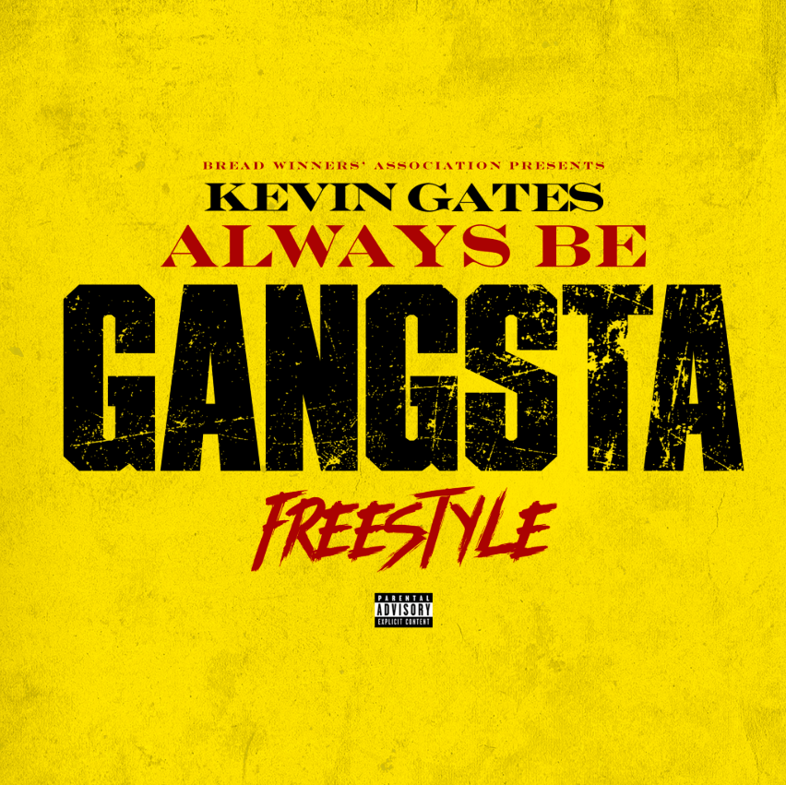
DOWNLOAD HI-RES ARTWORK

Multi-Platinum recording artist Kevin Gates recently guest-starred on Charlie Sloth’s Apple Music/Beats 1 Show, “Fire In The Booth” where he dropped an insane freestyle, “Always Be Gangsta.” Listen to the track HERE. Watch Kevin Gates on “Fire In The Booth” HERE.

“Always Be Gangsta” arrives on the heels of one of his most personal and special tracks yet. Gates wears his heart on his sleeve on the romantic track “Dreka,” named for his wife, manager, business partner and mother of his two children – affectionately known as #bossmaynedrek. Listen to “Dreka” HERE. Watch the visualizer for “Dreka” HERE.

Kevin and Dreka Gates recently teamed up to create the short film for Kevin’s track “Fatal Attraction” of his chart-topping album I’M HIM -- watch the visual HERE. The unstoppable power couple went on Complex’s Everyday Struggle for a rare and exclusive joint interview to speak about the Louisiana heritage and the voodoo culture that inspired the film, which was shot in New Orleans. The incredibly adorable and informative, must-see interview is streaming now HERE.

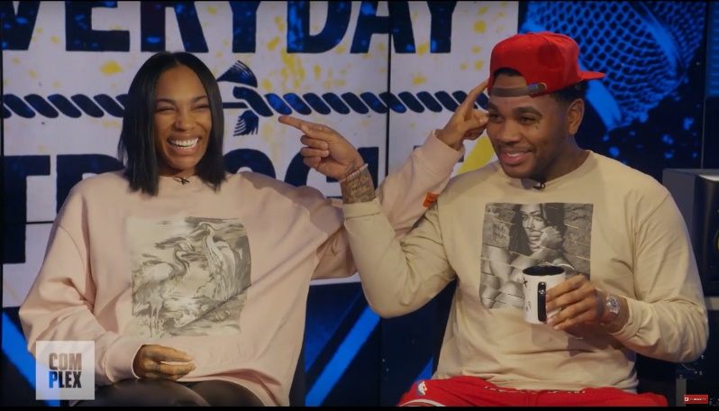

“Dreka” follows Gates’ critically acclaimed I’M HIM which arrived last year. The album debuted at #1 on the Billboard R&B/Hip-Hop Album Sales chart and at #4 on the Billboard 200 chart, giving Gates his fourth top 10 album. Pitchfork raved about the impressive showing from Gates by stating “seventeen songs with no guest features should be a recipe for exhaustion, yet there's hardly a trace of fat on I’M HIM.”

The Kevin & Dreka Gates Foundation – founded by the dynamic duo– partnered with The Crystal Campaign, a global movement of healing with the mission to make mental health as common and important of a conversation as physical health. Gates, who has always shared his struggle with mental health through his raw and emotional lyrics, has announced a “Walls Talking” inspired merch line that will raise funds for the Kevin & Dreka Gates Foundation which seeks to raise awareness and advocate for policy changes that support the mental health of formerly incarcerated people. Shop the full line HERE.

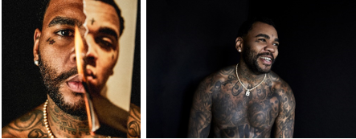
[Download – Credit: Jimmy Fontaine]

MORE ON KEVIN GATES
PRESS PHOTOS // ARTWORK // INSTAGRAM
WEBSITE // TWITTER // YOUTUBE // OFFICIAL BWA // ATLANTIC RECORDS

