FOR IMMEDIATE RELEASE
APRIL 3RD, 2020

4TH & ORANGE REMINDS YOU THIS IS “NOT THE END”

LONG BEACH GROUP PUSH POSITIVITY DURING PANDEMIC
LISTEN HERE: 4thAndOrange.lnk.to/NotTheEndPR

REGGAE ROCKERS CURATE QUARANTUNES PLAYLIST
LISTEN + FOLLOW HERE

WEST COAST HIP-HOP PIONEER WARREN G HOPPED ON “IN THE LBC” REMIX
LISTEN HERE | WATCH HERE

TOUR DATES WITH COLLIE BUDDZ + NATIRUTS POSTPONED

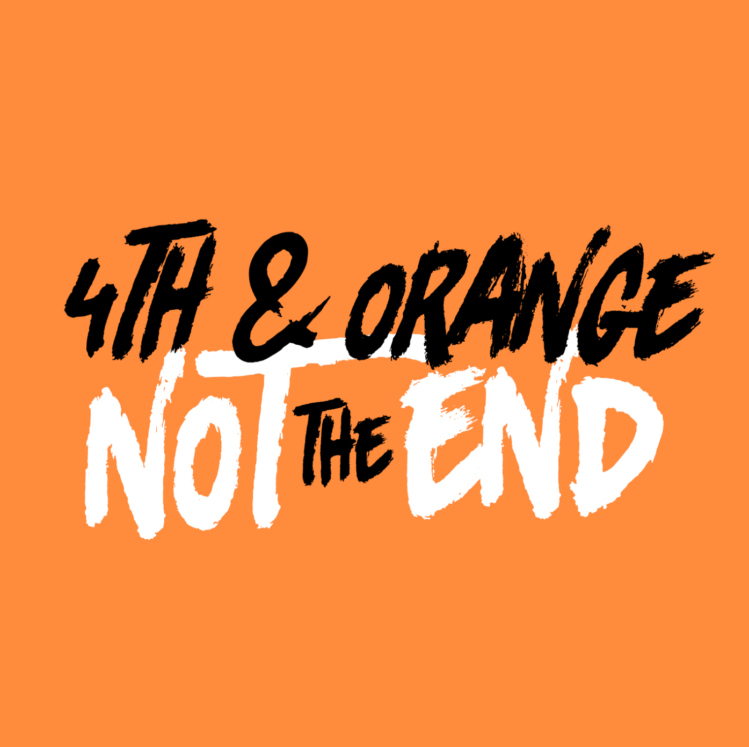
DOWNLOAD HIGH-RES COVER ART + PRESS PHOTOS

In the midst of the COVID-19 pandemic, 4th & Orange wants to remind you that this is “Not the End” with their latest single. The track pushes positivity and reinforces unity – a ray of sunshine to break up these cloudy times. “We wanted to find a way to spread a little positivity and hope. When it feels like it’s close to the end, it isn’t. It’s only the beginning of something new.” Listen to “Not the End” HERE. 4th & Orange also curated a playlist of their favorite songs to get you through the day; listen to the Quarantunes playlist HERE.

Last month, the reggae genre-benders recruited fellow Long Beach native Warren G for the “In The LBC” remix. Listen to the remix featuring the West Coast hip hop legend HERE. 4th & Orange released their feel-good Long Beach anthem in February in celebration of their iconic hometown; listen to the original track HERE. Watch the official music video HERE.

2020 brought a bubbling live performance itinerary. 4th & Orange kicked it off with their festival debut in Long Beach, CA at One Love Cali Reggae Fest, where they shared the bill with hometown heroes Sublime with Rome and reggae legends Dirty Heads. Weeks later, the band appeared at Chandler, AZ’s Arizona Roots Music & Arts Festival. Their festival performances at Reggae Rise Up Last Vegas and Reggae Rise Up St. Petersburg will be postponed; festival websites will have all information. 4th & Oranges tours with Collie Buddz and Natiruts will also be postponed; visit their website HERE for tour updates.

At the tail end of 2019, 4th & Orange dropped “Only You,” which sees the group putting their quintessential SoCal pop-reggae touch on an undisputed classic song. The track dropped alongside an electric companion visual directed by Jose Omar. They kickstarted the summer of 2019 with their sizzling debut single, “Girl Next Door,” with an official video directed by Michael Garcia that’s now boasting more than 2.5 million individual views. The single was swiftly followed by two additional summer smashes in “No More Favors” and “Junky.”

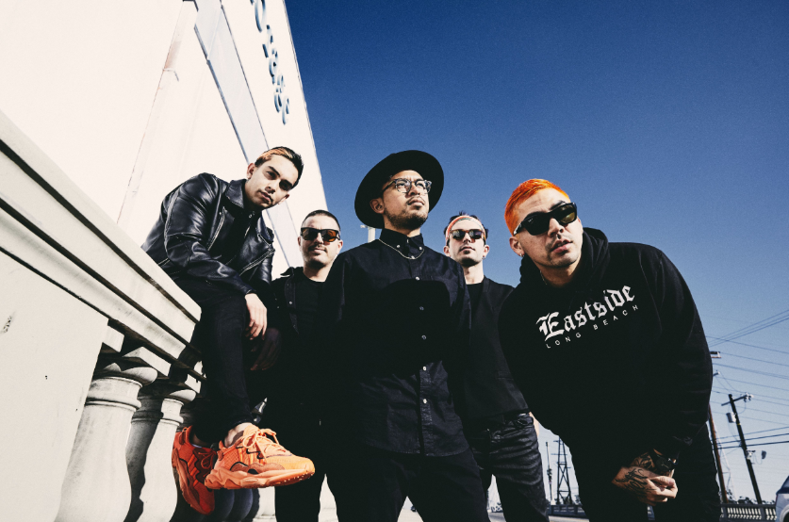
DOWNLOAD HIGH-RES PRESS PHOTO HERE
PHOTO CREDIT: JIMMY FONTAINE

BAND MEMBERS
Garrett Douglas - Lead Vocals
Chris “DJ Irey” Garcia - Keyboards / Producer
Ricardo Santiago – Guitar
Alex Bursztyn – Bass
Sam Ward – Drums

CONNECT WITH 4TH & ORANGE
INSTAGRAM | TWITTER | FACEBOOK | YOUTUBE

For additional press assets, please visit their press site HERE.

PRESS CONTACT
Chandler Owen | Chandler.Owen@atlanticrecords.com

