FOR IMMEDIATE RELEASE
APRIL 17TH, 2020

PJ CONTINUES THE QUARANTINE TAPES SERIES
WITH DUA LIPA COVER

R&B SONGSTRESS COVERS DUA LIPA’S “DON’T START NOW”
LISTEN TO THE THIRD QUARANTINE TAPE HERE

ON THE HEELS OF HER PREVIOUS QUARANTINE TAPES
“HIGH FASHION” BY RODDY RICCH
& JUSTIN BEIBER’S “INTENTIONS/YUMMY”

PJ SHARED HER QUARANTINE DIARY WITH THE RECORDING ACADEMY
READ WHAT SHE’S UP TO HERE

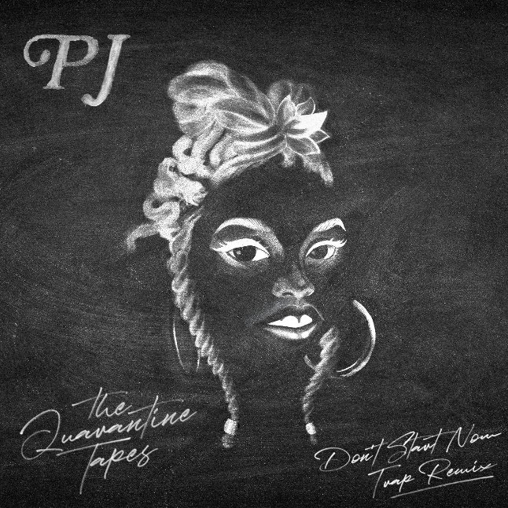
DOWNLOAD HIGH-RES COVER ART HERE

While her pen game has been on point, she has a story to tell by sharing her personal experiences along the way by branching out and creating her own artistry.
RESPECT MAGAZINE

Keep your eye on PJ; she’s nothing short of a star.
MEFEATER

Atlantic recording artist PJ continues to keep busy with her colorful cover series titled The Quarantine Tapes. Today she released a cover of Dua Lipa’s “Don’t Start Now” available HERE. Last week’s Quarantine Tape was an incredible cover medley of Justin Beiber’s “Intentions/Yummy;” listen HERE. The week prior, PJ debuted her series with a cover of labelmate Roddy Ricch’s breakout single “High Fashion;” listen HERE. The R&B songstress also shared her day-to-day in quarantine with the Recording Academy in their latest installment of the Quarantine Diaries; read HERE.

The tail end of 2019 saw PJ busy at work with SoundCloud exclusive singles and a partnership with UPROXX titled Penned By PJ. PJ broke down her singles “Run For Your Money,” “Smoke,” and “Honest,” showcasing her creative and artistic processes. The decorated single “Run For Your Money” received an exclusive premiere on okayplayer and ran alongside an in-depth profile piece.

The Soundcloud exclusives follow on the heels of “My Best Life,” available for streaming HERE. The track was joined by a companion video, directed by acclaimed director child., streaming HERE. PJ kicked off the summer with her breakout single “One Missed Call,” available to stream HERE. The track is joined by an official video, streaming HERE following an exclusive premiere via Essence, which wrote, “One Missed Call' is a colorful nod to Stevie Wonder…The singer’s vibrant video features dancing, tons of black girl magic, and a message to listen to your intuition.”

CONNECT WITH PJ
OFFICIAL | FACEBOOK | TWITTER | INSTAGRAM | YOUTUBE

FOR ADDITIONAL PRESS ASSETS, VISIT HER PRESS SITE HERE

PRESS CONTACT
Brittany Bell | Brittany.Bell@atlanticrecords.com

