FOR IMMEDIATE RELEASE
APRIL 30TH, 2020

TAYLA NEEDS TO TALK IN LATEST “COUCHED WITH TAYLA PARX”
GRAB A FRONT-ROW SEAT TO TAYLA’S LIVING ROOM SETS HERE

THE SONGSTRESS RECENTLY TALKED LIVE MUSIC WITH INDUSTRY
GATEKEEPERS VIA NPR’S WAMU THE 1A

MULTIPLE GRAMMY® AWARD NOMINATED SINGER-SONGWRITER
PLAYED EXCLUSIVE ACOUSTIC SET ON THE DIGITAL FADER FORT

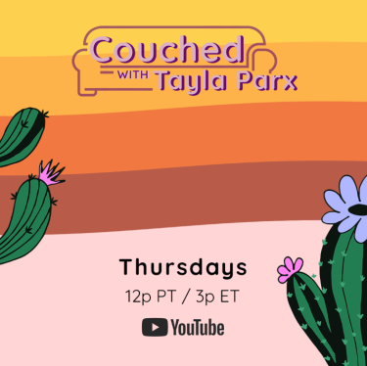
DOWNLOAD HIGH-RES PRESS ASSETS HERE

Multiple GRAMMY® Award-nominated recording artist Tayla Parx is back with the third installment of her personalized fill-in for Coachella, Couched with Tayla Parx, a personalized fill-in for Coachella. Parx invites fans to grab a front row seat to her vibrant living room sets for the six-episode Coached with Tayla Parx series via YouTube Thursdays at 12p PT / 3p ET. Watch the third episode, ‘We Need To Talk,’ HERE.

Last week, Couched with Tayla Parx saw the incredible songstress perform the fan favorite hit “Homiesexual.” Watch the second performance HERE. The series debut episode ‘Dirt’ is also available to stream HERE.

Last week Tayla Parx chatted with August Brown (LA Times) and Will Eastman (U Street Music Hall) on NPR’s WAMU The 1A. The industry gatekeepers discussed the direction of live music. Listen to the riveting conversation HERE. Entertainment Weekly hosted Tayla Parx last Friday for a live conversation during EW’s Songwriters Camp #UnitedAtHome. Check out her exclusive acoustic performance on The Fader’s Digital Fader Fort; listen to her at-home medley of “Dirt,” “Tomboys Have Feelings Too,” and “Easy” HERE.

Parx spent the beginning of 2020 on her debut headline tour, We Need To Talk Tour, which kicked off in her hometown of Dallas, TX and traveled through the U.S. and Europe. The singer-songwriter also partnered with Florida Georgia Line to release a genre-busting new single, “Fight,” available for streaming and download HERE. The track is joined by an official lyric video, streaming now via Parx’s official YouTube channel HERE. The Eye series hosted Parx for an exclusive performance of “Fight” and her break-out single “Me vs Us” via YouTube.

As its name suggests, the headline tour celebrated Parx’s acclaimed debut album, We Need To Talk, available now via Tayla Made/Atlantic at all DSPs and streaming services HERE. Hailed by Entertainment Weekly for possessing “equal parts swagger and vulnerability,” the album includes an array of acclaimed tracks including “Rebound (Feat. Joey Bada$$),” “Me Vs. Us,” “Slow Dancing,” and the hit single, “I Want You,” all joined by companion visuals streaming now at Parx’s official YouTube channel HERE. She has received a remarkable range of press coverage throughout her busy career, with profiles and features in such high profile publications as Vogue, Billboard, NYLON, High Snobiety, and more. Recent highlights include PAPER naming Parx to its “100 People Taking Over 2019” list, while Entertainment Weekly simply hailed her as “one of pop music’s go-to songwriters.” Parx has been “cutting a meticulous yet low-key warpath through popular music on a personal quest to land a No. 1 single on every genre chart,” wrote The New York Times, noting that it’s a “lofty goal that’s no longer far-fetched.”

As if all that weren’t enough, Parx – who traveled North America as special guest on Lizzo’s Cuz I Love You Tour and Anderson .Paak’s ABC Tour – recently launched Burnout, a landmark new songwriting camp with the important aim of fostering perspective, balance, and self-care for creative artists. The premiere Burnout camp was held in Brooklyn, NY this past October, with further camps planned. For additional information, please visit https://twitter.com/blazingburnout.

CONNECT WITH TAYLA PARX
OFFICIAL | INSTAGRAM | YOUTUBE | TWITTER | FACEBOOK

CONTACT
Brittany Bell | Brittany.bell@atlanticrecords.com
Chandler Owen (TOUR) | chandler.owen@atlanticrecords.com

For additional press assets, visit her press site:
https://press.atlanticrecords.com/tayla-parx/

