FOR IMMEDIATE RELEASE
MAY 1ST, 2020

SKOOLY IS READY TO “GO”

T.R.U. ARTIST REVEALS LATEST, OFFICIAL SINGLE OFF FORTHCOMING PROJECT
STREAM/DOWNLOAD “GO” HERE

MULTILAYERED SINGER & RAPPER TO RELEASE FULL-LENGTH
NOBODY LIKES ME ON MAY 22ND

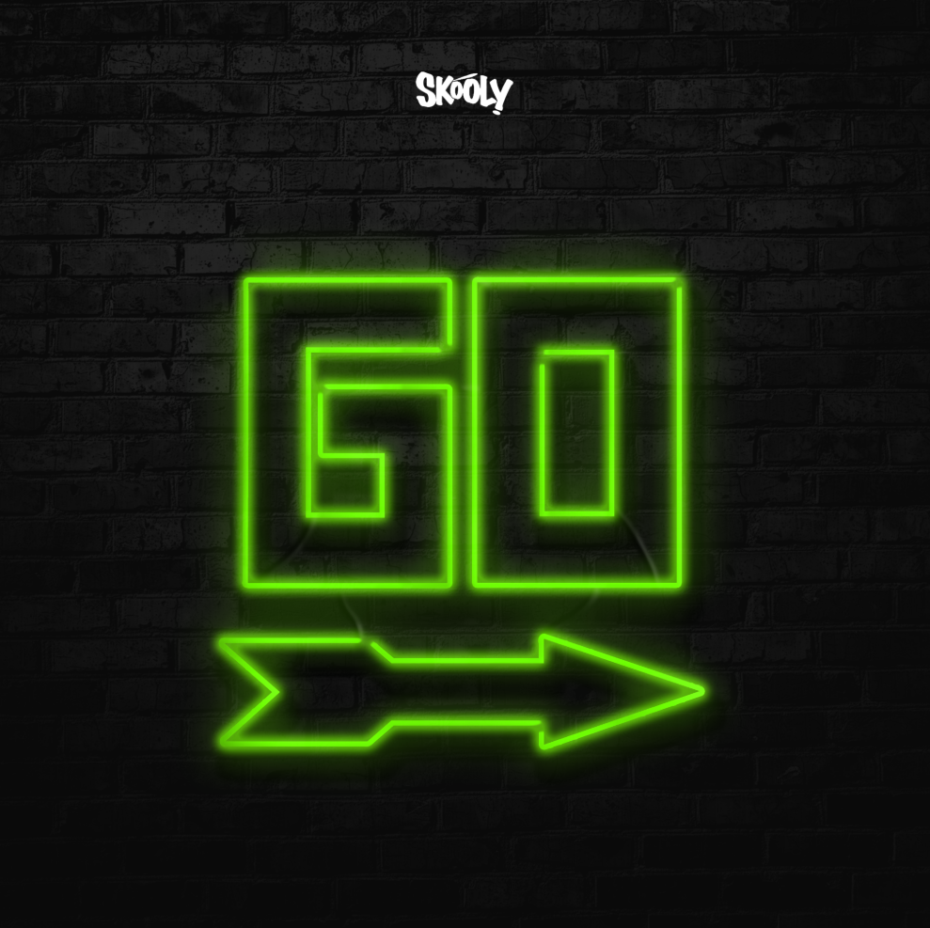
DOWNLOAD HIGH-RES SINGLE COVER ART HERE

The Atlanta artist’s voice—somewhere between nasally snarl and warped trill—splits an imaginary line that divides swag rap and contorted R&B. It was his calling card long before the rise of so-called “weirdo” rappers who wanted in on the magic of melody.
PITCHFORK

Skooly's one of Atlanta's best-kept secrets. Although he hasn't broken into a mainstream artist, he's connected with -- and possibly influenced -- many of the greatest exports out of the ATL in recent times.
HOTNEWHIPHOP

At 25, Skooly can already be considered a young OG in the rap game. Hailing from the westside of Atlanta, he helped start ATL’s buzzing rap group Rich Kidz 11 years ago as a 14-year-old rapper on the rise. Since then, his steady flow of new slaps has made him an unforgettable force in the area. Credited with influencing a few of the waves to come out of the ATL…
XXL

Today T.R.U. (The Real University) recording artist Skooly released the first single off his forthcoming project, “Go” (listen HERE). The past weeks have seen Skooly setting the table with appetizer tracks ahead of his anticipated full-length effort, Nobody Likes Me. Last week, the tested Atlanta singer and rapper dropped “Nasty” alongside its Next Friday-inspired companion visual. That release was preceded by the objective “Mulatto” and the official video he co-directed. Prior to its release, Skooly debuted the timely “Coachella” and its accompanying video on the would-be first weekend one of the Southern California festival.
Earlier this season, Skooly and the T.R.U. collective released their No Face No Case album, a 15-track compilation project highlighting street-certified talent from Atlanta’s various zones. Skooly kicked off the imprint’s weekly #TRUsday series on the stylish “Virgil Discount,” where showcased his quintessential along street executive 2 Chainz. Other #TRUsday releases included the bouncy “Pop Off” and the spirited “How I Feel” remix with Quando Rondo and NoCap. The dexterous artist can also be heard flexing with Quavo on the album cut “Reliable,” as well as a frenetic feature on the T.R.U. posse cut “Jefe Shit.”

Praised by Pitchfork for “changing the way Atlanta rapped,” the XXL Freshman hopeful has crafted a distinctive sound “that splits an imaginary line that divides swag rap and contorted R&B.” In addition to collaborations spanning Future to Young Thug, the well-connected Rich Kidz co-founder has maintained a devout following with a consistent supply of features, collaborations, and original music like his Blacc Jon Gotti mixtape and Don’t You Ever Forget Me series. Skooly was recruited in 2019 by GRAMMY® Award-winning t/rapper 2 Chainz to join his record label T.R.U. (The Real University) comprised of a vanguard of Atlanta hip-hop talent including Skooly, Sleepy Rose, Hott LockedN, and Worl. T.R.U. would announce its partnership with Atlantic Records that fall with the alarming “Shoot It Out” ahead of their full-length album which represented “a sonic vision that highlights the Atlanta sound” (Hot New Hip Hop).

“I know Skooly is a superstar,” says 2 Chainz. “I’ve been watching him since he was about 14 in Atlanta. As a little kid, he had a Lil Wayne vibe. I’m staying down with him. He’s 25-years-old, and he’s nowhere near his peak. He really knows where to sing and where to put the bars down.”

CONNECT WITH SKOOLY
Instagram | Twitter | YouTube | SoundCloud

SKOOLY PRESS CONTACT
Brittany Bell | Brittany.Bell@atlanticrecords.com

T.R.U. PRESS CONTACT
Fairley McCaskill | Fairley.McCaskill@atlanticrecords.com

