FOR IMMEDIATE RELEASE
MAY 14TH, 2020

HOUSTON ARTIST DON TOLIVER GIVES BACK TO HIS CITY

RAPPER PROVIDED 300 MEALS TO FRONTLINE WORKERS IN HIS NATIVE CITY
ALONGSIDE HOUSTON MAYOR + CONGRESSWOMAN

PARTNERED WITH LOCAL RESTAURANT LOST & FOUND MIDTOWN AT UMMC

CLICK HERE FOR PHOTOS | CLICK HERE FOR VIDEO RECAP

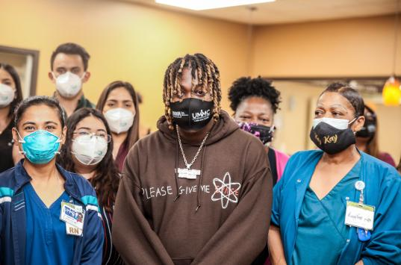

On March 12th, Houston artist Don Toliver provided 300 prepared lunches for frontline workers at UMMC alongside Congresswoman Sheila Jackson Lee with support from Houston Mayor Sylvester Turner. They partnered with local restaurant Lost & Found Midtown to give back to essential workers as a thank you for their unwavering courage during this difficult time.

“The COVID-19 pandemic has hit underserved populations and communities of color particularly hard,” says Congresswoman Lee. “Vulnerable communities, particularly African Americans, are dying everyday due to COVID-19. The most recent report shows 1,369,496 infections and 80,653 deaths in the United States, while Texas has 38,869 infections and 1,088 deaths and Harris County has 7,878 infections and 172 deaths. The fight for testing, testing, testing is crucial, and it cannot be achieved without outstanding medical teams and medical teams supported by a strong hospital like United Memorial Medical Center. Testing, data collection, contact tracing, and hospital care are all provided by dedicated medical providers who are clearly on the front lines helping save lives and continue to provide people with testing, testing, testing to fight this deadly virus.”

“The frontline workers at UMMC, along with other health professionals, have done a great job with COVID-19 testing throughout the community. I am grateful that recording artist Don Toliver visited Houston to recognize these selfless medical providers,” notes Houston Mayor Sylvester Turner. “Testing is crucial as we focus on saving lives during the pandemic, especially the lives of our seniors, at-risk and vulnerable populations. I recently got tested, and I encourage everyone to get tested, wear facial coverings and practice social distancing. We are in this fight together, and we cannot win the fight without compassionate people on the frontlines and without caring benefactors like Don Toliver who realize that these medical providers are saving lives.”

Click HERE for photos of the event and check out for a full video recap HERE. Please credit Roderick Jordan for all images.

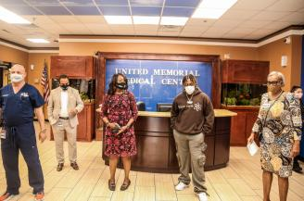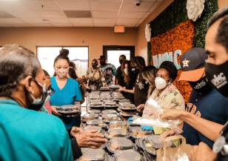

The Houston artist recently dropped his debut album Heaven or Hell, which garnered critical praise. “The whole project makes one thing very clear: He’s a star who will be around for a long time,” notes Complex. Apple recently featured him as their Up Next Artist. HYPEBEAST considers the album “a high energy testament to his rising status in the hip-hop world and smartly incorporates live audio from his album release party.” The album follows Don Toliver’s breakout performance on the Cactus Jack Billboard #1 album JACKBOYS and the viral hit single “No Idea.” In the midst of its success, Toliver dropped Heaven or Hell (CHOPNOTSLOP Remix) album on Travis Scott’s Cactus Jack Label (Cactus Jack/Atlantic.) It’s the chopped and screwed version of his previously released debut album Heaven Or Hell. Notable DJs on the album include DJ Candlestick , OG Ron C + The Trapstars.

PRESS CONTACT
BRITTANY BELL | BRITTANY.BELL@ATLANTICRECORDS.COM

