FOR IMMEDIATE RELEASE
MAY 22ND, 2020

SKOOLY CLAIMS NOBODY LIKES ME IN FULL-LENGTH LP

T.R.U. ARTIST DROPS HIGHLY-ANTICIPATED 18-TRACK LP

FEATURES INCLUDE LIL BABY & 2 CHAINZ WITH PRODUCTION
FROM TAY KEITH, CHOPHOUZE & MORE

NOBODY LIKES ME AVAILABLE TO STREAM/DOWNLOAD:
SKOOLY.LNK.TO/NOBODYLIKESME

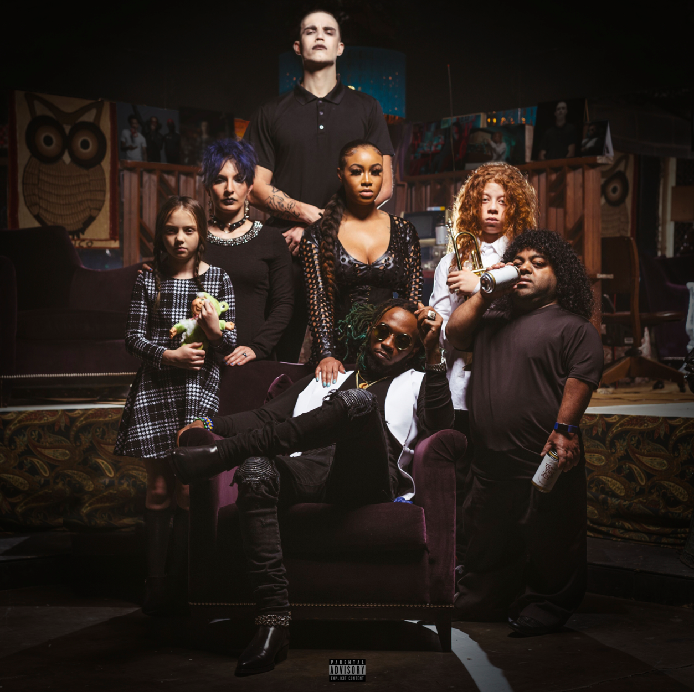
DOWNLOAD HIGH-RES COVER ART HERE

The Atlanta artist’s voice—somewhere between nasally snarl and warped trill—splits an imaginary line that divides swag rap and contorted R&B. It was his calling card long before the rise of so-called “weirdo” rappers who wanted in on the magic of melody.
PITCHFORK

Skooly's one of Atlanta's best-kept secrets. Although he hasn't broken into a mainstream artist, he's connected with -- and possibly influenced -- many of the greatest exports out of the ATL in recent times.
HOTNEWHIPHOP

Skooly’s steady flow of new slaps has made him an unforgettable force in the area. Credited with influencing a few of the waves to come out of the ATL…
XXL

T.R.U. (The Real University) recording artist Skooly today drops Nobody Likes Me, the long-awaited full-length album from the tested Atlanta rapper. The 18-track LP features Lil Baby and 2 Chainz with production from Tay Keith, Chophouze, and more. Nobody Likes Me is available now to stream and download HERE. Earlier this month, Skooly dropped the album’s debut single “Go,” stream the track HERE and watch it’s electric visual companion HERE.

Skooly celebrated the release of Nobody Likes Me with an incredible album listening party and viewing of his documentary at Atlanta’s legendary Startlight Drive-In Theatre. Fans were able to enjoy his new musical effort in the safest way possible – from the comfort of their cars. The past weeks have also seen Skooly setting the table with appetizer tracks ahead of Nobody Likes Me. The tested Atlanta singer and rapper dropped “Nasty” alongside its Next Friday-inspired companion visual. That release was preceded by the objective “Mulatto” and the official video he co-directed. Prior to its release, Skooly debuted the timely “Coachella” and its accompanying video on the would-be first weekend one of the Southern California festival.

ABOUT SKOOLY
Without bragging or boasting, Skooly quietly instigated one wave after another in his hometown of Atlanta. As a result, he left an indelible mark on the game evidenced by tens of millions of streams and glowing critical praise with Pitchfork even arguing he, “Changed the way Atlanta rapped.” At 14-years-old, he introduced himself to the culture as part of the influential group Rich Kidz. Among Straight Like That 1 & 2 [2011] and Everybody Eat Bread [2012], he turned up in the studio alongside icons such as Ludacris, Young Thug, and more. His voice would be heard by billions on instantly recognizable tags for like London On Da Track’s (“We got London On Da Track”). After solo success on the 2015 mixtape Blacc John Gotti, the Don’t Ever Forget Me trilogy, and a series of fiery singles, he ignites the next phase with his T.R.U. and Atlantic Records debut mixtape, Nobody Likes Me.

Setting the stage for the project, Skooly shined on the T.R.U. collective’s 2020 debut compilation, No Face No Case. His energy spiked through tracks like “Reliable” [feat. Quavo], “Jefe Shit,” “Pop Off,” “How I Feel” [feat. Quando Rondo & NoCap], and “Virgil Discount” [feat. 2 Chainz], the latter eclipsing 17 million streams and counting. In addition to plugs from GQ, Sway’s Universe, Genius, MTV, The Breakfast Club, and more, XXL deemed them one of “8 Rising Rap Crews You Need On Your Radar.” Riding this wave, Skooly comments on his place in the game and secures his future with Nobody Likes Me introduced by the single “Go” and highlighted by bangers like “Never Know” [feat. Lil Baby].

“I know Skooly is a superstar,” says 2 Chainz. “I’ve been watching him since he was about 14 in Atlanta. As a little kid, he had a Lil Wayne vibe. I’m staying down with him. He’s 25-years-old, and he’s nowhere near his peak. He really knows where to sing and where to put the bars down.”

TRACKLISTING
  - American Made (prod: MarioBeats)
  - Opp Boy (prod: Tay Keith)
  - Neva Know feat. Lil Baby (prod: Chophouze)
  - Talented (prod: Uncle Bari)
  - Go (prod: MarioBeats)
  - Soul Search (prod: Big A and Big Zar)
  - Nobody Likes Me (prod: JayTheGreat)
  - Imposter (prod: MikeMvjor and NoiseByNick)
  - Different (prod: JayTheGreat)
  - GOAT (prod: Quay Global)
  - Box Chevy feat. 2 Chainz (prod: Quay Global)
  - Late Night Tease (prod: Mike Mixer, Dun Deal and Eliot)
  - Turned Into A Villain (prod: Ceeo)
  - Genocide (acoustic) feat. Harp Szn
  - Lil Boy Shit (prod: Quay Global) *BONUS*
  - Pop Off (prod: Chophouze) *BONUS*
  - Virgil Discount feat. 2 Chainz (prod: June The Jenius, AJ Costly and Cubeatz) *BONUS*

CONNECT WITH SKOOLY
Instagram | Twitter | YouTube | SoundCloud

SKOOLY PRESS CONTACT
Brittany Bell | Brittany.Bell@atlanticrecords.com

