FOR IMMEDIATE RELEASE
MAY 28, 2020

TAYLA PARX DOESN’T WANT TO “DANCE ALONE”

MULTIPLE GRAMMY® AWARD NOMINATED SINGER-SONGWRITER
UNVEILS JOYOUS NEW SINGLE OFF FORTHCOMING ALBUM
LISTEN TO “DANCE ALONE” HERE

OFFICIAL LYRIC VIDEO STREAMING NOW HERE

REWATCH SEASON TWO OF COUCHED WITH TAYLA PARX HERE

EAGERLY AWAITED NEW ALBUM, COPING MECHANISMS, DUE LATER THIS YEAR

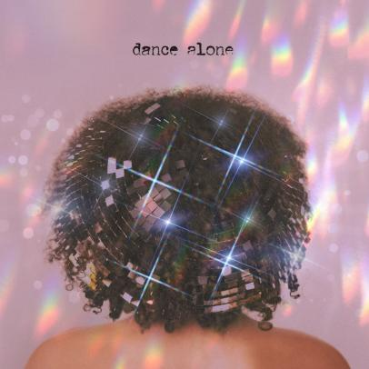
DOWNLOAD HIGH-RES ARTWORK + ASSETS HERE

Multiple GRAMMY® Award-nominated recording artist Tayla Parx is back with the highly-anticipated debut single “Dance Alone” off her forthcoming album Coping Mechanisms, set for release later this year. The ebullient new single is available now via TaylaMade/Atlantic at all DSPs and streaming services HERE; the high-spirited track is joined by an official lyric video and streaming now via YouTube HERE.

“Dance Alone is about that deep desire to connect with someone in order to cope,” notes Parx. “We all have that special someone who makes us feel things where we literally ache for them or feel for them. It’s about human connection, which we all desperately need right now, and how we realize we are not alone.”

Co-written by Parx and GRAMMY® Award-winner Kameron Glasper (Babyface, Tyrese) and Lara Andersson, and produced by Jeff “Gitty” Gitelman (H.E.R., J. Cole, Mac Miller) and Oscar Görres (The Weeknd, Taylor Swift, Charli XCX) at Parx’s own Grey Noise Studios in New York City, the natural joy of “Dance Alone” heralds Parx’s eagerly anticipated new album, COPING MECHANISMS, due to arrive at long last later this year. Additional new music releases will follow in the coming weeks.

Over the past few months, Parx continued her hugely popular at-home performance series, Couched With Tayla Parx, filmed live in Tayla's living room. Watch the personalized fill-in for Coachella via her YouTube channel HERE. Episodes include amazing performances of her hit singles “Dirt,” “Homiesexual,” “Rebound,” and more.

Parx – who kicked off 2020 with her first ever U.S. headline tour, dubbed the “We Need To Talk Tour” – has made a number of exclusive appearances in recent weeks, including a living room acoustic set for The FADER’s Digital FORT as well an exclusive conversation on NPR and WAMU 88.5’s 1a discussing the future of live music in the post-pandemic future (streaming HERE).

Last year saw Parx team with Florida Georgia Line for the genre-busting single, “Fight (Feat. Florida Georgia Line),” available for streaming and download HERE. The track is joined by an official lyric video, streaming now via Parx’s official YouTube channel HERE. “Fight (Feat. Florida Georgia Line)” quickly reaped critical attention, with Consequence of Sound raving, “The track has all the twang you’d expect from a country pop swayer, but Parx finds a unique way to put her own sensibilities on the style.”

Furthermore, 2019 saw the release of Parx’s acclaimed debut album, WE NEED TO TALK, available now via TaylaMade/Atlantic at all DSPs and streaming services HERE. Hailed by Entertainment Weekly for possessing “equal parts swagger and vulnerability,” the album includes an array of acclaimed tracks including “Rebound (Feat. Joey Bada$$),” “Me Vs. Us,” “Slow Dancing,” and the hit single, “I Want You,” all joined by companion visuals streaming now at Parx’s official YouTube channel HERE.

A 2019 GRAMMY® Award nominee and the first female songwriter to have three simultaneous top 10 songs – Ariana Grande’s “7 Rings” and “thank u, next” and Panic! At The Disco’s “High Hopes” – in the Billboard “Hot 100” since 2014, Parx has received a remarkable range of press coverage throughout her busy career, with profiles and features in such high profile publications as Vogue, Billboard, NYLON, High Snobiety, and more. Recent highlights include PAPER naming Parx to its “100 People Taking Over 2019” list, while Entertainment Weekly simply hailed her as “one of pop music’s go-to songwriters.” Parx has been “cutting a meticulous yet low-key warpath through popular music on a personal quest to land a No. 1 single on every genre chart,” wrote The New York Times, noting that it’s a “lofty goal that’s no longer far-fetched.”

As if all that weren’t enough, Parx – who last year traveled North America as special guest on Lizzo’s blockbuster “Cuz I Love You Tour” and Anderson .Paak’s sold out “ABC Tour” – recently launched Burnout, a landmark new songwriting camp with the important aim of fostering perspective, balance, and self-care for creative artists. The premiere Burnout camp was held in Brooklyn, NY this past October, with further camps planned for the coming months. For additional information, please visit https://twitter.com/blazingburnout.

CONNECT WITH TAYLA PARX
OFFICIAL | INSTAGRAM | YOUTUBE | TWITTER | FACEBOOK

CONTACT
Brittany Bell | brittany.bell@atlanticrecords.com
Chandler Owen (TOUR) | chandler.owen@atlanticrecords.com

