ROB VICIOUS, OHGEESY, AND FENIX FLEXIN ROCK WITH LIL BOAT ON A TRAP-HAPPY NEW SINGLE

BUY/STREAM "RIDE OUT" FT. LIL YACHTY:
HTTPS://SHORELINE.LNK.TO/RIDEOUT

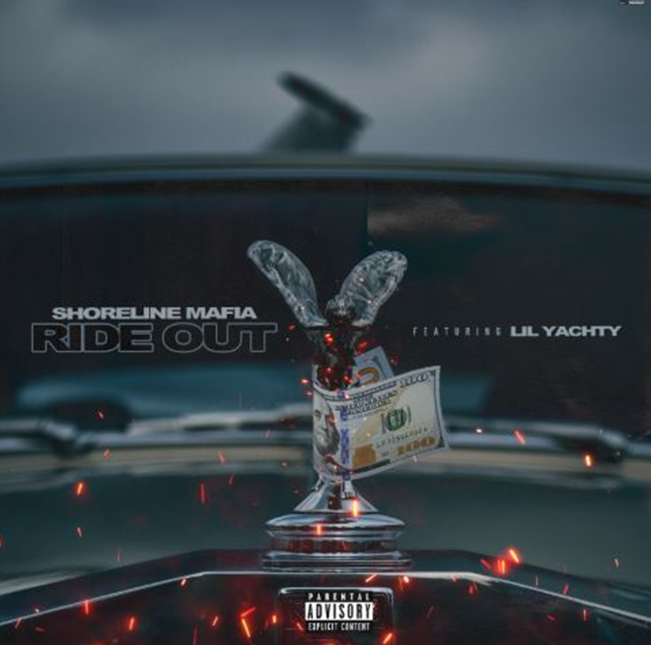

"After dropping a terrific debut album last November — a stylish bundle of songs that somehow felt nonchalant and meticulous at once — Shoreline Mafia has since become one of the most fascinating acts in a resurgent L.A. rap scene. And on Saturday night, the [collective's] chemistry was something you could practically reach out and touch. These guys love rapping, and even more than that, they love rapping with each other." - Washington Post

Shoreline Mafia is leading L.A.’s unruly rap renaissance." - The FADER

Specializing in party anthems of all shapes and sizes, Shoreline Mafia turn heads from coast to coast. Today, the L.A. collective shares "Ride Out," a cross-regional new banger. Marked by paranoid keys, buoyant 808s, and crisp handclaps, "Ride Out" complements chaotic production with blasé bars from three Shoreline Mafia members and Lil Yachty, who delivers a memorable hook without the assistance of auto-tune. The song is packed with quotable moments, as Rob Vicious skrrts in his brand new Tesla, OhGeesy unleashes some drugged-out catchphrases, and Fenix Flexin gives a stern warning to the opps.
"Ride Out" is Shoreline Mafia's second single of 2020, following the Too $hort-flipping tomper "Gangstas & Sippas" ft. Q Da Fool. With over 3.2 million plays on Spotify alone on the track, Shoreline Mafia shared an animated video for "Gangstas & Sippas" last week. At the start of the year, OhGeesy lent a standout verse to "Hella Neck," the new single by Carnage, which also features Tyga and Takeoff. Earlier this month, Rob Vicious shared his new mixtape Breakthrough, which featured production from Three 6 Mafia's DJ Paul and a guest appearance from Fenix Flexin.
The pulse of Los Angeles loudly echoes through its rap crews. In the late eighties, N.W.A. reflected the pre-riot tension of a city on the brink of total collapse. Cypress Hill finally gave the Latin community (and smokers everywhere) a seat at the pop culture table throughout the nineties. Odd Future magnified the skate mayhem of the Fairfax district in the aughts. That brings us to Shoreline Mafia. Since formally launching in 2016, the collective of four diverse, dynamic, and dangerous talents— OhGeesy [Alejandro Coranza], Rob Vicious [Robert Maggee], Fenix Flexin [Fenix Ryinski], and Master Kato [Malik Carson]—went from popular Soundcloud uploads to selling out arenas and picking up platinum plaques. The group has garnered unanimous acclaim from Pitchfork, The FADER, Forbes, The Washington Post, Noisey, and more, and racked up more than 2 billion streams by 2020.

CONNECT WITH SHORELINE MAFIA
official site | instagram | twitter | facebook | spotify | youtube | soundcloud

PRESS CONTACT
BRITTANY.BELL@ATLANTICRECORDS.COM

