FOR IMMEDIATE RELEASE

MAY 29, 2020

**4TH & ORANGE KICK OFF SUMMERTIME WITH “STORY OF MY LIFE”**

**ALTERNATIVE ROCKERS DROP POP-TINGED SINGLE**

**LISTEN HERE:** [**4THANDORANGE.LNK.TO/STORYOFMYLIFEPR**](https://nam04.safelinks.protection.outlook.com/?url=http%3A%2F%2F4thandorange.lnk.to%2FStoryOfMyLifePR&data=02%7C01%7CChandler.Owen%40atlanticrecords.com%7Cead8282b15a94e39de6608d8033f8c96%7C8367939002ec4ba1ad3d69da3fdd637e%7C0%7C0%7C637262918756265138&sdata=%2FqNdrcNbIxHE9kVeFI6W653BPIQx2SBrikO8Ide%2BV4I%3D&reserved=0)

**LONG BEACH GROUP ENLIST TOON 53 PRODUCTIONS FOR ANIMATED VISUAL**

**WATCH “STORY OF MY LIFE” VISUAL** [**HERE**](http://4thandorange.lnk.to/StoryOfMyLifePR/youtube)

**LIVESTREAM PERFORMANCE ANNOUNCED ON STASH BASH ON JUNE 5TH**

**WATCH THEIR ENERGETIC 30-MINUTE SET AT 6:15PM PT/ 9:15PM ET**

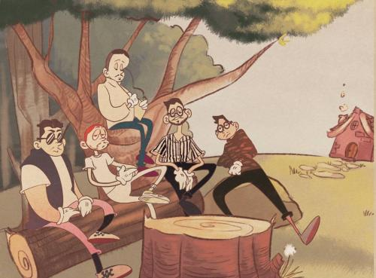

[*DOWNLOAD HIGH-RES COVER ART + PRESS PHOTOS*](https://press.atlanticrecords.com/4th-orange/)

Spreading sunshine the Long Beach way, **4th & Orange** is back with “**Story of My Life**.” The alternative, pop-tinged single arrives alongside a nostalgia-inspired animation visual by the incredible Toon 53 Productions. Watch the [incredible visual](http://4thandorange.lnk.to/StoryOfMyLifePR/youtube) via YouTube, streaming now. “Story of My Life,” produced by **Lucas Secon (Britney Spears, Christina Aguilera**), is available today to stream and download at all DSPs and streaming services [HERE](http://4thandorange.lnk.to/StoryOfMyLifePR).

4th & Orange today also announce their livestream set next Friday, June 5th at the **Virtual Stash Bash.** The online festival is hosted out of Boston, MA and sponsored by [Revolutionary Clinics](https://nam04.safelinks.protection.outlook.com/?url=https%3A%2F%2Fwww.revolutionaryclinics.org%2F&data=02%7C01%7CChandler.Owen%40atlanticrecords.com%7C3be85ccf7eff4d9ef56808d80317fe54%7C8367939002ec4ba1ad3d69da3fdd637e%7C0%7C0%7C637262748884736972&sdata=7vl1WDkxfYdWoGBuyCAgXa%2BGQ0EltVI41%2FsR3VVdMUI%3D&reserved=0), [DO617](https://nam04.safelinks.protection.outlook.com/?url=https%3A%2F%2Fwww.facebook.com%2FDo617%2F&data=02%7C01%7CChandler.Owen%40atlanticrecords.com%7C3be85ccf7eff4d9ef56808d80317fe54%7C8367939002ec4ba1ad3d69da3fdd637e%7C0%7C0%7C637262748884736972&sdata=O35jpu29i1UiYRxwkn2eWMUJB3G6kG2ociPOTNSMYYU%3D&reserved=0), [Secret Boston](https://nam04.safelinks.protection.outlook.com/?url=https%3A%2F%2Fwww.facebook.com%2FSecretBoston%2F&data=02%7C01%7CChandler.Owen%40atlanticrecords.com%7C3be85ccf7eff4d9ef56808d80317fe54%7C8367939002ec4ba1ad3d69da3fdd637e%7C0%7C0%7C637262748884746969&sdata=IFCiHvFoiJ9%2FQkjOli%2FguETnodWPX3vj4cwKz%2FYZRUA%3D&reserved=0) and more. The event will consist of musical performances, cooking segments,  marijuana product reviews, guest speakers, giveaways and more. 4th & Orange will perform for a thirty-minute set in the 6pm PT / 9pm PT hour. To watch their set, please visit their Facebook page on June 5th. To get excited for this livestream performance, watch their killer headlining set at R**eggae 360’s Ascension Summer Kick Off** virtual festival [HERE](https://www.facebook.com/4thandorange/videos/289739668715332/).

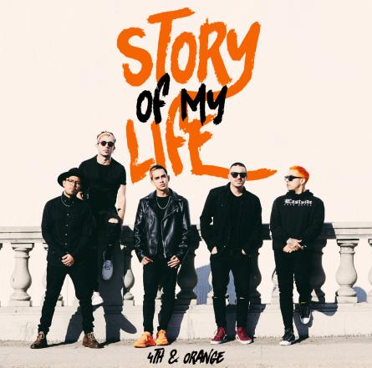

In the midst of the COVID-19 pandemic, 4th & Orange reminded you that this is “**Not the End**” with their latest single. The track pushes positivity and reinforces unity – a ray of sunshine to break up these cloudy times. Listen to “Not the End” [HERE](https://nam04.safelinks.protection.outlook.com/?url=https%3A%2F%2F4thandorange.lnk.to%2FNotTheEndPR&data=02%7C01%7CChandler.Owen%40atlanticrecords.com%7Cf2adaa4c58404c9754dc08d7d6669548%7C8367939002ec4ba1ad3d69da3fdd637e%7C0%7C0%7C637213608421706356&sdata=ZG5idQiUuNmbsTY7VwP6BoqoxeaJb0Xw68ZklejRMCI%3D&reserved=0). 4th & Orange also curated a playlist of their favorite songs to get you through the day; listen to the ***Quarantunes*** playlist [HERE](https://open.spotify.com/playlist/3bbuZKmLBxwMDKiORbltCT?si=-Kd6StiCRWm7oU07fr7qWg). The reggae genre-benders were also seen recruiting fellow Long Beach native **Warren G** for the “In The LBC” remix. Listen to the remix featuring the West Coast hip hop legend [HERE](https://4thAndOrange.lnk.to/WarrenGRmxPR). 4th & Orange released their feel-good Long Beach anthem in February in celebration of their iconic hometown; listen to the original track [HERE](http://4thandorange.lnk.to/InTheLBCPR). Watch the official music video [HERE](https://www.youtube.com/watch?v=gFJsYbWiJtE&feature=youtu.be).

2020 brought a bubbling live performance itinerary. 4th & Orange kicked it off with their festival debut in Long Beach, CA at [One Love Cali Reggae Fest](https://www.onelovecalifest.com/), where they shared the bill with hometown heroes **Sublime with Rome** and reggae legends **Dirty Heads**. Weeks later, the band appeared at Chandler, AZ’s [Arizona Roots Music & Arts Festival](https://arizonarootsfestival.com/4th-and-orange). Their festival performances at **Reggae Rise Up Last Vegas** and **Reggae Rise Up St. Petersburg** will be postponed; festival websites will have all information. 4th & Oranges national tours with **Collie Buddz** and **Natiruts** will also be postponed; visit their website [HERE](https://www.4thandorange.com/tour/) for tour updates.

At the tail end of 2019, 4th & Orange dropped “[Only You](https://atlantic.lnk.to/OnlyYouPr),” which sees the group putting their quintessential SoCal pop-reggae touch on an undisputed classic song. The track dropped alongside an electric [companion visual](https://www.youtube.com/watch?v=YOA4_U5yeiA) directed by **Jose Omar**. They kickstarted the summer of 2019 with their sizzling debut single, “[Girl Next Door](https://atlantic.lnk.to/GirlNextDoorID),” with an [official video](https://www.youtube.com/watch?v=6S9cpWTOYcw) directed by **Michael Garcia** that’s now boasting more than **2.5 million** individual views. The single was swiftly followed by two additional summer smashes in “[No More Favors](https://atlantic.lnk.to/NoMoreFavorsID)” and “[Junky](https://atlantic.lnk.to/JunkyID).”

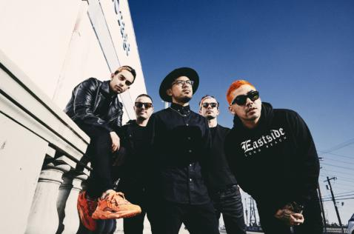

*DOWNLOAD HIGH-RES PRESS PHOTO* [*HERE*](https://press.atlanticrecords.com/4th-orange/)

*PHOTO CREDIT: JIMMY FONTAINE*

**BAND MEMBERS**

Garrett Douglas - Lead Vocals

Chris “DJ Irey” Garcia - Keyboards / Producer

Ricardo Santiago – Guitar

Alex Bursztyn – Bass

Sam Ward – Drums

**CONNECT WITH 4TH & ORANGE**

[INSTAGRAM](https://www.instagram.com/4thandorange/) | [TWITTER](https://twitter.com/4thandorange) | [FACEBOOK](https://www.facebook.com/4thandorange/) | [YOUTUBE](https://www.youtube.com/channel/UClmb8V8yRbLQYWYwinVXBBQ)

*For additional press assets, please visit their press site* [*HERE*](http://press.atlanticrecords.com/4th-orange/)*.*

**PRESS CONTACT**

Chandler Owen | [Chandler.Owen@atlanticrecords.com](mailto:Chandler.Owen@atlanticrecords.com)