FOR IMMEDIATE RELEASE
MAY 29th, 2020

PJ UNVEILS WAITING FOR PARIS

ACCLAIMED R&B SINGER-SONGWRITER RELEASES MUCH-ANTICIPATED NEW EP

INCLUDES PREVIOUSLY RELEASED BREAKOUT SINGLE “COUNTERFEIT”
+ “PRIVATELY” VISUAL AVAILABLE NOW

HIT COVER SERIES, THE QUARANTINE TAPES, CONTINUING NOW VIA SOUNDCLOUD

LIVE PERFORMANCE ON OFFICIAL DR. MARTENS INSTAGRAM SET FOR JUNE 9TH

WAITING FOR PARIS AVAILABLE NOW AT ALL DSPS AND STREAMING SERVICES

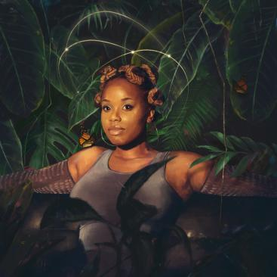
DOWNLOAD HIGH-RES PRESS ASSETS HERE

“While her pen game has been on point, she has a story to tell by sharing her personal experiences along the way by branching out and creating her own artistry.” – RESPECT MAGAZINE

“Keep your eye on PJ; she’s nothing short of a star.” – MEFEATER

Atlantic recording artist PJ has announced today’s release of her eagerly awaited new EP. Waiting For Paris is available now at all DSPs and streaming services. The EP includes the breakout single “Counterfeit,” which is available for streaming now. Watch the official “Privately” visual HERE.

PJ will celebrate WAITING FOR PARIS with an exclusive live performance on the official Dr. Martens Instagram (@drmartensofficial), set for June 9th. In the meantime, the acclaimed R&B songstress will continue her hugely popular cover series, The Quarantine Tapes, streaming now via SoundCloud. Previous installments include unique versions of such hits as Doja Cat’s “Say So,” Dua Lipa’s “Don’t Start Now,” Justin Bieber’s “Intentions/Yummy,” and labelmate Roddy Ricch’s breakout single “High Fashion.” As if that weren’t enough, PJ also recently shared her current day-to-day with the Recording Academy for a recent installment of their ongoing Quarantine Diaries. PJ has been working hand-in-hand with UPROXX on a number of projects, including Penned By PJ, an exclusive series breaking down the story and craft behind her singles, “Run For Your Money,” “Smoke,” and “Honest.” In addition, PJ joined UPROXX’s popular Instagram for the recent Doing My Part W. PJ.

In 2018, embracing a newfound confidence blending pop, soul, and country to create a distinctively original R&B approach she describes simply as “dripping in soul.” Recent singles like “My Best Life“ (watch the official video HERE) and “One Missed Call“ mark an inspiring new era for PJ’s unique artistry. Indeed Essence hailed “One Missed Call” as “a colorful nod to Stevie Wonder,” further praising the track’s “vibrant video” – streaming HERE – for “(featuring) dancing, tons of black girl magic, and a message to listen to your intuition.” As compelling on stage as she is in the studio, PJ has toured alongside such like-minded artists as ELHAE and Pink Sweat$ for his latest 2019 Pink Beginnings 11-city tour run. What’s more, PJ was among the new stars performing last year as part of MTV’s influential PUSH Live concert series. Her single “Steps” recently appeared in the Being Mary Jane season finale in 2019.

Raised in Greensboro, NC, PJ moved to Los Angeles in 2014 and quickly became known as a gifted songwriting talent, with hit tracks for such artists as Charlie Puth (“Left Right Left“), Meek Mill (“I Don’t Know (Feat. Paloma Ford)“), and Wiz Khalifa (“True Colors (Feat. Nicki Minaj)“) among her many credits along with incredible collaborations with G-Eazy, Ty Dolla $ign, and more. Her single, ”Tell Me (Feat. Jevon Doe),” racked up over 3.5 million Spotify streams along with acclaim from Ones to Watch, HipHopDX, and many others.

TRACKLISTING
Privately
Counterfeit
I'm Forreal
Y'Oh
Smoke
Price Went Up

CONNECT WITH PJ
OFFICIAL | FACEBOOK | TWITTER | INSTAGRAM | YOUTUBE

FOR ADDITIONAL PRESS ASSETS, VISIT HER PRESS SITE HERE

PRESS CONTACT
Brittany Bell | Brittany.Bell@atlanticrecords.com

