**Remix: Shoreline Mafia - "Gangstas & Sippas" ft. YG & Q Da Fool**

**L.A.'s Favorite Rap Collective Recruits One of the City's Biggest Stars for a Fiery Remix**

[**shoreline.lnk.to/GSRemix**](http://shoreline.lnk.to/GSRemix)

|  |
| --- |
| **Tune In Saturday at 8PM ET to Watch Shoreline Perform For Monster Energy’s Live On Location Series** |

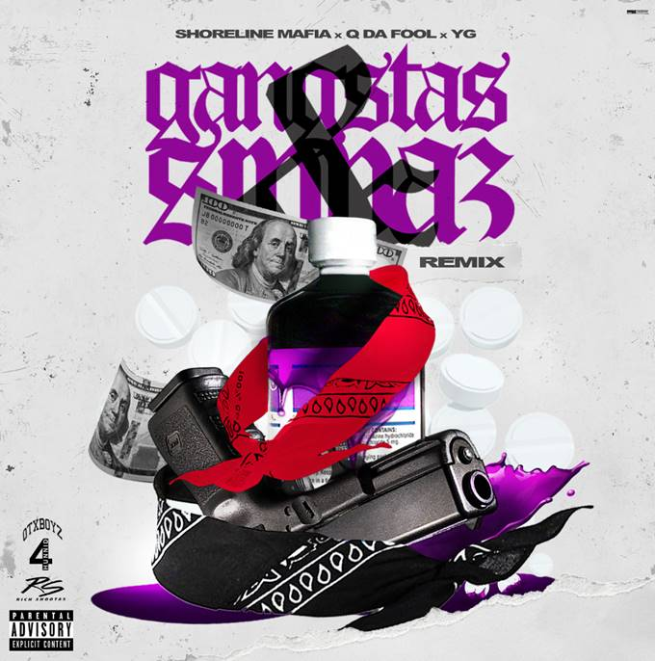

Setting the West Coast ablaze with their party-positive rhymes, **Shoreline Mafia**has the ear of L.A.'s rap royalty. Teaming up with one of their city's biggest stars for an action-packed remix, Shoreline shares **"Gangstas & Sippas" (Remix) ft. YG**. A relentless slapper inspired by a 2008 **Too $hort**'s cult hit, "Gangstas & Sippas" was the first new Shoreline track of 2020, boasting standout verses from **OhGeesy** and **Q Da Fool** and an instantly memorable hook from **Fenix Flexin**. Energized after leading a Black Lives Matter rally on Hollywood Blvd. earlier this month, YG comes correct with his verse, bragging about his come-up and heading to Rodeo Drive with a full wallet. With over 3.2 million plays on Spotify alone on the original track, "Gangstas & Sippas" (Remix) follows **"**[**Ride Out**](https://shoreline.lnk.to/RideOut)," a recent Shoreline Mafia single with a guest spot from **Lil Yachty**. Listen [HERE](http://shoreline.lnk.to/GSRemix).

This Saturday, June 27th, Shoreline Mafia will perform as part of [**Monster Energy's Live On Location**](https://www.youtube.com/playlist?list=PLWX4Jt4X9kyqt6oziZ0xgp3NmAugsLMjK)series of livestreams. Tune in at 8pm ET/5pm PT on [**Monster's official YouTube**](https://www.youtube.com/monsterenergy) to watch members of Shoreline Mafia perform live for the first time since the lockdown started.

The "Gangstas & Sippas" (Remix) is the latest release in the lead-up to ***Mafia Bidness***, the collective's forthcoming debut album. Earlier this week, Shoreline [**invited**](https://www.instagram.com/p/CByKINdJOQU/) eager fans to create their own cover art for the upcoming album, highlighting some of the best examples on their [**Instagram**](https://www.instagram.com/p/CBzOCOkpxSv/). Last month, **Rob Vicious** shared his new mixtape [***Breakthrough***](https://robvicious.lnk.to/Breakthrough), which featured production from **Three 6 Mafia's DJ Paul** and a guest appearance from Fenix Flexin. Fenix is currently preparing to release his first solo project later this year.

**ABOUT SHORELINE MAFIA**

The pulse of Los Angeles loudly echoes through its rap crews. In the late eighties, N.W.A. reflected the pre-riot tension of a city on the brink of total collapse. Cypress Hill finally gave the Latin community (and smokers everywhere) a seat at the pop culture table throughout the nineties. Odd Future magnified the skate mayhem of the Fairfax district in the aughts. That brings us to Shoreline Mafia. Since formally launching in 2016, the collective of four diverse, dynamic, and dangerous talents— OhGeesy [Alejandro Coranza], Rob Vicious [Robert Maggee], Fenix Flexin [Fenix Ryinski], and Master Kato [Malik Carson]—went from popular Soundcloud uploads to selling out arenas and picking up platinum plaques.

**CONNECT WITH SHORELINE MAFIA**

[**official site**](https://www.hellawave.com/) | [**instagram**](https://www.instagram.com/shorelinemafia) | [**twitter**](https://twitter.com/SHORELINEMAFIA) | [**facebook**](https://www.facebook.com/ShorelineMafia/) | [**spotify**](https://open.spotify.com/artist/4tYSBptyGeVyZsk8JC4JHZ) | [**youtube**](https://www.youtube.com/channel/UCTGvupQMw-IokKJ6U9zFgjQ) | [**soundcloud**](http://soundcloud.com/shorelinemafia)