FOR IMMEDIATE RELEASE
JULY 3RD, 2020

SHORELINE MAFIA ANNOUNCES MAFIA BIDNESS, COMING JULY 31ST VIA ATLANTIC RECORDS

L.A.'S FAVORITE RAP COLLECTIVE SHARES "CHANGE YA LIFE," THEIR LATEST SUMMER JAM
LISTEN: SHORELINE.LNK.TO/CHANGEYALIFE

SHORELINE PREPARES THEIR BIGGEST STATEMENT YET, WELCOMING AN ALL-STAR GUEST LIST TO THEIR PARTY-POSITIVE WEST COAST WORLD

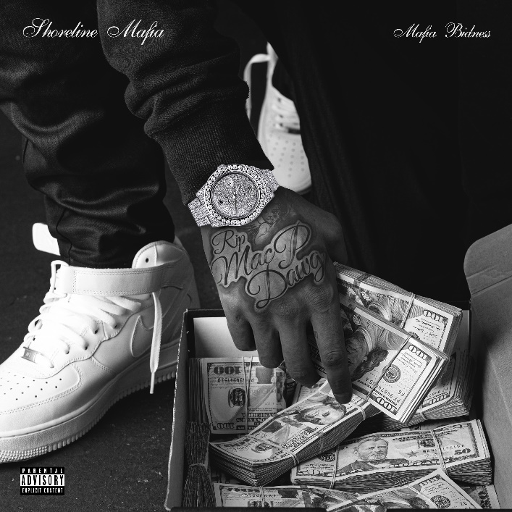

“Shoreline Mafia is leading L.A.’s unruly rap renaissance." - The FADER

One of the most popular hip-hop acts on the West Coast, Shoreline Mafia has accomplished so much since forming in 2018–sold-out tours, platinum plaques, festival headlines, and more. Putting a bow on their meteoric rise, Shoreline announces Mafia Bidness, their highly-anticipated debut album. Working with frequent collaborators and new faces, Mafia Bidness expands and refines the Shoreline sound, offering viciously clever bars atop propulsive instrumentals. Hosted by OhGeesy, Fenix Flexin, Rob Vicious, and Master Kato, the upcoming project fits firmly within the West Coast tradition, offering beats that reference classic hyphy, G-funk, and party rap tracks, bringing hard-hitting L.A. anthems produced by frequent collaborators RonRon and Ace The Face, and furthering the deep connection between flourishing rap scenes in Los Angeles and Detroit. Mafia Bidness hits DSPs on July 31st via Atlantic Records and is now available for pre-order.

Along with the announcement of Mafia Bidness, Shoreline Mafia introduces a new line of merch, featuring two colors of crew necks, a hoodie, a t-shirt, and a button-down emblazoned with "Shoreline" in block letters. Fans can select an item of their choice, bundled with pre-order of the Mafia Bidness album.

To accompany the announcement of the project, Shoreline Mafia shares "Change Ya Life," a glistening new single. Produced by Detroit native Helluva (Tee Grizzley's "First Day Out," Megan Thee Stallion's "B.I.T.C.H."), "Change Ya Life" combines fluttering synths with crisp handclaps and thunderous low-end, creating a compulsive head-nodder. The new song is a two-hander by OhGeesy and Fenix Flexin, as the two emcees brag about their new Benzes and infinite bottles of Dom Perignon. Though the mood is mostly celebratory, Fenix takes time to dwell on the paranoia that comes with newfound riches: "It get tricky when there's n****s eatin' out your pockets/It get tricky when these b*tches know you really got it." "Change Ya Life" joins previous singles "Gangstas & Sippas" and "Ride Out" as instant gratis tracks, available with pre-order of the album.

Mafia Bidness is the culmination of a massive year for Shoreline Mafia. Last week, the crew connected with YG for "Gangstas & Sippas" (Remix), a new version of the Too $hort-sampling, Q Da Fool-featuring slapper. Earlier this year, Shoreline recruited Lil Yachty for the laid-back rider's anthem "Ride Out." Last month, Rob Vicious shared his new mixtape Breakthrough, which featured production from Three 6 Mafia's DJ Paul and a guest appearance from Fenix Flexin. Fenix is currently preparing to release his first solo project later this year. In February, before the COVID pandemic, Shoreline performed their first festival-headlining set at Vancouver's Lil Fest.

Stay tuned for much more information about Mafia Bidness in the coming weeks.

ABOUT SHORELINE MAFIA
The pulse of Los Angeles loudly echoes through its rap crews. In the late eighties, N.W.A. reflected the pre-riot tension of a city on the brink of total collapse. Cypress Hill finally gave the Latin community (and smokers everywhere) a seat at the pop culture table throughout the nineties. Odd Future magnified the skate mayhem of the Fairfax district in the aughts. That brings us to Shoreline Mafia. Since formally launching in 2016, the collective of four diverse, dynamic, and dangerous talents— OhGeesy [Alejandro Coranza], Rob Vicious [Robert Maggee], Fenix Flexin [Fenix Ryinski], and Master Kato [Malik Carson]—went from popular Soundcloud uploads to selling out arenas and picking up platinum plaques.

The group has garnered unanimous acclaim from Pitchfork, The FADER, Forbes, The Washington Post, Noisey, and more, and racked up more than 2 billion streams by 2020.

CONNECT WITH SHORELINE MAFIA
OFFICIAL SITE | INSTAGRAM | TWITTER | FACEBOOK | SPOTIFY | YOUTUBE | SOUNDCLOUD

PRESS CONTACT
Brittany.Bell@atlanticrecords.com

