FOR IMMEDIATE RELEASE
JULY 9, 2020

ABIR, FRAGRANCE OF A FLOWER (عبير), BLOSSOMS WITH “INFERNO”

STUNNING “INFERNO” VISUAL SHOT IN BIRTHPLACE OF MOROCCO OUT TODAY

VISIONARY NEW EP, HEAT, DUE AUGUST 7TH

STREAM/DOWNLOAD “INFERNO”: ABIR.LNK.TO/INFERNOPR

WATCH “INFERNO”: ABIR.LNK.TO/INFERNOVIDEOPR

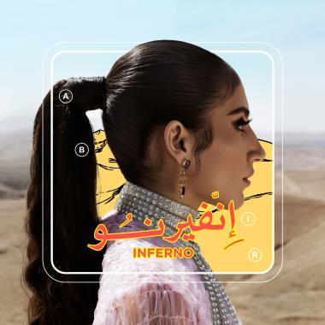
DOWNLOAD HIGH-RES ASSETS HERE

Moroccan-American vocal powerhouse, ABIR makes a bold statement with her new single “Inferno”, along with a stunning visual that was filmed on location in a desert in Marrakesh. “Inferno” celebrates ABIR’s Moroccan roots, while director, Sharif Abdel Mawla, perfectly captures the essence of the “modern Arab woman”, ABIR self-proclaims to be. “Inferno” is available now at all DSPs and streaming services HERE. Watch “Inferno” ABIR’s official YouTube channel HERE.

“Inferno” marks the first single from ABIR’s forthcoming EP, HEAT, slated for a late summer release. With its kinetic beat and lush string arrangement, the track serves as a potent introduction to the EP’s message of finding strength through self-celebration.

“I’m a lot of things a Muslim Arab woman isn’t expected to be,” notes ABIR. “What she looks like, what she does, how she acts, how she feels, what she wants . . . The current narrative is uninformed and it’s honestly fucking boring.”

HEAT sees ABIR infusing modern pop/R&B with the extraordinary sounds of her native Morocco, bridging her two worlds for reasons that extend far beyond simply music. Created in partnership with 2x GRAMMY® Award-nominee Mick Schultz (Rihanna, Kelly Clarkson), the EP is rich with lavish string work, complex rhythms, and commanding melodies, often sculpted with traditional North African instruments. Songs like “Inferno” are gorgeously textured and uniquely powerful, expertly spotlighting the NYC-based artist’s hypnotic vocal presence and intensely personal songcraft. An exclusive “Rebirth“ teaser heralding HEAT can be viewed via YouTube.

“The last year has been such a transitional time as far as really owning my identity,” ABIR says, “and that allowed me to get to the point of making the music I always wanted to make – something that challenges people’s perceptions of what it means to be an Arab woman in the modern world.”

Hailed by Billboard as one of the “most exciting new voices” in recent memory, ABIR has already made a huge impact on contemporary pop, earning acclaim and attention for her sultry fusion of R&B, dance grooves, and intimate lyricism. The Morocco-born, New York City-based artist first broke through with 2018’s “Finest Hour,” her RIAA gold certified collaboration with chart-topping electronic production trio Cash Cash. The track proved one of that summer’s biggest anthems, topping iTunes’ “Dance Songs” chart for eight weeks on its way to the overall Top 40.

ABIR followed the success of “Finest Hour” (RIAA gold certified) with her own remarkable debut EP, MINT (RIAA platinum certified), highlighted by the acclaimed singles, “Tango“ and “Young & Rude.” The latter track earned wide-ranging applause upon its arrival, with Idolator raving, “ABIR is shaping up to be one of the breakout stars of 2018…The amazingly-titled ‘Young & Rude’ (is) an instantly anthemic pop song about letting your hair down and living in the moment. Those themes are conveyed perfectly in the video.”

ABIR has spent much of the past two years expanding her already-significant knowledge of Moroccan music, notably studying the Arabic scale to better integrate it into her own idiosyncratic take on pop and R&B. HEAT represents the culmination of years of growth and self-discovery for ABIR, a remarkable journey that extends to a blossoming new connection with the meaning of her name, an Arabic word (عبير) that translates as “fragrance of a flower.”

“So many things I’ve always talked about doing, I finally got to do with this project,” ABIR says. “I’m so comfortable in my skin, and I just want to share what I represent and what my culture is. I know that we have so much to offer the world, and I’m not afraid to get loud about it.”

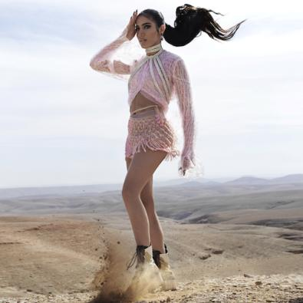
(PHOTO CREDIT: DOMEN & VAN DE VELDE)

For additional press assets, visit her press site press.atlanticrecords.com/abir.

CONNECT WITH ABIR
OFFICIAL |INSTAGRAM| TWITTER | FACEBOOK l YOUTUBE

PRESS CONTACT
FAIRLEY MCCASKILL | FAIRLEY.MCCASKILL@ATLANTICRECORDS.COM

