FOR IMMEDIATE RELEASE
JULY 9, 2021

T.R.U. BREAK OUT ARTIST SLEEPY ROSE IS SITTING “AT THE DINNER”
STREAM | WATCH

T.R.U.’S NO FACE NO CASE AVAILABLE EVERYWHERE HERE

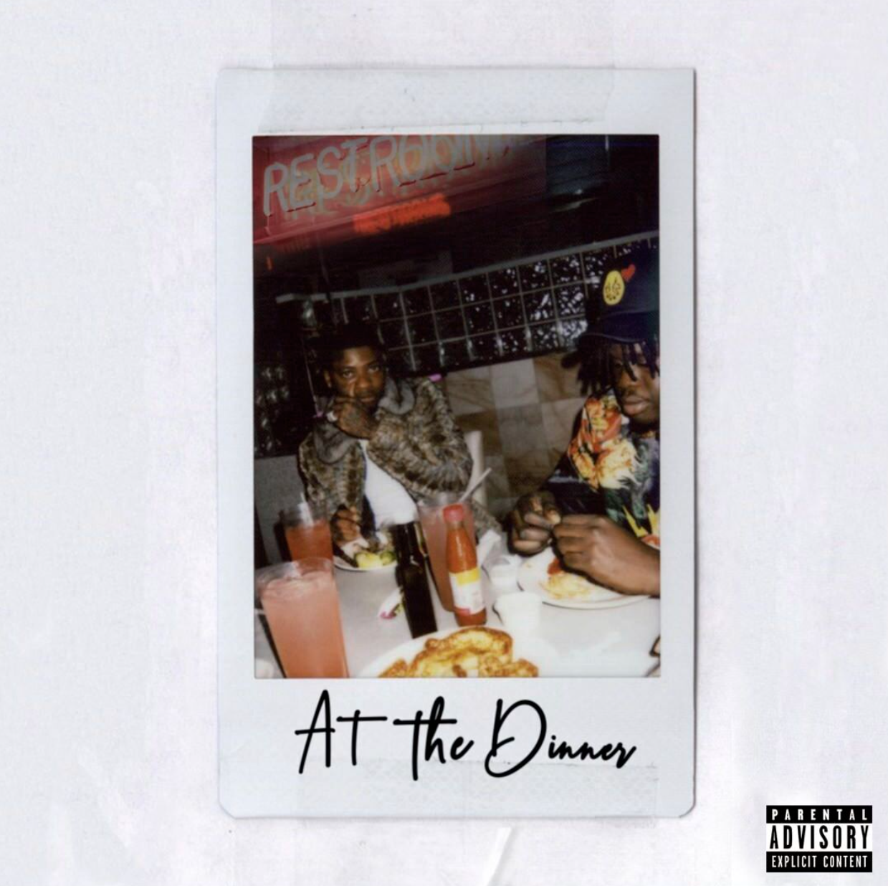
DOWNLOAD ARTWORK | DOWNLOAD PRESS PHOTO, CRED: CAM KIRK

T.R.U. (The Real University) break out artist and 2 Chainz protégé, Sleepy Rose, serves his latest banger “At The Dinner.” Decked out in a mink coat at a smoked-out, hood-luxe dinner table, the Atlanta rapper spits braggadocious bars over a hard-hitting beat produced by Papito. The Howard Ross-directed visual is available now on YouTube. The new track is a follow to Sleepy’s “Woo” and “Georgia” from off of T.R.U.’s 2020 debut compilation, NO FACE NO CASE.

In 2019 2 Chainz launched his T.R.U. label in partnership with Atlantic Records in 2019 with a goal of formally presenting a new vanguard of Atlanta-based hip-hop talent. Kicking off 2020 with the debut compilation album No Face No Case, it arrived amidst a wave of positive reception, including praises from Complex, XXL, Rap Radar, and more. Hot New Hip Hop notes how the crew “joined together to introduce a sonic vision that highlights the Atlanta sound.” No Face No Case featured the #TRUsday series of singles released each Tuesday since the start of 2020, including 2 Chainz & Skooly’s “Virgil Discount,” Sleepy Rose’s “Woo,” Skooly’s “How I Feel (Remix) (Feat. NoCap & Quando Rondo),” and Worl’s “New Levels New Devils.” The 15-track release features additional appearances from NLE Choppa, Quavo and Bear1boss, and also includes the previously released posse-cut “Shoot It Out,” Skooly’s bop “Pop Off,” Sleepy Rose & 2 Chainz’ hometown anthem “Georgia” and Hott LockedN’s menacing “G-Wagon.”

ABOUT SLEEPY ROSE
A tough and turbulent upbringing in the Atlanta neighborhood of Godby Road-Old National College Park molded Sleepy Rose and encouraged him to blossom into a formidable MC who translates his struggles into stories. Locked up for two years, he started rapping by tapping out a beat anywhere—from on his chest to the doors and walls of the jail. Upon his release, he turned heads with his first YouTube upload “Gangsta.” Following the death of his sister whom the family referred to as Rose, he tattooed a rose on his face in tribute and as a reminder: “We rose up out of the gutter. A rose keeps going high too.”

He sharpened a signature sound punctuated by local lingo on “Where You From,” “Striking” and “Mhmm.” Growing up on the same block as Hott LockedN, 2 Chainz flew both MCs to Los Angeles for an explosive session and signed them both to T.R.U. (The Real University) in 2019. T.R.U. provides a home to a rising vanguard of hip-hop talent and posits a platform for personal success as well. In partnership with Atlantic Records, the Atlanta-based label imprint includes flagship artists: Skooly, WORL, Hott LockedN, and Sleepy Rose. Sleepy Rose was introduced on the compilation No Face No Case with the first single “Shoot It Out” ft. 2 Chainz, WORL and Hott LockedN.

“Our A&R showed me Sleepy Rose,” recalls 2 Chainz. “I was seeing the visuals and hearing the music. I noticed he had the look, but he really had the music. He came from nothing, and I knew he could make an impact.”

CONNECT WITH SLEEPY ROSE
INSTAGRAM | YOUTUBE | TWITTER | SOUNDCLOUD

CONNECT WITH T.R.U. – THE REAL UNIVERSITY
OFFICIAL | INSTAGRAM | TWITTER | YOUTUBE | SOUNDCLOUD

PRESS CONTACT
FAIRLEY MCCASKILL | FAIRLEY.MCCASKILL@ATLANTICRECORDS.COM

