FOR IMMEDIATE RELEASE
JULY 17, 2020

SHORELINE MAFIA POPS OFF WITH “PERC POPPER”

OHGEESY AND FENIX FLEXIN INDULGE IN THEIR FAVORITE PASTIME
LISTEN TO “PERC POPPER” HERE
WATCH THE VISUALIZER HERE

THE LATEST SINGLE FROM THE L.A. COLLECTIVE'S UPCOMING PROJECT MAFIA BIDNESS
TO BE RELEASE JULY 31ST

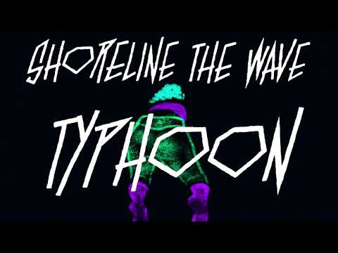
FOR PRESS ASSETS, VISIT THEIR PRESS SITE HERE

The most gleefully hedonistic emcees in L.A.'s new rap renaissance, Shoreline Mafia specialize in hard-hitting, party-positive bangers. Today, the West Coast's favorite rap collective shares "Perc Popper," an unapologetically raw new anthem. Produced by DJ Flipp, "Perc Popper" is a showcase for Fenix Flexin and OhGeesy, as the two emcees engage in a friendly competition to determine who is more savage: "In a foreign whip n**** and it's stolen/Look at my mouth, lil b*tch, I'm golden," says Fenix. "Perc Popper" is the latest single from Mafia Bidness, the group's upcoming debut album, following the Helluva-produced "Change Ya Life" (1.5 million Spotify streams in two weeks).
Working with frequent collaborators and new faces, Mafia Bidness expands and refines the Shoreline sound, offering viciously clever bars atop propulsive instrumentals. Hosted by OhGeesy, Fenix Flexin, Rob Vicious, and Master Kato, the upcoming project fits firmly within the West Coast tradition, offering beats that reference classic hyphy, G-funk, and party rap tracks, bringing hard-hitting L.A. anthems produced by frequent collaborators RonRon and Ace The Face, and furthering the deep connection between flourishing rap scenes in Los Angeles and Detroit. Dedicated to the memory of the collective's late friend Mac P Dawg, Mafia Bidness hits DSPs on July 31st via Atlantic Records and is now available for pre-order.
Mafia Bidness is the crown jewel of a massive year for Shoreline Mafia. In late June, the crew connected with YG for "Gangstas & Sippas" (Remix), a new version of the Too $hort-sampling, Q Da Fool-featuring slapper. Earlier this year, Shoreline recruited Lil Yachty for the laid-back rider's anthem "Ride Out." Both "Ride Out" and "Gangstas & Sippas" (Remix) will appear on Mafia Bidness.
This spring, Rob Vicious shared his new mixtape Breakthrough, which featured production from Three 6 Mafia's DJ Paul and a guest appearance from Fenix Flexin. Fenix is currently preparing to release his first solo project later this year. In February, before the COVID pandemic, Shoreline performed their first festival-headlining set at Vancouver's Lil Fest.

ABOUT SHORELINE MAFIA
The pulse of Los Angeles loudly echoes through its rap crews. In the late eighties, N.W.A. reflected the pre-riot tension of a city on the brink of total collapse. Cypress Hill finally gave the Latin community (and smokers everywhere) a seat at the pop culture table throughout the nineties. Odd Future magnified the skate mayhem of the Fairfax district in the aughts. That brings us to Shoreline Mafia. Since formally launching in 2016, the collective of four diverse, dynamic, and dangerous talents— OhGeesy [Alejandro Coranza], Rob Vicious [Robert Maggee], Fenix Flexin [Fenix Ryinski], and Master Kato [Malik Carson]—went from popular Soundcloud uploads to selling out arenas and picking up platinum plaques.
The group has garnered unanimous acclaim from Pitchfork, The FADER, Forbes, The Washington Post, Noisey, and more, and racked up more than 2 billion streams by 2020.

Stay tuned for much more information about Mafia Bidness in the coming weeks.
Buy/Stream "Perc Popper": https://shoreline.lnk.to/PercPopper
Watch the visualizer for "Perc Popper": https://youtu.be/mLbmSqaI944
Pre-order Mafia Bidness: https://www.hellawave.com/mafiabidness

CONNECT WITH SHORELINE MAFIA
official site | instagram | twitter | facebook | spotify | youtube | soundcloud

PRESS CONTACT
Brittany Bell | Brittany.Bell@atlanticrecords.com

