FOR IMMEDIATE RELEASE

JULY 30, 2021

**BRI STEVES SHARES HER TRUTH ON *TBH***

**PHILADELPHIA RAPPER/SINGER UNVEILS LONG AWAITED NEW PROJECT**

**VIA ATLANTIC RECORDS**

[**STREAM HERE**](https://nam04.safelinks.protection.outlook.com/?url=https%3A%2F%2Fbristeves.lnk.to%2FTBHPR&data=04%7C01%7CChandler.Owen%40atlanticrecords.com%7C8f32254412eb40e9744e08d9520b64ae%7C8367939002ec4ba1ad3d69da3fdd637e%7C0%7C0%7C637631031163268485%7CUnknown%7CTWFpbGZsb3d8eyJWIjoiMC4wLjAwMDAiLCJQIjoiV2luMzIiLCJBTiI6Ik1haWwiLCJXVCI6Mn0%3D%7C1000&sdata=b3dZ9iP9yUMAKq1uxE58CTmXirdZdCYj6s%2BEYcO7usk%3D&reserved=0)

**INCLUDING ANTHEMIC “ANTI QUEEN” & NEW MELODIC “GAF (FT. GUAPDAD 4000)”**

**SULTRY “GAF (FT. GUAPDAD 4000)” VIDEO COMING MONDAY AUGUST 2ND**

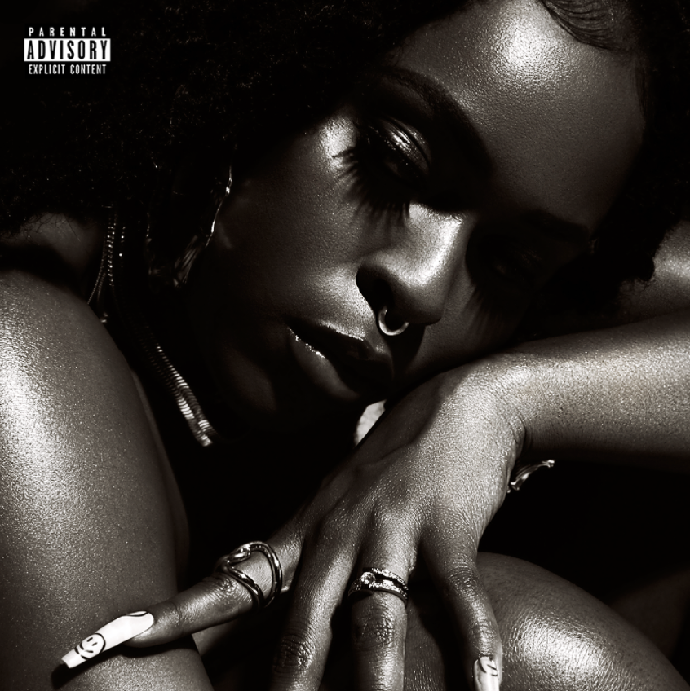

[*DOWNLOAD HIGH-RES ARTWORK HERE*](https://nam04.safelinks.protection.outlook.com/?url=https%3A%2F%2Fwarnermusicgroup.box.com%2Fs%2Fdt1f3eqlce34k6ghsu9xiynton7f9l5j&data=04%7C01%7CChandler.Owen%40atlanticrecords.com%7C85cd9bf737c040176fa408d94c7abc5b%7C8367939002ec4ba1ad3d69da3fdd637e%7C0%7C0%7C637624912293827773%7CUnknown%7CTWFpbGZsb3d8eyJWIjoiMC4wLjAwMDAiLCJQIjoiV2luMzIiLCJBTiI6Ik1haWwiLCJXVCI6Mn0%3D%7C1000&sdata=DaJqJmZBK6CslXban5kHDJC1reDiofOe7Ej%2BJvqnhsk%3D&reserved=0)

Acclaimed rapper, singer, producer, and musician Bri Steves is very proud to announce today’s premiere of her eagerly anticipated new project, *TBH*, available now via Atlantic Records [HERE](https://nam04.safelinks.protection.outlook.com/?url=https%3A%2F%2Fbristeves.lnk.to%2FTBHPR&data=04%7C01%7CChandler.Owen%40atlanticrecords.com%7C8f32254412eb40e9744e08d9520b64ae%7C8367939002ec4ba1ad3d69da3fdd637e%7C0%7C0%7C637631031163268485%7CUnknown%7CTWFpbGZsb3d8eyJWIjoiMC4wLjAwMDAiLCJQIjoiV2luMzIiLCJBTiI6Ik1haWwiLCJXVCI6Mn0%3D%7C1000&sdata=b3dZ9iP9yUMAKq1uxE58CTmXirdZdCYj6s%2BEYcO7usk%3D&reserved=0).

*TBH* – which of course stands for *To Be Honest* – is highlighted by the sultry new summer single, “GAF (Feat. Guapdad 4000).” The project showcases recent singles “[Sober](https://bristeves.lnk.to/SOBERID),” “[Stick Up (Feat. Poundside Pop)](https://bristeves.lnk.to/StickUpID),” and the groundbreaking anthem, “[ANTI QUEEN](https://bristeves.lnk.to/ANTIQUEENPR).” “ANTI QUEEN” proved a landmark release for Steves, fusing rap and vocals, femininity and masculinity, nostalgia and modernity, to create a creative new approach unlike any other. The track is joined by an equally striking companion video, directed by ATL-based photographer/filmmaker Derek Blanks and streaming now via YouTube [HERE](https://BriSteves.lnk.to/AntiQueenVideoPR).

The remarkable “ANTI QUEEN” saw Steves receive a prestigious BET Her Award nomination, placing her among such iconic fellow artists as SZA, Brandy, Ciara, and Alicia Keys. What’s more, the one and only Missy Elliott named Steves to *Good Morning Americ*a’s “[GMA Inspiration List: Who's Making Black History In 2021?](https://abcnews.go.com/GMA/News/gma-inspiration-list-making-black-history-2021/story?id=75228763#Music),” enthusing, “*I love the boldness Bri Steves brings as a rising star. She’s an outside-the-box-type of artist. Her message reminds me of myself at the early stages of my career, where people tried to box me into one category over another. Is she a rapper, a singer, a producer, a songwriter or a dancer? What is she? Well, I was all of them because I’m an artist. And now we see Bri Steves perfectly blending her different styles in her own dope way. That’s exciting to see in music, especially for a female artist.*”

Hailed by *Ones to Watch* as a “*hip-hop visionary*,” Bri Steves is quickly proving to be a milestone artist, a gifted rapper and powerhouse vocalist who easily alternates between steely and confrontational rhymes to sugary melodic hooks, all capturing her unique perspective on the female experience. The Philadelphia-born rapper, singer, poet, and producer studied viola with the Delaware Symphony Orchestra at the tender age of 10 but eventually chose to embark on a different path inspired by such champion lyricists as the Notorious B.I.G., Joey Bada$$, and J. Cole. Having mastered her rap skills, Bri focused on her singing voice while attending Temple University, establishing herself as a true double threat on the mic.

Steves signed to Atlantic Records in her senior year and in 2018, released her T-Minus and Hitmaka-produced debut single, “[Jealousy](https://BriSteves.lnk.to/JealousyID).” The track proved a top 15 chart smash while drawing critical acclaim from the likes of *The FADER*, which named her one of “5 Artists Ready To Be Philadelphia’s Next Champion,” writing, “*Steves alternates between rapping and singing with ease…(She) exudes a confidence that's contagious.*” As remarkable on stage as she is in the studio, Bri has spent a great deal of time honing her talents on the road, including shows supporting such like-minded artists as H.E.R., Mary J. Blige, Pharrell, and her mentor, Kendrick Lemar. A wide ranging new live schedule will be announced soon – for updates, please visit [www.bristeves.com](http://www.bristeves.com).

**TRACKLISTING:**

1. Too Far
2. GAF ft. Guapdad4000
3. Til It’s Gone
4. Sober
5. ANTI QUEEN
6. Switch Sides
7. Jealousy
8. Stick Up ft. Poundside Pop
9. Like You Should ft. Symba

|  |  |  |
| --- | --- | --- |
|  |  |  |

[DOWNLOAD HIGH-RES HERE](https://nam04.safelinks.protection.outlook.com/?url=https%3A%2F%2Fwarnermusicgroup.box.com%2Fs%2Fis3jptor8v0xzyvldy0b4hnbhz3mmafr&data=04%7C01%7CChandler.Owen%40atlanticrecords.com%7Ccfa109a48eb64d4fce8108d951ecd83b%7C8367939002ec4ba1ad3d69da3fdd637e%7C0%7C0%7C637630900061045800%7CUnknown%7CTWFpbGZsb3d8eyJWIjoiMC4wLjAwMDAiLCJQIjoiV2luMzIiLCJBTiI6Ik1haWwiLCJXVCI6Mn0%3D%7C1000&sdata=FgA4Y0IK2e2SXjPBi4t1ZinA9lmxApLjSbzw3%2FX9D8k%3D&reserved=0) | CRED: JIMMY FONTAINE

*“Bri Steves is a queen.”*

**MISSY ELLIOTT**

*“11 Hip-hop and R&B artists to watch”*

**BILLBOARD**

*“Steves alternates between rapping and singing with ease…(She) exudes a confidence that's contagious.”*

**THE FADER**

“A hip-hop visionary.”

**ONES TO WATCH**

*“21 artists to watch in 2021”*

**ESSENCE**

*“One hell of a voice, relentless bars, and an equally powerful personality — reminding folks of the power that lies within Black girl magic.”*

**FLAUNT**

**CONNECT WITH BRI STEVES**

[OFFICIAL](http://www.bristeves.com/) | [TWITTER](https://twitter.com/bristeves) | [INSTAGRAM](https://www.instagram.com/bristeves) | [YOUTUBE](https://www.youtube.com/channel/UC9xF24lvvsAt6J7bIjvfn7A)

**PRESS CONTACT**

Fairley McCaskill | [Fairley.McCaskill@atlanticrecords.com](mailto:Fairley.McCaskill@atlanticrecords.com)