FOR IMMEDIATE RELEASE

AUGUST 2, 2021

**BRI STEVES TAPS GUAPDAD 4000 FOR SULTRY “GAF” VISUAL**

[**WATCH HERE**](https://www.youtube.com/watch?v=SJIDQ2WOuqU)

**OFF PHILADELPHIA RAPPER/SINGER’S LONG-AWAITED PROJECT *TBH***

[**STREAM HERE**](https://nam04.safelinks.protection.outlook.com/?url=https%3A%2F%2Fbristeves.lnk.to%2FTBHPR&data=04%7C01%7CChandler.Owen%40atlanticrecords.com%7C8f32254412eb40e9744e08d9520b64ae%7C8367939002ec4ba1ad3d69da3fdd637e%7C0%7C0%7C637631031163268485%7CUnknown%7CTWFpbGZsb3d8eyJWIjoiMC4wLjAwMDAiLCJQIjoiV2luMzIiLCJBTiI6Ik1haWwiLCJXVCI6Mn0%3D%7C1000&sdata=b3dZ9iP9yUMAKq1uxE58CTmXirdZdCYj6s%2BEYcO7usk%3D&reserved=0)

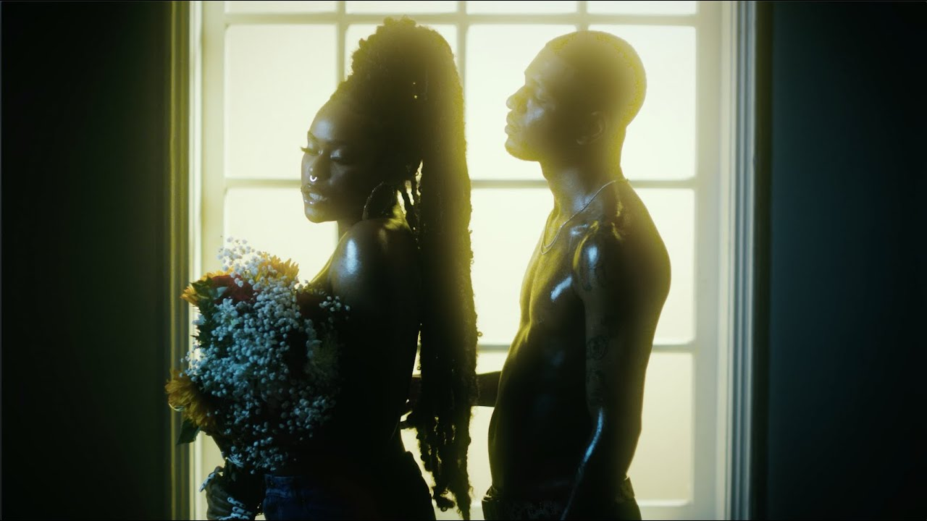

[*DOWNLOAD TBH ARTWORK HERE*](https://nam04.safelinks.protection.outlook.com/?url=https%3A%2F%2Fwarnermusicgroup.box.com%2Fs%2Fdt1f3eqlce34k6ghsu9xiynton7f9l5j&data=04%7C01%7CChandler.Owen%40atlanticrecords.com%7C85cd9bf737c040176fa408d94c7abc5b%7C8367939002ec4ba1ad3d69da3fdd637e%7C0%7C0%7C637624912293827773%7CUnknown%7CTWFpbGZsb3d8eyJWIjoiMC4wLjAwMDAiLCJQIjoiV2luMzIiLCJBTiI6Ik1haWwiLCJXVCI6Mn0%3D%7C1000&sdata=DaJqJmZBK6CslXban5kHDJC1reDiofOe7Ej%2BJvqnhsk%3D&reserved=0)

Philadelphia’s rapper/singer Bri Steves kicks off the week with the silky smooth [companion visual](https://www.youtube.com/watch?v=SJIDQ2WOuqU) to “GAF (ft. Guapdad 4000),” the sultry new summer single off her latest project [*TBH*](https://nam04.safelinks.protection.outlook.com/?url=https%3A%2F%2Fbristeves.lnk.to%2FTBHPR&data=04%7C01%7CChandler.Owen%40atlanticrecords.com%7C8f32254412eb40e9744e08d9520b64ae%7C8367939002ec4ba1ad3d69da3fdd637e%7C0%7C0%7C637631031163268485%7CUnknown%7CTWFpbGZsb3d8eyJWIjoiMC4wLjAwMDAiLCJQIjoiV2luMzIiLCJBTiI6Ik1haWwiLCJXVCI6Mn0%3D%7C1000&sdata=b3dZ9iP9yUMAKq1uxE58CTmXirdZdCYj6s%2BEYcO7usk%3D&reserved=0). “GAF” showcases Steves’ effortless flow between hard-hitting rapper and smooth, melodic storyteller. [VIBE Magazine](https://nam04.safelinks.protection.outlook.com/?url=https%3A%2F%2Fwww.vibe.com%2Fmusic%2Fmusic-premieres%2Fnew-music-friday-vibe-magazine-2-1234624474%2F&data=04%7C01%7CChandler.Owen%40atlanticrecords.com%7C75cedd6101784cefe80f08d953a4eaba%7C8367939002ec4ba1ad3d69da3fdd637e%7C0%7C0%7C637632790108041801%7CUnknown%7CTWFpbGZsb3d8eyJWIjoiMC4wLjAwMDAiLCJQIjoiV2luMzIiLCJBTiI6Ik1haWwiLCJXVCI6Mn0%3D%7C1000&sdata=Va9cP5WFz5%2BgYJVyQLUveYcYe2oeEYYkyULXsWwjqTk%3D&reserved=0) notes it is “a reminder of Steve’s multifaceted talents and is worthy of a slot in your rotation.”

[*TBH*](https://nam04.safelinks.protection.outlook.com/?url=https%3A%2F%2Fbristeves.lnk.to%2FTBHPR&data=04%7C01%7CChandler.Owen%40atlanticrecords.com%7C8f32254412eb40e9744e08d9520b64ae%7C8367939002ec4ba1ad3d69da3fdd637e%7C0%7C0%7C637631031163268485%7CUnknown%7CTWFpbGZsb3d8eyJWIjoiMC4wLjAwMDAiLCJQIjoiV2luMzIiLCJBTiI6Ik1haWwiLCJXVCI6Mn0%3D%7C1000&sdata=b3dZ9iP9yUMAKq1uxE58CTmXirdZdCYj6s%2BEYcO7usk%3D&reserved=0) – which of course stands for *To Be Honest* – showcases such recent singles as “[Sober](https://bristeves.lnk.to/SOBERID),” “[Stick Up (Feat. Poundside Pop)](https://bristeves.lnk.to/StickUpID),” and the groundbreaking anthem, “[ANTI QUEEN](https://bristeves.lnk.to/ANTIQUEENPR).” The latter proved a landmark release for Steves, fusing rap and vocals, femininity and masculinity, nostalgia and modernity, to create a creative new approach unlike any other. The track is joined by an equally striking companion video, directed by ATL-based photographer/filmmaker Derek Blanks and streaming now via YouTube [HERE](https://BriSteves.lnk.to/AntiQueenVideoPR).

The remarkable “ANTI QUEEN” saw Steves receive a prestigious BET Her Award nomination, placing her among such iconic fellow artists as SZA, Brandy, Ciara, and Alicia Keys. What’s more, the one and only Missy Elliott named Steves to *Good Morning Americ*a’s “[GMA Inspiration List: Who's Making Black History In 2021?](https://abcnews.go.com/GMA/News/gma-inspiration-list-making-black-history-2021/story?id=75228763#Music),” enthusing, “*I love the boldness Bri Steves brings as a rising star. She’s an outside-the-box-type of artist. Her message reminds me of myself at the early stages of my career, where people tried to box me into one category over another. Is she a rapper, a singer, a producer, a songwriter or a dancer? What is she? Well, I was all of them because I’m an artist. And now we see Bri Steves perfectly blending her different styles in her own dope way. That’s exciting to see in music, especially for a female artist.*”

**TRACKLISTING:**

1. Too Far
2. GAF ft. Guapdad4000
3. Til It’s Gone
4. Sober
5. ANTI QUEEN
6. Switch Sides
7. Jealousy
8. Stick Up ft. Poundside Pop
9. Like You Should ft. Symba

|  |  |  |
| --- | --- | --- |
|  |  |  |

[DOWNLOAD HIGH-RES HERE](https://nam04.safelinks.protection.outlook.com/?url=https%3A%2F%2Fwarnermusicgroup.box.com%2Fs%2Fis3jptor8v0xzyvldy0b4hnbhz3mmafr&data=04%7C01%7CChandler.Owen%40atlanticrecords.com%7Ccfa109a48eb64d4fce8108d951ecd83b%7C8367939002ec4ba1ad3d69da3fdd637e%7C0%7C0%7C637630900061045800%7CUnknown%7CTWFpbGZsb3d8eyJWIjoiMC4wLjAwMDAiLCJQIjoiV2luMzIiLCJBTiI6Ik1haWwiLCJXVCI6Mn0%3D%7C1000&sdata=FgA4Y0IK2e2SXjPBi4t1ZinA9lmxApLjSbzw3%2FX9D8k%3D&reserved=0) | CRED: JIMMY FONTAINE

*“Bri Steves is a queen.”*

**MISSY ELLIOTT**

*“11 Hip-hop and R&B artists to watch”*

**BILLBOARD**

*“Steves alternates between rapping and singing with ease…(She) exudes a confidence that's contagious.”*

**THE FADER**

“A hip-hop visionary.”

**ONES TO WATCH**

*“21 artists to watch in 2021”*

**ESSENCE**

*“One hell of a voice, relentless bars, and an equally powerful personality — reminding folks of the power that lies within Black girl magic.”*

**FLAUNT**

**CONNECT WITH BRI STEVES**

[OFFICIAL](http://www.bristeves.com/) | [TWITTER](https://twitter.com/bristeves) | [INSTAGRAM](https://www.instagram.com/bristeves) | [YOUTUBE](https://www.youtube.com/channel/UC9xF24lvvsAt6J7bIjvfn7A)

**PRESS CONTACT**

Fairley McCaskill | [Fairley.McCaskill@atlanticrecords.com](mailto:Fairley.McCaskill@atlanticrecords.com)