FOR IMMEDIATE RELEASE
AUGUST 7, 2020

ABIR (عبير) BRINGS THE HEAT IN NEW EP

VOCAL POWERHOUSE SCORCHES THE SONIC SUMMER LANDSCAPE
WITH EAGERLY-AWAITED EP

MOROCCAN AMERICAN ARAB-POP STAR DROPS POWERFUL VISUAL TO “YALLAH”
WATCH OFFICIAL “YALLAH” VIDEO: ABIR.LNK.TO/HEAT

INCLUDES STUNNING SINGLE “INFERNO”
WATCH OFFICIAL “INFERNO” VIDEO: ABIR.LNK.TO/INFERNOVIDEOPR

STREAM/DOWNLOAD HEAT: ABIR.LNK.TO/YALLAHVIDEO

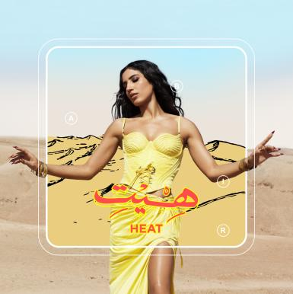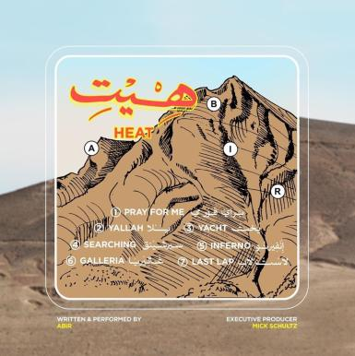
DOWNLOAD HIGH-RES ASSETS HERE

Abir is using Arab-Pop to shatter the Muslim woman stereotype. The singer-songwriter's unapologetic new project HEAT shows that she has something to say — and she's not afraid to get loud.
NYLON

Moroccan-American vocal powerhouse ABIR infuses modern pop and R&B with the extraordinary sounds of her native country Morocco in HEAT, the latest EP from the Arab-Pop songstress. The album is accompanied by the explosive companion visual to “Yallah,” a uniquely powerful visual that showcases the artist’s hypnotic vocal presence. HEAT is available now at all DSPs and streaming services HERE. Watch “Yallah” via ABIR’s official YouTube channel HERE.

“’Yallah’ is an anthem for marginalized communities everywhere,” notes ABIR. “It’s for anybody who stands for something that goes against what’s expected of them – specifically interfaith, interracial, and LGBTQ+ relationships. The word yallah in Arabic means ‘let’s go’ or ‘come on.’ This single is my way of expressing, ‘Forget what the non-believers or haters say. Let them keep talking, because we’re going to keep fighting for what we love and care about no matter what.’”

In HEAT, ABIR brings forth her brand of Arab-Pop, bridging her two worlds for reasons that extend far beyond simply music. Created in partnership with 2x GRAMMY® Award-nominee Mick Schultz (Rihanna, Kelly Clarkson), the EP is rich with lavish string work, complex rhythms, and commanding melodies, often sculpted with traditional North African instruments. Songs like “Inferno” are gorgeously textured and expertly spotlight the NYC-based artist’s intensely personal songcraft. The exclusive “Rebirth“ teaser heralding HEAT can be viewed via YouTube.

“The last year has been such a transitional time as far as really owning my identity,” ABIR says, “and that allowed me to get to the point of making the music I always wanted to make – something that challenges people’s perceptions of what it means to be an Arab woman in the modern world.”

ABIR heralded HEAT with the bold single “Inferno,” along with a stunning visual that was filmed on location in a desert in Marrakesh. “Inferno” celebrates ABIR’s Moroccan roots, while director, Sharif Abdel Mawla, perfectly captures the essence of the “modern Arab woman” ABIR self-proclaims to be. With its kinetic beat and lush string arrangement, the track serves as a potent introduction to the EP’s message of finding strength through self-celebration. “Inferno” was met with mass critical acclaim – with EARMILK noting how the track “is a sultry, infectious joint sprinkled with the traditional percussion, flutes and strings of North Africa.” V Magazine further exclaims, “Not only does the singer seduce listeners with her voice, but ABIR definitely showcases strength and fearlessness as an Arab-American Muslim woman in the music industry.” “The song is the ideal backdrop for establishing a new genre that bridges the gap combining east and west flavors of catchy melodies which she refers to as Arab-Pop,” exclaimed NYLON of the incredible single.

Hailed by Billboard as one of the “most exciting new voices” in recent memory, ABIR has already made a huge impact on contemporary pop, earning acclaim and attention for her sultry fusion of R&B, dance grooves, and intimate lyricism. The Morocco-born, New York City-based artist first broke through with 2018’s “Finest Hour,” her RIAA gold certified collaboration with chart-topping electronic production trio Cash Cash. The track proved one of that summer’s biggest anthems, topping iTunes’ “Dance Songs” chart for eight weeks on its way to the overall Top 40.

ABIR followed the success of “Finest Hour” (RIAA gold certified) with her own remarkable debut EP, MINT (RIAA platinum certified), highlighted by the acclaimed singles, “Tango“ and “Young & Rude.” The latter track earned wide-ranging applause upon its arrival, with Idolator raving, “ABIR is shaping up to be one of the breakout stars of 2018…The amazingly-titled ‘Young & Rude’ (is) an instantly anthemic pop song about letting your hair down and living in the moment. Those themes are conveyed perfectly in the video.”

ABIR has spent much of the past two years expanding her already-significant knowledge of Moroccan music, notably studying the Arabic scale to better integrate it into her own idiosyncratic take on pop and R&B. HEAT represents the culmination of years of growth and self-discovery for ABIR, a remarkable journey that extends to a blossoming new connection with the meaning of her name, an Arabic word (عبير) that translates as “fragrance of a flower.”

“So many things I’ve always talked about doing, I finally got to do with this project,” ABIR says. “I’m so comfortable in my skin, and I just want to share what I represent and what my culture is. I know that we have so much to offer the world, and I’m not afraid to get loud about it.”

HEAT TRACKLIST
1. Pray For Me
2. Yallah
3. Yacht
4. Searching
5. Inferno
6. Galleria
7. Last Lap

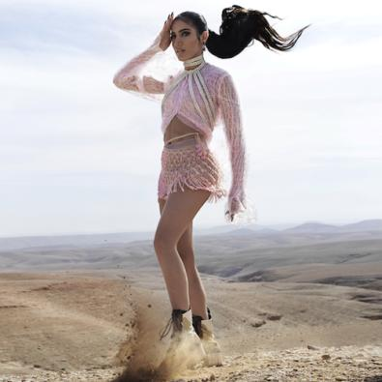
(PHOTO CREDIT: DOMEN & VAN DE VELDE)

For additional press assets, visit her press site press.atlanticrecords.com/abir.

CONNECT WITH ABIR
OFFICIAL |INSTAGRAM| TWITTER | FACEBOOK l YOUTUBE

PRESS CONTACT
FAIRLEY MCCASKILL | FAIRLEY.MCCASKILL@ATLANTICRECORDS.COM

