FOR IMMEDIATE RELEASE
AUGUST 21, 2020

4TH & ORANGE GIVES AN INTIMATE PERFORMANCE OF
“STORY OF MY LIFE (ACOUSTIC)”

ALTERNATIVE ROCKERS DROP ACOUSTIC VERSION OF “STORY OF MY LIFE”
LISTEN HERE: 4THANDORANGE.LNK.TO/SOMLACOUSTIC

WATCH THE ACOUSTIC PERFORMANCE LIVE OUT OF LONG BEACH HERE

ORIGINAL TOON 53 PRODUCTIONS ANIMATED VISUAL HITS OVER 4 MILLION VIEWS
WATCH ANIMATED “STORY OF MY LIFE” VISUAL HERE

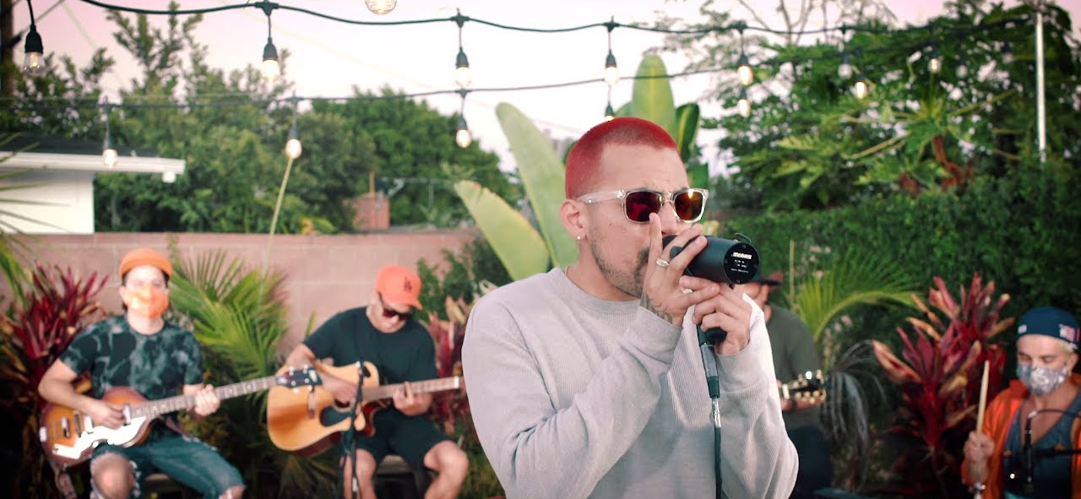
DOWNLOAD PRESS ASSETS

Southern California outfit 4th & Orange invite you to an intimate backyard performance of their stripped-down hit “Story Of My Life.” Watch the incredible performance HERE. “Story Of My Life (Acoustic)” is available at all streaming services HERE. The original version dropped alongside nostalgic, old-school animation styled lyric video. The Toon 53 production animated visual recently surpassed 4 million views via YouTube – watch it HERE.

“Since Lucas Secon was the producer of the original “Story Of My Life” record, it felt great when we, as a band, were able to strip it down organically and recreate it into something of our own,” notes 4th & Orange of the acoustic single. “This was something special for us as it’s our first acoustic video and song. Long Beach is home, so we shot the live performance in our buddy’s backyard to give it that classic California, summertime feel.”

4th & Orange stay connected to their fans through the pandemic by keeping a bubbling live, virtual performance schedule – enabling them to offer positive vibrations and luminous energy through the screen. They kicked off summertime with a headlining set at Reggae 360’s Ascension Summer Kick Off virtual festival; watch HERE. They’ve stayed busy with performances at Rev Clinic’s Summer Stash Bash and Reggae 360’s Summer Festival, along with a full performance on Sessions. The beginning of 2020 saw them on the festival circuit at One Love Cali Reggae Festival in Long Beach, CA, and Chandler, AZ’s Arizona Roots Festival. Their festival performances at Reggae Rise Up Last Vegas and Reggae Rise Up St. Petersburg will be postponed; festival websites will have all information. 4th & Oranges national tours with Collie Buddz and Natiruts will also be postponed; visit their website HERE for tour updates.

During the COVID-19 pandemic, 4th & Orange reminded you that this is “Not the End,” an incredible single that pushes positivity and reinforces unity. Listen to “Not the End” HERE. 4th & Orange also curated a playlist of their favorite songs to get you through the day; listen to the Quarantunes playlist HERE. The reggae genre-benders were also seen recruiting fellow Long Beach native Warren G for the “In The LBC” remix. Listen to the remix featuring the West Coast hip hop legend HERE. 4th & Orange released their feel-good Long Beach anthem in February in celebration of their iconic hometown; listen to the original track HERE. Watch the official music video HERE.

At the tail end of 2019, 4th & Orange dropped “Only You,” which sees the group putting their quintessential SoCal pop-reggae touch on an undisputed classic song. The track dropped alongside an electric companion visual directed by Jose Omar. They kickstarted the summer of 2019 with their sizzling debut single, “Girl Next Door,” with an official video directed by Michael Garcia that’s now boasting more than 2.5 million individual views. The single was swiftly followed by two additional summer smashes in “No More Favors” and “Junky.”

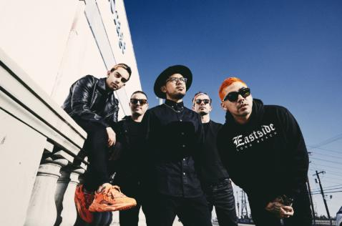
DOWNLOAD HIGH-RES PRESS PHOTO HERE
PHOTO CREDIT: JIMMY FONTAINE

BAND MEMBERS
Garrett Douglas - Lead Vocals
Chris “DJ Irey” Garcia - Keyboards / Producer
Ricardo Santiago – Guitar
Alex Bursztyn – Bass
Sam Ward – Drums

CONNECT WITH 4TH & ORANGE
INSTAGRAM | TWITTER | FACEBOOK | YOUTUBE

For additional press assets, please visit their press site HERE.

PRESS CONTACT
Chandler Owen | Chandler.Owen@atlanticrecords.com

