FOR IMMEDIATE RELEASE
AUGUST 26, 2021

#FLASHBACKFRIDAY TO SILK SONIC TAKING OVER LA’S DISCOASIS SKATE PARTY
WATCH + DOWNLOAD RECAP HERE

“SKATE” TO SILK SONIC
STREAM HERE | WATCH HERE

AN EVENING WITH SILK SONIC DUE JANUARY 2022

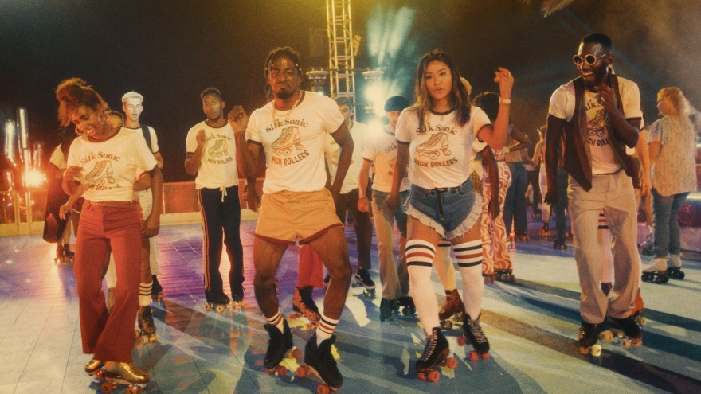
DOWNLOAD EVENT PHOTOS | CRED: JOHN ESPARZA

In the spirit of #FlashbackFriday, let’s throw it back to the weekend following Silk Sonic’s release of their highly anticipated second single, “Skate,” off their January 2022 slated debut album, An Evening With Silk Sonic. The Elle Empire-produced takeover of Southern California’s Discoasis was an evening filled with glidin’ and groovin’ on fly skates to sounds provided by DJ Casanova.

WATCH + DOWNLOAD RECAP HERE
[INCLUDES SOCIAL CLIPS]

Most recently, Silk Sonic graced the cover of Rolling Stone’s September issue, where fans got an inside look at Mars and .Paak’s deep friendship and quest for the perfect throwback jam. The duo also announced their debut album is set for a January 2022 release. Silk Sonic coasted into the release of “Skate” on the wave of success from their debut single “Leave the Door Open,” which earned them Best Group at the 2021 BET Awards. It became the group’s first #1 single on the Billboard Hot 100, spending two non-consecutive weeks at #1 and 18 consecutive weeks in the top 10. They released the live version “Leave The Door Open (Live)” and serenaded audiences three times over at the GRAMMY® Awards, iHeartRadio Music Awards, and the BET Awards.

ABOUT SILK SONIC:
The seeds of the collaboration were planted in 2017 when Anderson .Paak and Bruno Mars toured together on the European leg of his 24K Magic World Tour. One late-night jam session on the road unlocked immediate chemistry. Just before the world slipped into quarantine, Bruno called Anderson: “Remember that idea we had back in 2017? Let’s do it.” One studio session grew into to a months-long collaboration, culminating the “setlist of doom.” Legendary Bootsy Collins christened Silk Sonic and came in as the “special guest host” for An Evening With Silk Sonic, their debut album.

Silk Sonic was finally set free on March 5th, 2021. Within less than a month, their debut single “Leave The Door Open” cracked over 230 million streams, and currently sits at 1.2 billion streams with over 346 million official video views. It reeled in rave reviews, including Variety who noted it “could be a Best R&B Song GRAMMY® winner from 1974.” After petitioning the GRAMMY® Awards to #LetSilkSonicThrive, they made their debut performance with “Leave The Door Open” and served up a powerful tribute to Little Richard.

CONNECT WITH SILK SONIC
WEBSITE | FACEBOOK | TWITTER | INSTAGRAM | YOUTUBE | TIKTOK | SPOTIFY | APPLE MUSIC

CONNECT WITH BRUNO MARS
WEBSITE | FACEBOOK | TWITTER | INSTAGRAM | YOUTUBE

CONNECT WITH ANDERSON .PAAK
WEBSITE | FACEBOOK | TWITTER | INSTAGRAM | YOUTUBE

CONTACT FOR SILK SONIC/BRUNO MARS:
SHEILA.RICHMAN@ATLANTICRECORDS.COM
BRITTANY.BELL@ATLANTICRECORDS.COM

CONTACT FOR ANDERSON .PAAK:
KRISTEN.FOSTER@FULLCOV.COM
ERICA.GERARD@FULLCOV.COM

