FOR IMMEDIATE RELEASE
SEPTEMBER 24, 2020

WATCH PJ PERFORM ON KELLY CLARKSON WITH COMMON

R&B SONGSTRESS PERFORMS “DON’T FORGET” WITH COMMON FROM THE NETFLIX SHOW BOOKMARKS
WATCH THE PERFORMANCE HERE

WATCH PJ PERFORM “ELEMENT” FEATURED ON THE OFFICIAL INSECURE SEASON 4 SOUNDTRACK
LIVE FROM SOUTH LA’S ALTA ADAMS HERE

PJ’S EP WAITING FOR PARIS AVAILABLE NOW

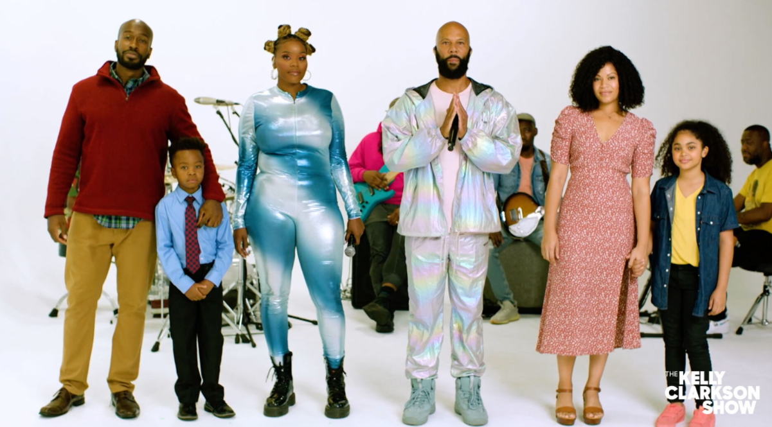
PHOTO COURTESY OF THE KELLY CLARKSON SHOW
DOWNLOAD PJ’S HIGH-RES PRESS ASSETS HERE

“The award-winning singer-songwriter is making her return to remind everyone of her singing prowess and doing it with pure confidence.” – UPROXX

“With a confident, energetic, and daring vibe, “Waiting For Paris” takes dips into pop, soul, and country, all while remaining true to a classic R&B finish.” – LADYGUNN

Waiting for Paris . . . feels deeply homespun and wonderfully warm . . . The year is 2020 and PJ is no longer an underdog—she deserves household name status. – AUDIOMACK

R&B songstress PJ teamed up with Common this afternoon to perform “Don’t Forget” on The Kelly Clarkson Show. The track is featured on the Netflix’s newest series Bookmarks – where black celebrities and artists read children's books by Black authors to spark meaningful conversations about empathy, equality, justice, self-love, and anti-racism. Some guests include Common, Jill Scott, Tiffany Haddish and more. Watch PJ and Common’s incredible performance on Kelly Clarkson HERE. PJ also recently dropped by South LA’s Alta Adams to give her single “Element” an LA backdrop for an incredible live performance on the patio; watch HERE. “Element” was featured on season 4 for INSECURE and on the INSECURE: Music From the HBO Original Series, Season 4 soundtrack. The record was used as the music bed for Issa Rae’s EMMY nomination category for Best Lead Actress in a Comedy Series.

“Element” arrived on the INSECURE: Music From the HBO Original Series, Season 4 soundtrack and was welcomed with an incredible companion visual available HERE. Further, the INSECURE soundtrack took over NPR Music in support of the release and featured PJ for their Tiny Desk Concert series – watch her performance HERE.

PJ broke boundaries with her latest single “Privately (Remix)” featuring Voisey winner Terria Chrischelle. The songstress recently teamed up with the Voisey App to launch the #PrivatelyChallenge, giving fans the opportunity to remix her original track. Voisey winner Terria Chrischelle slayed the game and PJ welcomed her to the official remix. This is the first time an artist signed to a major label has released a remix featuring a Voisey App winner. PJ is dedicated to supporting upcoming songwriters and passionate about uplifting their voices to make them heard. “Privately (Remix)” featuring Voisey winner Terria Chrischelle is available to stream and download at all major DSPs and streaming services HERE.

PJ dropped her EP titled Waiting For Paris this summer which includes features from Symba and Dreamville artist, Lute and has half a million streams to date. The EP includes the breakout single “Counterfeit,” which is available for streaming now. Watch the official “Privately” visual HERE. PJ’s single “Element” arrived on the INSECURE: Music From the HBO Original Series, Season 4 soundtrack and was welcomed with an incredible companion visual available HERE. She recently joined fellow soundtrack artists and actors for the official INSECURE Soundtrack Music Panel – watch the talent will dive into discussions on the importance of black music for the culture as well as topics around dating and relationships HERE. Further, the INSECURE soundtrack took over NPR Music in support of the release and featured PJ for their Tiny Desk Concert series – watch her performance HERE.

The acclaimed R&B songstress will continue her hugely popular cover series, The Quarantine Tapes, streaming now via SoundCloud. Her emotional cover of “Death Bed (Coffee For Your Head)” by Powfu dropped just last week. Previous installments include unique versions of such hits as Doja Cat’s “Say So,” Dua Lipa’s “Don’t Start Now,” Justin Bieber’s “Intentions/Yummy,” and labelmate Roddy Ricch’s breakout single “High Fashion.” As if that weren’t enough, PJ also recently shared her current day-to-day with the Recording Academy for a recent installment of their ongoing Quarantine Diaries. PJ has been working hand-in-hand with UPROXX on a number of projects, including Penned By PJ, an exclusive series breaking down the story and craft behind her singles, “Run For Your Money,” “Smoke,” and “Honest.” In addition, PJ joined UPROXX’s popular Instagram for the recent Doing My Part W. PJ.

In 2018, embracing a newfound confidence blending pop, soul, and country to create a distinctively original R&B approach she describes simply as “dripping in soul.” Recent singles like “My Best Life“ (watch the official video HERE) and “One Missed Call“ mark an inspiring new era for PJ’s unique artistry. Indeed Essence hailed “One Missed Call” as “a colorful nod to Stevie Wonder,” further praising the track’s “vibrant video” – streaming HERE – for “(featuring) dancing, tons of black girl magic, and a message to listen to your intuition.” As compelling on stage as she is in the studio, PJ has toured alongside such like-minded artists as ELHAE and Pink Sweat$ for his latest 2019 Pink Beginnings 11-city tour run. What’s more, PJ was among the new stars performing last year as part of MTV’s influential PUSH Live concert series. Her single “Steps” recently appeared in the Being Mary Jane season finale in 2019.

Raised in Greensboro, NC, PJ moved to Los Angeles in 2014 and quickly became known as a gifted songwriting talent, with hit tracks for such artists as Charlie Puth (“Left Right Left“), Meek Mill (“I Don’t Know (Feat. Paloma Ford)“), and Wiz Khalifa (“True Colors (Feat. Nicki Minaj)“) among her many credits along with incredible collaborations with G-Eazy, Ty Dolla $ign, and more. Her single, ”Tell Me (Feat. Jevon Doe),” racked up over 3.5 million Spotify streams along with acclaim from Ones to Watch, HipHopDX, and many others.
CONNECT WITH PJ
OFFICIAL | FACEBOOK | TWITTER | INSTAGRAM | YOUTUBE

FOR ADDITIONAL PRESS ASSETS, VISIT HER PRESS SITE HERE

PRESS CONTACT
Brittany Bell | Brittany.Bell@atlanticrecords.com

