FOR IMMEDIATE RELEASE
JANUARY 14, 2020

SLEEPY ROSE DROPS NEW SINGLE “WOO”

T.R.U. (The Real University) PRESENTS THE OFFICIAL 90S-INSPIRED COMEDY VISUAL HERE

SECOND #TRUSDAYS SINGLE, FOLLOWING SKOOLY’S “VIRGIL DISCOUNT”

T.R.U. COLLECTIVE TO DROP DEBUT COMPILATION NO FACE NO CASE FEBRUARY 7TH

“WOO” AVAILABLE TO STREAM/DOWNLOAD HERE
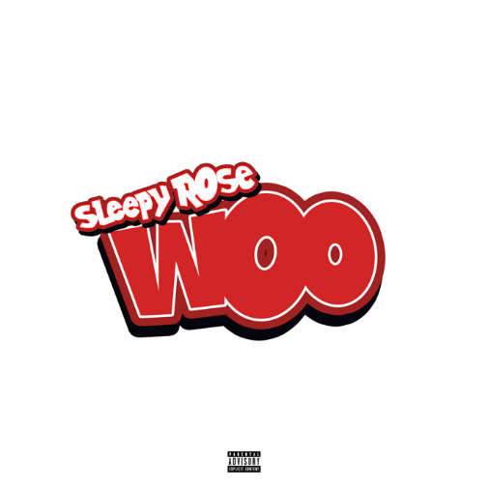

DOWNLOAD HIGH-RES SINGLE COVER ART HERE
DOWNLOAD HIGH-RES NO FACE NO CASE COVER ART HERE

Today, T.R.U. (The Real University) and Atlantic Records recording artist Sleepy Rose drops “Woo” produced by Big Papito; available at all DSPs HERE. The track is accompanied by a creative visual which references the 1996 film Don't Be a Menace to South Central While Drinking Your Juice in the Hood, directed by Allen Parks; watch it HERE. “Woo” is the second single to kick-off #TRUsdays – weekly Tuesday releases of new music from T.R.U. recording artists in anticipation for the upcoming compilation No Face No Case on February 7th.

Earlier this season, GRAMMY® Award-winning 2 Chainz’s T.R.U. and Atlantic Records dropped their debut single “Shoot It Out” and companion visual. Directed by Darius Turbak and the Cloud Harvest Team, the official “Shoot It Out” visual premiered on Complex and is available HERE. Sleepy Rose would follow that release with his ode to “Georgia” feat. 2 Chainz and a video directed by Sam Green. T.R.U. would later take over the Atlanta Hawk’s first ever Peachtree Nights with a special halftime performance of the single.

2 Chainz first introduced the T.R.U. brand with 2011’s seminal mixtape, T.R.U. REALIGION, followed the next year by his RIAA platinum certified, GRAMMY® Award-nominated solo debut, BASED ON A T.R.U. STORY, and further developed over the course of eleven trailblazing mixtapes and five solo albums. In 2019, the acclaimed ATL superstar officially founded the T.R.U. label, teaming with Atlantic Records with a goal of formally presenting a new vanguard of Atlanta-based hip-hop talent.

“I treat the record label as school with various levels,” 2 Chainz says. “That’s why we refer to it as ‘The Real University.’ It’s a course you go through. Ever since my mixtape days, I’ve used the acronym T.R.U. It was a school of thought I put in place. It was all about me practicing what I preach, getting comfortable in my own skin, going through ups and downs, and moving forward. Atlantic gave me the opportunity to share my vision. I’ve done so much music, and I’ve been successful. I’d like to pass those lessons to the youth. I’m concentrated on the future, making someone else’s dreams come true and giving them some rich people problems.”

ABOUT SLEEPY ROSE
Roses bloom under the influence of the environment. A tough and turbulent upbringing in the Atlanta neighborhood of Godby Road-Old National College Park molded Sleepy Rose and encouraged him to blossom into a formidable MC who translates his struggles into stories. Locked up for two years, he started rapping by tapping out a beat anywhere—from on his chest to the doors and walls of the jail. Upon his release, he turned heads with his first YouTube upload “Gangsta.” Following the death of his sister whom the family referred to as Rose, he tattooed a rose on his face in tribute and also as a reminder “We rose up out of the gutter. A rose keeps going high too.”

He sharpened a signature sound punctuated by local lingo on “Where You From,” “Striking,” and “Mhmm.” Growing up on the same block as Hott LockedN, 2 Chainz flew both MCs to Los Angeles for an explosive session and signed them both to T.R.U. (The Real University) in 2019.

CONNECT WITH SLEEPY ROSE
Instagram | YouTube | Twitter | Soundcloud

PRESS CONTACT
Fairley McCaskill | Fairley.McCaskill@atlanticrecords.com

