FOR IMMEDIATE RELEASE
JANUARY 21ST, 2020

SKOOLY UNLEASHES “HOW I FEEL” (REMIX) FT. NOCAP & QUANDO RONDO

T.R.U. (The Real University) UNVEILS CINEMATIC COMPANION VISUAL HERE

THIRD #TRUSDAYS SINGLE IN ANTICIPATION OF T.R.U. COLLECTIVE DEBUT COMPILATION
NO FACE NO CASE ON FEBRUARY 7TH

“HOW I FEEL” FT. NOCAP & QUANDO RONDO AVAILABLE TO STREAM/DOWNLOAD HERE

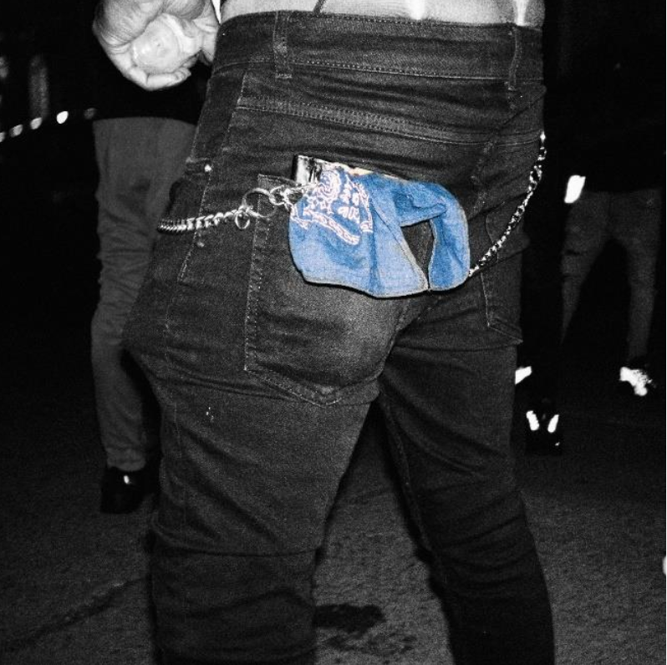

DOWNLOAD HIGH-RES SINGLE COVER ART HERE
DOWNLOAD HIGH-RES NO FACE NO CASE COVER ART HERE

T.R.U. (The Real University) and Atlantic Records recording artist Skooly enlisted NoCap and Quando Rondo for the today’s #TRUsday drop – “How I Feel” (Remix). Produced by Feddy, “How I Feel” is available at all DSPs HERE. The track is accompanied by a Terrius Mykel-directed cinematic visual, watch it HERE. “How I Feel” follows “Woo” by Sleepy Rose and “Virgil Discount” by Skooly ft. 2 Chainz in the succession of #TRUsday single releases in weekly anticipation of the upcoming T.R.U. recording artists compilation No Face No Case on February 7th.

Hailed by Pitchfork for “changing the way Atlanta raps,” Skooly has crafted a truly distinctive signature sound, switching seamlessly back and forth between laidback verses and sizzling singing. In addition to collaborations spanning Future to Young Thug, Skooly drew millions of Spotify streams with tracks like “Habit (Feat. 2 Chainz),” “Crazy Shit (Feat. Lil Xan),” and “Really Rich,” as well as the recent bangers, “Lil Boy Shit” and “Proud Of You.” Signed to T.R.U. in 2019, he made his proper debut with “Pop Off.”

Earlier this season, GRAMMY® Award-winning 2 Chainz’s T.R.U. and Atlantic Records dropped their debut single “Shoot It Out” and companion visual. Directed by Darius Turbak and the Cloud Harvest Team, the official “Shoot It Out” visual premiered on Complex and is available HERE.

“I know Skooly is a superstar,” says 2 Chainz. “I’ve been watching him since he was about 14 in Atlanta. As a little kid, he had a Lil Wayne vibe. I’m staying down with him. He’s 25-years-old, and he’s nowhere near his peak. He really knows where to sing and where to put the bars down.”

2 Chainz first introduced the T.R.U. brand with 2011’s seminal mixtape, T.R.U. REALIGION, followed the next year by his RIAA platinum certified, GRAMMY® Award-nominated solo debut, BASED ON A T.R.U. STORY, and further developed over the course of eleven trailblazing mixtapes and five solo albums. In 2019, the acclaimed ATL superstar officially founded the T.R.U. label, teaming with Atlantic Records with a goal of formally presenting a new vanguard of Atlanta-based hip-hop talent.

“I treat the record label as school with various levels,” 2 Chainz says. “That’s why we refer to it as ‘The Real University.’ It’s a course you go through. Ever since my mixtape days, I’ve used the acronym T.R.U. It was a school of thought I put in place. It was all about me practicing what I preach, getting comfortable in my own skin, going through ups and downs, and moving forward. Atlantic gave me the opportunity to share my vision. I’ve done so much music, and I’ve been successful. I’d like to pass those lessons to the youth. I’m concentrated on the future, making someone else’s dreams come true and giving them some rich people problems.”

CONNECT WITH SKOOLY
Instagram | Twitter | YouTube | SoundCloud

SKOOLY PRESS CONTACT
Brittany Bell | Brittany.Bell@atlanticrecords.com

TRU PRESS CONTACT
Fairley.McCaskill@atlanticrecords.com

