FOR IMMEDIATE RELEASE
OCTOBER 2, 2020

TAYLA PARX IS IN A BLUE STATE

MULTIPLE GRAMMY® AWARD NOMINATED SINGER-SONGWRITER
OFFERS COVER COMPILATION MINI PROJECT

INCREDIBLE PERFORMANCES OF MARVIN GAYE, LAURYN HILL AND KIRK FRANKLIN

EAGERLY AWAITED NEW ALBUM, COPING MECHANISMS, DUE 11/20

A BLUE STATE AVAILABLE AT ALL DSPS AND STREAMING SERVICES HERE

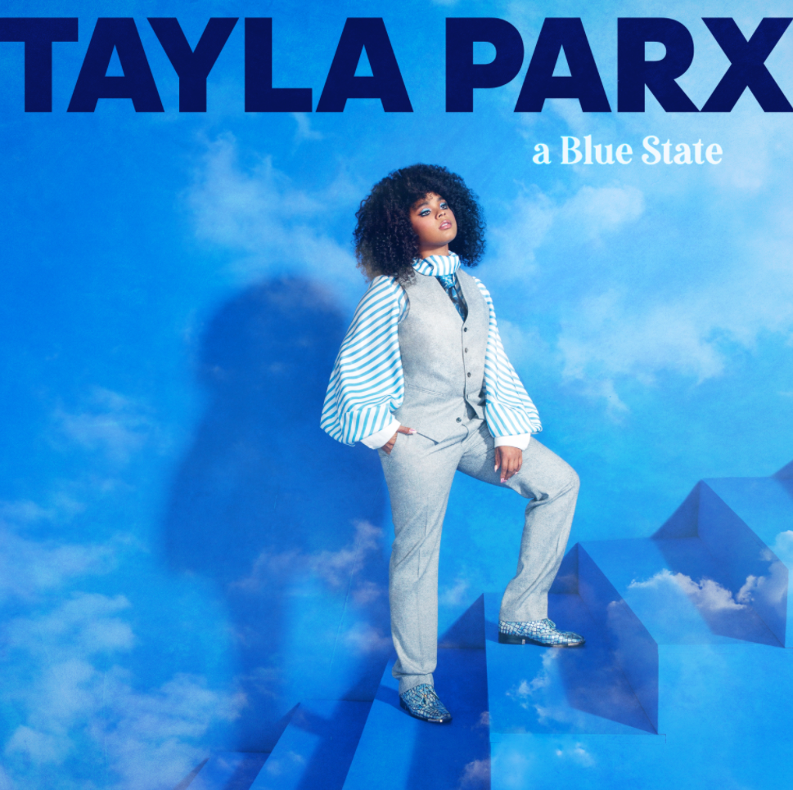
DOWNLOAD HIGH-RES COVER ART HERE

Multiple GRAMMY® Award-nominated recording artist Tayla Parx today releases A Blue State, a powerful cover compilation mini project reflecting her mood and political nuance. Parx pays homage to Kirk Franklin’s “I Smile,” Marvin Gaye’s “What’s Going On” and Lauryn Hill’s “Everything is Everything” in the incredible collection which precedes her eagerly anticipated new album, COPING MECHANISMS, due to arrive 11/20. A Blue State is available now via Tayla Made/Atlantic at all DSPs and streaming services HERE.

“Before my album, I wanted to surprise you guys with a collection of songs that I’ve not only cried to but been inspired by,” notes Tayla Parx in an Instagram post about A Blue State. “They’ve brought me an abundance of light in such a dark time. I hope to bring that same light to the people I care most about, my Taylatots. This one’s for you.”

A Blue State was heralded this spring by the acclaimed single, “Dance Alone,” available now at all DSPs and streaming services. Hailed by Insider as one of “the 18 best LGBQ love songs of all time,” the disco-infused track proved a sensation upon arrival, earning over 1.2 million Spotify streams (including placement on Michelle Obama’s #BlackGirlMagic playlist) amidst widespread critical applause from the likes of Variety, which declared, “‘Dance Alone’ has perhaps the defining chorus of 2020.” “Dance Alone” is joined by a joyously energetic official video, filmed at Parx’s home in Los Angeles and streaming now via YouTube HERE.

ABOUT TAYLA PARX
By gently caring for herself first, Tayla Parx blossoms as an artist. As a result, the GRAMMY® Award-nominated singer, songwriter, performer, and disruptor empowers, enlightens, and emboldens audiences. Since 2017, she has transcended expectations, conventions, and boundaries, generating tens of millions of streams with each project and earning recognition from critics, peers, and fans all the way up to First Lady Michelle Obama.

Following her breakout TAYLAMADE mixtape and the success of her smash “Runaway (Feat. Khalid) (29 million streams), she made a statement on her 2019 debut album, WE NEED TO TALK. Powered by such anthems as “I Want You” (6.3 million Spotify streams), “Me Vs. Us” (1.3 million Spotify streams), and “Rebound (Feat. Joey Bada$$)” (1.2 million Spotify streams), the collection incited critical applause from Rolling Stone who observed, “The new album, like Parx’s best hits, is playful and conversational, blending pop, R&B and traces of rap.”

As her profile rose, Parx served up an unforgettable live show night after night on tour with the likes of Lizzo and Anderson.Paak. Concurrently, she established herself as a history-making force behind-the-scenes with a discography streamed over 1 billion times and counting. Christened a 2019 “Hitmaker” by Billboard, Tayla made history as the first female songwriter to log three simultaneous Top 10 entries on Billboard’s “Hot 100” since 2014 for penning Ariana Grande’s “7 Rings” and “thank u, next” and Panic! At The Disco’s “High Hopes.” Tayla’s GRAMMY® Award-nominated catalog also comprises Janelle Monáe’s DIRTY COMPUTER, Christina Aguilera’s “Like I Do (Feat. GoldLink],” The Internet’s “Ego Death,” and Hairspray.

Along the way, Parx also worked on Tayla. Rather than let a breakup break her, she took action, parlaying healthy coping mechanisms into bold bops. By doing so, she strengthened herself and her art as evidenced on her long awaited second full-length album, COPING MECHANISMS.

“I’m ever-changing,” Parx says. “I’m unwilling to let my creative side die—ever. I’m a businesswoman, I’m a brand, and I’m a human. I’m working on being a better one all the time too. I’m going to allow myself to continue to evolve. My message is, ‘It’s okay to not be okay sometimes.’ It’s also okay to be better than okay other times. Be nice to yourself. Go through those growing pains, because they enable you to become who you’re meant to be.”

# # #

CONNECT WITH TAYLA PARX
OFFICIAL | INSTAGRAM | YOUTUBE | TWITTER | FACEBOOK

CONTACT
Brittany Bell | brittany.bell@atlanticrecords.com
Chandler Owen (TOUR) | chandler.owen@atlanticrecords.com

