**TAYLA PARX TO KICK OFF “A TAYLA MADE POP UP EXPERIENCE” IN LOS ANGELES ON THURSDAY, OCTOBER 18TH  AT THE MICROSOFT LOUNGE**

**INTERACTIVE AND VISUAL EXPERIENCE FOR FANS TO PREVIEW TAYLA’S UPCOMING PROJECT *WE NEED TO TALK***

**FREE LYFT RIDES TO BE PROVIDED TO AND FROM VENUE**

**TAYLA PARX TO DROP NEXT TRACK/VIDEO *“SLOW DANCING”* DURING POP UP EXPERIENCE**

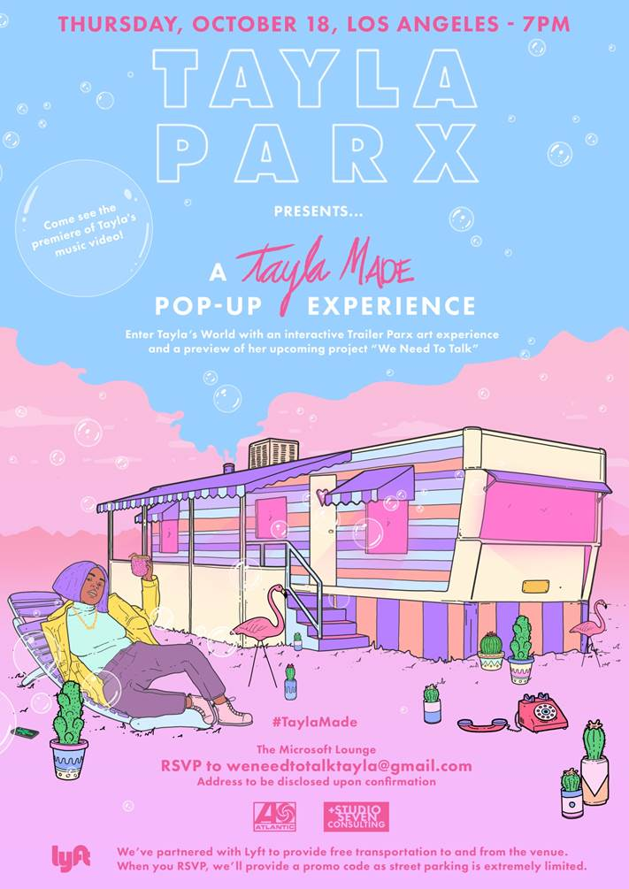

On **Thursday** **October 18th** in **Los Angeles**, at The Microsoft Lounge, **TAYLA PARX** will open up and allow fans to step into what it’s like to be in her world. The ***TAYLA MADE POP-UP EXPERIENCE***, hosted by Tayla herself, will be a wild visual feast with whimsical objects, oversized props and dreamy pastels and neons dotted throughout the space. As a partnership with **LYFT,** guests will be provided with a promo code for a **FREE** ride to and from the venue once they RSVP.

Fans will be able to feel the vibe of an extra playful contrast of Tayla’s feminine tomboy aesthetic in her interactive trailer park art experience, while enjoying the “Life Is A Garden, Don't Be A Prick” succulent garden, quirky TaylaMade cocktails and gourmet versions of ‘guilty pleasure American classics.’ The pop-up will be a nod to her “Trailer Parx” merchandise line and will also include a first-time listening/viewing of her new track/video **“Slow Dancing”**due to release on all DSPSs that evening, with many other unexpected surprises along the way.

3x GRAMMY® Award-nominated recording artist **Tayla Parx** recently released her anticipated new single/companion visual [**“Me Vs. Us”**](https://www.youtube.com/watch?v=Fuind6upxyc&feature=youtu.be) following an exclusive premiere via [**Complex**](https://www.complex.com/music/2018/09/tayla-parx-me-vs-us-video). Co-produced by Parx, Haze, and xSDTRK, “Me Vs. Us” showcases Parx’s ability to harmonize effortlessly while describing what it feels like to choose between loving someone more than you love yourself. The multi-platinum certified singer-songwriter-producer’s upcoming project, entitled **WE NEED TO TALK** will be her major label release following the debut of her solo mixtape [**TAYLA MADE**](https://taylaparx.lnk.to/TaylaMadePR).

Recently named to **Spotify’s** [**Secret Genius Ambassador**](http://secretgenius.com/) list of visionary songwriters and producers, **Tayla Parx** has penned tracks for artists such as **Alicia Keys, Janelle Monet, Demi Lovato, Fifth Harmony, Chris Brown, Christina Aguilera, Prince Royce and Nicki Minaj. Apple Music** recently revealed a special [**“Songbook: Tayla Parx”**](https://itunes.apple.com/us/playlist/songbook-tayla-parx/pl.54d7712abd9c4bb0a0a4f2b5e7465015) playlist showcasing her many hit tracks [**HERE**](https://itunes.apple.com/us/playlist/songbook-tayla-parx/pl.54d7712abd9c4bb0a0a4f2b5e7465015)**.**

Debuting summer ‘17 with her successful solo mixtape, [**TAYLA MADE**](https://taylaparx.lnk.to/TaylaMadePR), Parx revealed her unique versatile voice over pop rhythmic beats and proved her talents go beyond writing chart topping hits. Stand out track [**“Mama Ain’t Raise No Bitch,”**](https://www.youtube.com/watch?v=b2MJXqNXhdM)   pushed a message of women owning their vulnerability and using it to grow. Parx kicked off 2018 with her track [**“Runaway (Feat. Khalid)”**](https://www.youtube.com/watch?v=2uNJ9Ha1v3E&feature=youtu.be). Critics nationwide hailed the single upon its release, with [**HotNewHipHop**](https://www.hotnewhiphop.com/tayla-parx-runaway-feat-khalid-new-song.1974891.html)  stating, *“Undoubtedly Parx has volumes of talent stowed away, ready at her disposal.”*

**CONNECT WITH TAYLA PARX**

[**OFFICIAL**](http://www.taylaparx.com/)

[**INSTAGRAM**](http://instagram.com/taylaparx)

[**YOUTUBE**](https://www.youtube.com/channel/UCXR82zHJ6FuWccQQqxtNHyw)

[**TWITTER**](https://twitter.com/TAYLAPARX)

[**FACEBOOK**](https://www.facebook.com/taylaparx/)