FOR IMMEDIATE RELEASE
OCTOBER 16, 2020

TAYLA PARX UNVEILS “RESIDUE”

MULTIPLE GRAMMY® AWARD NOMINATED ARTIST
RETURNS WITH THE BREAK UP SONG FOR THE EX YOU CAN’T SHAKE

OFFICIAL LYRIC VIDEO STREAMING NOW | WATCH HERE

SECOND SINGLE OFF EAGERLY AWAITED NEW ALBUM, COPING MECHANISMS, DUE 11/20

PARX ANNOUNCES DIGITAL BURNOUT: COPING MECHANISMS EDITION
SAVE TO WIN ACCESS HERE

COMPILATION MINI PROJECT A BLUE STATE AVAILABLE HERE

“RESIDUE” AVAILABLE TODAY AT ALL DSPS AND STREAMING SERVICES HERE

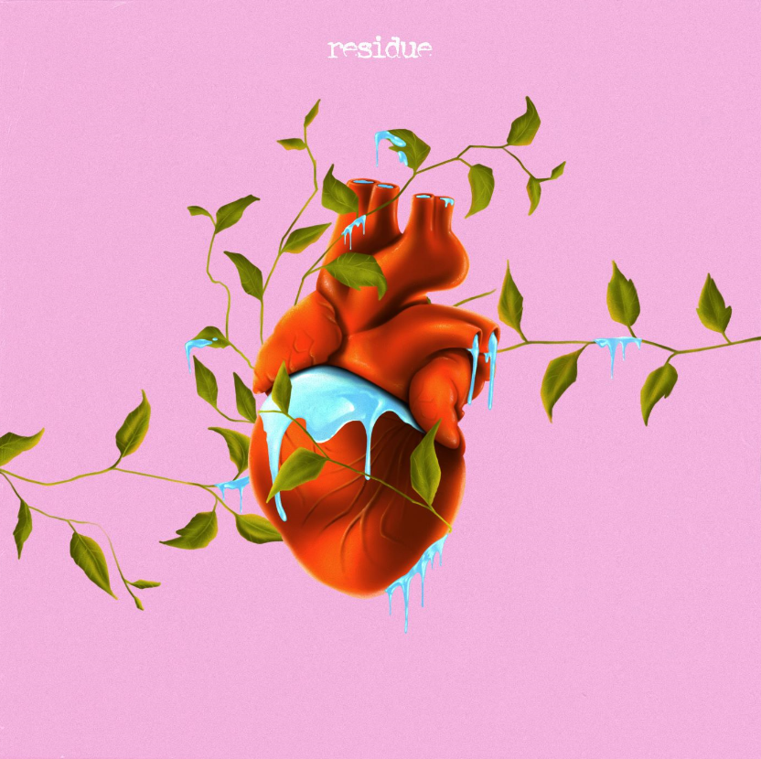
DOWNLOAD HIGH-RES COVER ART HERE

Multiple GRAMMY® Award-nominated recording artist Tayla Parx has announced today’s release of her emotionally raw, powerfully pop-tinged single. “Residue” is available now via Tayla Made/Atlantic at all DSPs and streaming services HERE. “Residue” precedes Parx’s eagerly-anticipated new album, COPING MECHANISMS, due to arrive at long last on November 20th. Watch the official lyric video HERE.

“‘It’s about one of those moments when you try to get somebody off your brain or heart,” Parx says of “Residue.” “You’re confessing, ‘I’m trying to get rid of you,” which is another one of my unhealthy coping mechanisms. In certain cases, you’re being avoidant and acting like it was never there versus finding solutions to the problem head-on.”

Today Parx also reveals details about her virtual wellness retreat, a digital Burnout: Coping Mechanisms Edition. From October 23rd through 25th from 1pm to 2pm ET each day. Join Tayla Parx and special guests to go through different coping mechanisms Tayla uses to help her get through these crazy times. Save to win access to Burnout: Coping Mechanisms Edition HERE.

“Residue” was first heralded this spring by the acclaimed first single, “Dance Alone,” available now at all DSPs and streaming services. Hailed by Insider as one of “the 18 best LGBQ love songs of all time,” the disco-infused track proved a sensation upon arrival, earning over 1.2 million Spotify streams (including placement on Michelle Obama’s #BlackGirlMagic playlist) amidst widespread critical applause from the likes of Variety, which declared, “‘Dance Alone’ has perhaps the defining chorus of 2020.” “Dance Alone” is joined by a joyously energetic official video, filmed at Parx’s home in Los Angeles and streaming now via YouTube HERE. Most recently, Parx released A Blue State, a powerful cover compilation mini project reflecting her mood and political nuance. Parx pays homage to Kirk Franklin’s “I Smile,” Marvin Gaye’s “What’s Going On” and Lauryn Hill’s “Everything is Everything.” A Blue State is available now via Tayla Made/Atlantic at all DSPs and streaming services HERE.

ABOUT TAYLA PARX
By gently caring for herself first, Tayla Parx blossoms as an artist. As a result, the GRAMMY® Award-nominated singer, songwriter, performer, and disruptor empowers, enlightens, and emboldens audiences. Since 2017, she has transcended expectations, conventions, and boundaries, generating tens of millions of streams with each project and earning recognition from critics, peers, and fans all the way up to First Lady Michelle Obama.

Following her breakout TAYLAMADE mixtape and the success of her smash “Runaway (Feat. Khalid) (29 million streams), she made a statement on her 2019 debut album, WE NEED TO TALK. Powered by such anthems as “I Want You” (6.3 million Spotify streams), “Me Vs. Us” (1.3 million Spotify streams), and “Rebound (Feat. Joey Bada$$)” (1.2 million Spotify streams), the collection incited critical applause from Rolling Stone who observed, “The new album, like Parx’s best hits, is playful and conversational, blending pop, R&B and traces of rap.”

As her profile rose, Parx served up an unforgettable live show night after night on tour with the likes of Lizzo and Anderson.Paak. Concurrently, she established herself as a history-making force behind-the-scenes with a discography streamed over 1 billion times and counting. Christened a 2019 “Hitmaker” by Billboard, Tayla made history as the first female songwriter to log three simultaneous Top 10 entries on Billboard’s “Hot 100” since 2014 for penning Ariana Grande’s “7 Rings” and “thank u, next” and Panic! At The Disco’s “High Hopes.” Tayla’s GRAMMY® Award-nominated catalog also comprises Janelle Monáe’s DIRTY COMPUTER, Christina Aguilera’s “Like I Do (Feat. GoldLink],” The Internet’s “Ego Death,” and Hairspray.

Along the way, Parx also worked on Tayla. Rather than let a breakup break her, she took action, parlaying healthy coping mechanisms into bold bops. By doing so, she strengthened herself and her art as evidenced on her long awaited second full-length album, COPING MECHANISMS.

“I’m ever-changing,” Parx says. “I’m unwilling to let my creative side die—ever. I’m a businesswoman, I’m a brand, and I’m a human. I’m working on being a better one all the time too. I’m going to allow myself to continue to evolve. My message is, ‘It’s okay to not be okay sometimes.’ It’s also okay to be better than okay other times. Be nice to yourself. Go through those growing pains, because they enable you to become who you’re meant to be.”

# # #

CONNECT WITH TAYLA PARX
OFFICIAL | INSTAGRAM | YOUTUBE | TWITTER | FACEBOOK

CONTACT
Brittany Bell | brittany.bell@atlanticrecords.com
Chandler Owen (TOUR) | chandler.owen@atlanticrecords.com

