FOR IMMEDIATE RELEASE
OCTOBER 17, 2019

MISSY ELLIOTT DROPS ANOTHER GROUNDBREAKING VISUAL

“DRIPDEMEANOR” FEATURES R&B ARTIST SUM1
DIRECTED BY DEREK BLANKS + MISSY ELLIOTT

ACCLAIMED TRACK FEATURED ON NEW EP

ICONOLOGY AVAILABLE NOW AT ALL DSPS HERE

WATCH “DRIPDEMEANOR” HERE

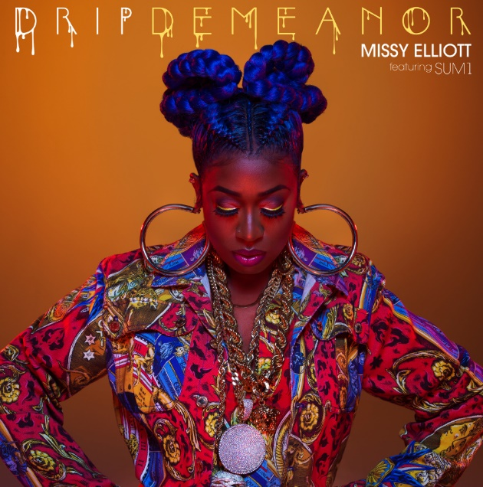

DOWNLOAD HIGH-RES COVER ART HERE

Five-time GRAMMY® Award winner Missy Elliott has unveiled a spectacular new visual for “DripDemeanor” featuring R&B singer, Sum1. “DripDemeanor”, directed by Derek Blanks, is the second visual from her recently released EP, ICONOLOGY, which is available everywhere via Atlantic Records/Goldmind and can be streamed HERE. Hailed by Esquire as “pure nineties-inspired R&B perfection,” Derek Blanks fittingly captures the essence of a true Missy Elliott visual with futuristic shots paired with precise choreography by Sean Bankhead. Just in time for homecoming season, Missy pays homage to the HBCU culture, spotlighting members of the Omega Psi Phi and Kappa Alpha Psi® Fraternities, Inc. effortlessly strolling throughout the visual.

WATCH “DRIPDEMEANOR” HERE.

Produced by Elliott, Timbaland, and Wili Hendrix, “ICONOLOGY” was acclaimed upon its surprise late summer release by the likes of USA Today, which declared the EP to be “a master class at the school of Missy Misdemeanor Elliott…The project brings back the Missy fans know and love, with booming bass beats that are the perfect backdrop to showcase her lyrical prowess.” The EP also includes the remarkable single, “Throw It Back,” accompanied by a new companion video, co-starring Teyana Taylor and streaming now via YouTube HERE, where it has already drawn over 15 million views thus far. The clip drew unprecedented acclaim upon its multi-platform premiere, with Elle advising readers to “cancel all music videos today because Missy Elliott's 'Throw It Back' is the Only One That Matters.” “One of the best visuals from any music video this year,” enthused Esquire. “’Throw It Back’ absolutely delivers, with a beat that defies anyone not to dance and a nostalgia-inducing ‘flip it and reverse it’ reference.” Perhaps Marie Claire said it best: “Throw It Back” is “a complete return to form for the icon… Not only is she back, but she's somehow even better, which I didn't know was possible.”

Elliott – who was recently seen starring on the July 2019 cover of Marie Claire – made history once again this summer as the first female rapper ever to receive the MTV Video Music Awards’ prestigious Michael Jackson Video Vanguard Award. Indeed, Missy stole the show with a dazzling performance of hits – streaming HERE – that included “Throw It Back,” “The Rain (Supa Dupa Fly),” “Get Ur Freak On,” “Work It,” “Pass That Dutch,” and “Lose Control.” “Missy Elliott is finally MTV Video Vanguard Award recipient,” raved Harper’s Bazaar, “and she proved that she earned every bit of the accolade with an epic performance at the VMAs.”

Furthermore, 2019 has already seen Elliott break new ground as the first female hip-hop artist and the third-ever rapper to be inducted into the Songwriters Hall of Fame. In addition, Elliott recently received an honorary Doctor of Music degree from Berklee College of Music, becoming the first female rapper to receive an honorary doctorate from the prestigious institution and celebrating her lasting contributions to music and popular culture.

One of the most significant female artists in contemporary music history, Missy Elliott is an avant-garde solo superstar, pioneering songwriter-producer, and across-the-board cultural icon. The five-time GRAMMY® Award winner – with nominations spanning three decades – has attained unprecedented success, including U.S. sales in excess of 30 million. Missy’s six studio albums have each been RIAA platinum certified or better, marking her as the only female rapper to achieve that remarkable accomplishment.

Born in Portsmouth, VA, Missy first made waves for her inventive songwriting and production work, among them a score of hits for the late Aaliyah – including “One In A Million,” “If Only Your Girl Knew,” and “Hot Like Fire” – as well as such chart-topping favorites as SWV’s “Can We,” 702’s “Where My Girls At?,” Destiny’s Child’s “Confessions,” and Whitney Houston’s “In My Business.”

Elliott’s milestone solo debut, 1997’s RIAA platinum certified “SUPA DUPA FLY,” proved a landmark, debuting at #3 on the Billboard 200 – the highest charting debut for a female rapper at that date. Immediately acclaimed upon release as a boundary-shattering masterpiece, “SUPA DUPA FLY” spawned a string of blockbuster hit singles, including “Sock It 2 Me,” “Hit Em Wit Da Hee,” “Beep Me 911,” and of course “The Rain (Supa Dupa Fly).” “DA REAL WORLD” followed in 1999, showcasing the record-breaking #1 hit, “Hot Boyz (Remix) (Feat. Lil’ Mo, Nas, Eve & Q-Tip).”

2001’s “MISS E… SO ADDICTIVE” was yet another platinum certified milestone, a worldwide sensation that established Elliott as hip-hop’s preeminent female artist. With its six note Punjabi hook, the album’s “Get Ur Freak On” redefined contemporary pop and hip hop, earning Missy her first-ever GRAMMY® Award (for “Best Rap Performance”). “UNDER CONSTRUCTION” debuted at #3 on the Billboard 200 upon its 2002 release and has since been certified 2x platinum for 2.5 million sales in the U.S. alone. “Work It,” the album’s lead single made history by spending an incredible 10 weeks at #2 on Billboard’s “Hot 100,” tied as the longest running #2 single not to reach the #1 position. Missy’s sixth studio album, 2005’s “THE COOKBOOK” featured the GRAMMY®-nominated “We Run This” and the chartbusting “Lose Control (Feat. Ciara & Fatman Scoop).”

Missy’s massive mainstream accomplishments extended far beyond her own solo works, including innumerable guest appearances on singles and remixes by a truly diverse span of musical artists. As one of modern pop’s definitive songwriters and producers, Elliott’s star-studded list of songwriting credits continues to grow, including collaborations with Beyoncé, Janet Jackson, Katy Perry, Ciara, Monica, K. Michelle, Faith Evans, Ginuwine, Fantasia, Jazmine Sullivan, and Justin Timberlake, among others.

CONNECT WITH MISSY ELLIOTT
OFFICIAL | TWITTER | INSTAGRAM | YOUTUBE | FACEBOOK

Please visit Missy Elliott’s press site for additional assets HERE.

CONTACT
Fairley McCaskill | Fairley.McCaskill@atlanticrecords.com

